**MO SW-PBS Classroom Expectations & Rules - Planning & Implementation Guide**

**Step 1. Classroom Expectations & Rules: Activity** **Worksheet EXAMPLE**

|  |  |
| --- | --- |
| **Unexpected Behavior in**  **Your Classroom** | **Replacement / Expected Behaviors**  **(What do you want Students to do instead?)** |
| *1. Students talk out during discussions.* | *1. Raise hand to talk during discussions.* |
| *2. Students don’t hand in complete work.* | *2. Hand in complete work.* |
| *3. Students are tardy.* | *3. Be on time to class > in seat ready to start when bell rings.* |
| *4. Students don’t have their stuff* | *4. Bring all materials and equipment to class.* |
| *5. Students cuss* | *5. Use appropriate language with students and adults.* |
| *6. Push each other when lining up* | *6. Walk and keep hands & feet to self.* |

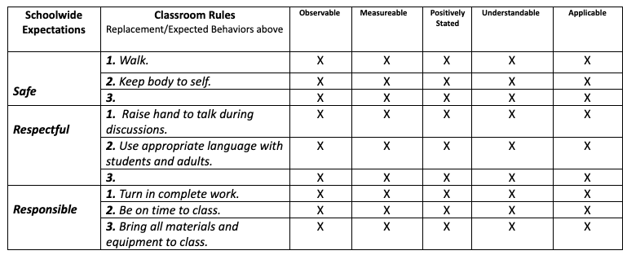

* What were the unexpected behaviors this teacher observed?
* What were the possible replacement behaviors this teacher listed?
* Consider if you agree with this teacher’s brainstormed list of replacement behaviors and rules?
* Do they meet the OMPU guidelines?

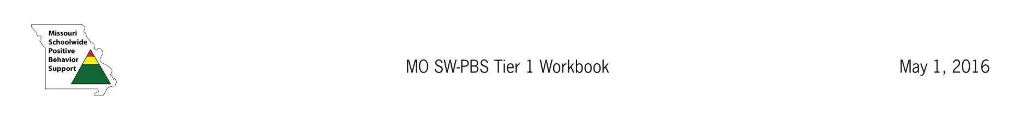

MO SW-PBS Effective Teaching & Learning Practices (ETLPs)

2024

**Step 2. Classroom Expectations & Rules: Activity** **Worksheet**

|  |  |
| --- | --- |
| **Unexpected Behaviors in Your Classroom** | **Replacement / Expected Behaviors**  **(What do you want Students to do instead?)** |
|  |  |
|  |  |
|  |  |
|  |  |
|  |  |
|  |  |

|  |  |  |  |  |  |  |
| --- | --- | --- | --- | --- | --- | --- |
| **Schoolwide Expectations**  **(From your schoolwide matrix)** | **Classroom Rules**  **(From the Replacement/Expected Behaviors above)** | **Observable** | **Measurable** | **Positive** | **Understandable** | **Applicable** |
|  | **1.** |  |  |  |  |  |
| **2.** |  |  |  |  |  |
| **3.** |  |  |  |  |  |
|  | **1.** |  |  |  |  |  |
| **2.** |  |  |  |  |  |
| **3.** |  |  |  |  |  |
|  | **1.** |  |  |  |  |  |
| **2.** |  |  |  |  |  |
| **3.** |  |  |  |  |  |
|  | **1.** |  |  |  |  |  |
| **2.** |  |  |  |  |  |
| **3.** |  |  |  |  |  |
|  | **1.** |  |  |  |  |  |
| **2.** |  |  |  |  |  |
| **3.** |  |  |  |  |  |

What are the behaviors that would be unexpected in YOUR classroom setting?

What would be possible replacement behaviors for those that are unexpected?

Now group or categorize  your brainstormed behaviors or rules so they align to the building wide expectations AND provide expected replacement behaviors for YOUR Classroom.

Finally, review each of your draft rules and consider if they meet the OMPUA guidelines.



MO SW-PBS Effective Teaching & Learning Practices (ETLPs)

2024

**Step 3. ______________________________________’s_ Classroom Matrix - Last Updated ________________**

|  |  |  |  |  |  |  |
| --- | --- | --- | --- | --- | --- | --- |
| **Schoolwide Expectations** | **All Settings**  (From School Matrix) | **Transitions** | **Whole Group** | **Small Group** | **Independent Work** | **When You Need Help** |
|  |  |  |  |  |  |  |
|  |  |  |  |  |  |  |
|  |  |  |  |  |  |  |
|  |  |  |  |  |  |  |



MO SW-PBS Effective Teaching & Learning Practices (ETLPs)

2024

**Step 4. Reviewing and Refining Classroom Matrix DRAFT & Plan for Teaching**

How will I engage **student voice** in the drafting of our ***Classroom Expectations and Rules***?

How might I have the students review Matrix for OMPUA?

Do I plan a formal commitment process for students? If yes, what are some possible approaches to commitment?

How will I engage **family voice** in drafting our ***Classroom Expectations and Rules***?

What kind of **signage** would be appropriate for my classroom and how might I engage students in developing the signage?

When do I plan to **teach** the ***Classroom Expectations and Rules***?

* During the first week of school?
* During the first 6 weeks of school?
* When and how will you teach intermittently throughout the school year?
* When do I anticipate your students might need booster lessons on your classroom expectations and rules (e.g., after holiday breaks, or snow days, before standardized testing periods, etc.).

What ***Pre-Corrects*** do I think would be helpful in reducing learning errors?

What are my plans for giving students feedback on their demonstration of our ***Classroom Expectations and Rules***?

When do I plan to use the ***Classroom Expectations & Rules Self-Assessment and Practice Profile*** to monitor my plan and implementation fidelity?



MO SW-PBS Effective Teaching & Learning Practices (ETLPs)

2024