## **C2L3_HO2: Pause and Reflect 1 Intrinsic or Extrinsic**

**Instructions:** Look at each of the pictures, below. Which of them represent someone doing something just for the sheer pleasure of doing it?

Which pictures show someone who is probably doing an activity for a reason other than the pleasure they get from the it?

Are there any that you are not sure about? Maybe it depends? You may resume the lesson when you are ready.

|  |  |  |  |  |  |  |  |  |
| --- | --- | --- | --- | --- | --- | --- | --- | --- |
| Intrinsic | Rationale |  | Intrinsic | Rationale |  | Intrinsic | Rationale |  |
| Extrinsic | Rationale |  | Extrinsic | Rationale |  | Extrinsic | Rationale |  |

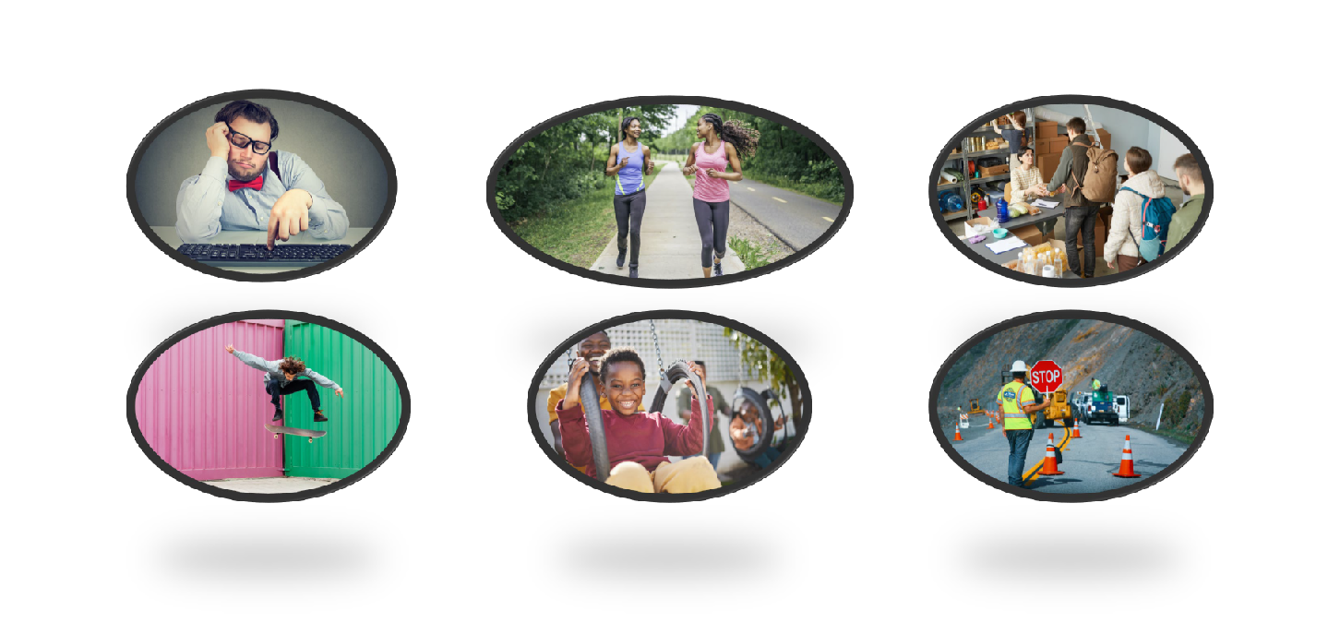

|  |  |  |  |  |  |  |  |  |
| --- | --- | --- | --- | --- | --- | --- | --- | --- |
| Intrinsic | Rationale |  | Intrinsic | Rationale |  | Intrinsic | Rationale |  |
| Extrinsic | Rationale |  | Extrinsic | Rationale |  | Extrinsic | Rationale |  |