**HO-3 Comparing Similar Behaviors - Why function is important?**

Read the scenarios and then complete the table with the ABC Continuum and consider what the function of the student’s unexpected behaviors might be.

**Scenario 1**

**Bill** often says he hates math. One morning he refused to open his math book or get out his notebook and just sat there.

The teacher reminded him to get started.

He said he hated math and folded his arms.

The teacher approached him and said that he needed to get ready for math or he would have to do it during the break.

He then pushed the math book on the floor and said he was not going to do any (expletive) math.

The teacher sent him to the office for noncompliance and disrespect. The teacher has noted that Bill often refuses to do work when a new concept has been introduced and has a history of poor math grades.

Therefore, the antecedents include math, new concepts, and working independently.

The consequences for Bill have been to be sent to a buddy room or to the office.

| Antecedent | Behavior | Consequence | Function |
| --- | --- | --- | --- |
|  |  |  |  |

**Scenario 2**

Another student, **Ann,** was having a bad day.

Before school, three girls had ignored Ann’s attempts to join in a conversation.

During class, she did not get out her materials and mumbled that she never got any help.

The teacher came over to help her get ready to work. The teacher talked with her and asked her to get out her science book.

Ann got out the book while the teacher was by her. As soon as the teacher walked away, Ann slammed the book shut and shoved it back under her desk. 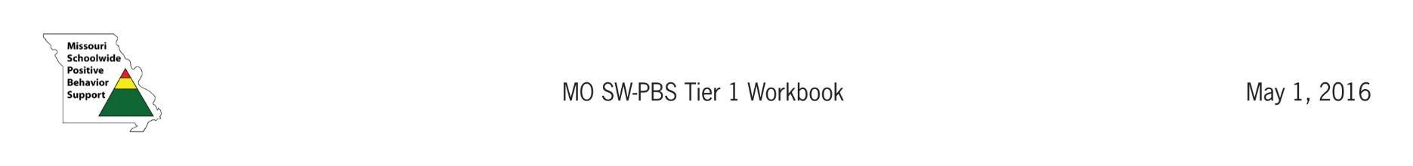

The teacher went back to her and Ann got out her book.

The teacher has noted that Ann’s pattern of unexpected behavior occurs when Ann is expected to work independently (antecedent) as she much prefers to work with a partner or in a small group.

When Ann refuses to work, the teacher is usually able to give her enough one-on-one attention (consequence) for Ann to complete the task although she finds Ann very capable of doing the work.

| Antecedent | Behavior | Consequence | Function |
| --- | --- | --- | --- |
|  |  |  |  |

**Guiding questions:**

* What ***unexpected behaviors*** are similar for these two students?
* What are the ***antecedents*** to these ***unexpected behaviors***?
* What are the ***consequences*** of these ***unexpected behaviors***?
* As a result, what are the ***functions*** of Bill and Ann’s behaviors?
* How might your strategies to change these students' behavior be different based on the function?

