The Data Collection Tool (DCT)
The MO SW-PBS Data Collection Tool is an Excel based spreadsheet for collecting Office Discipline Referral (ODR) data, and associated contextual information. It is designed to assist teams in using discipline data for decision-making. The DCT holds up to five years of ODR data. This data is summarized by over 26 standard monthly and cumulative yearly reports to aid school based teams in problem solving around individual and schoolwide behavioral data. Standard charts include the following:
- Absolute counts of ODRs per month
- Multi-year ODR frequencies per day per month
- ODRs by type of behavior (by month and cumulative for year)
- ODRs by location (by month and cumulative for year)
- ODRs by time of day (by month and cumulative for year)
- ODRs by day of week (by month and cumulative for year)
- ODRs by student
- ODRs by perceived motivation (by month and cumulative for year)
- ODRs by gender (by month and cumulative for year)
- ODR frequencies by racial composition (multi-year)
- Risk ratios by race, ethnicity, and presence of disability (multi-year
- Frequency of ODRs by IEP status (multi-year)
- ODRs by others involved (by month and cumulative for year)
- ODRs by grade level (by month and cumulative for year)
- ODRs by staff (by month and cumulative for year)
- ODRs by administrative decision (by month and cumulative for year)
- Total days of suspension (by month)
- Total days of suspension by race and ethnicity (by month and cumulative for year)
- Minor (classroom managed) behaviors by behavior type (by month and cumulative for year)
- Minor (classroom managed) behaviors by location (by month and cumulative for year)
- Minor (classroom managed) behaviors by time (by month and cumulative for year)
- Minor (classroom managed) behaviors by motivation (by month and cumulative for year)
- Minor (classroom managed) behaviors by student
- Triangle Chart for year
- Multi-year Triangle chart
Furthermore, there is a schoolwide dashboard that provides monthly and cumulative reports of the Big-5 data (how often, what behaviors, where, when, and who). This allows teams to make decisions when the entire school is the unit of analysis. Similarly, there is a Minors behavior dashboard, allowing the team to view quickly a set of standard monthly and cumulative charts of classroom-managed behaviors. Finally, a student dashboard allows teams to look at data by individual students. This allows teams to make decisions when the individual student is the unit of analysis.
In addition to the standard charts, the spreadsheet utilizes Excel’s pivot table feature to enable teams to “drill down,” or analyze data surrounding a specific behavior, setting, time or student(s). This increases the ability of the team to focus intervention efforts on specific behaviors, where and when they occur, and the students who are engaging in the behavior.

First Use
The first time you download the spreadsheet from the website, you will be prompted by your computer to do two things, “Enable Editing” and “Enable Content.”
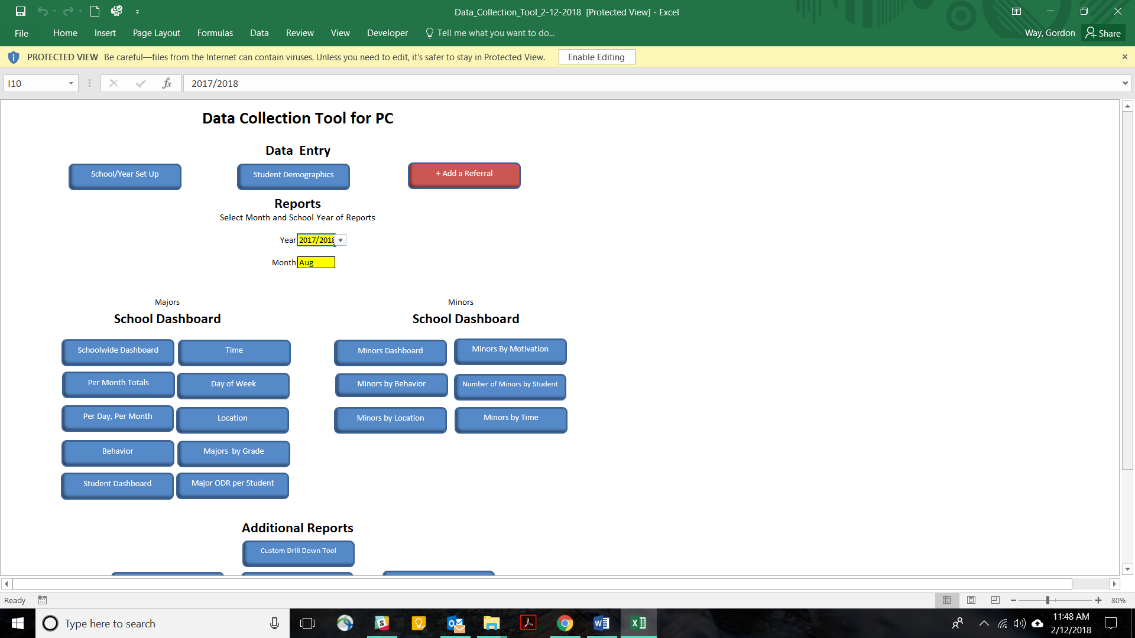
Figure 1
Enabling editing allows the user to use a Microsoft Office product downloaded from the internet.
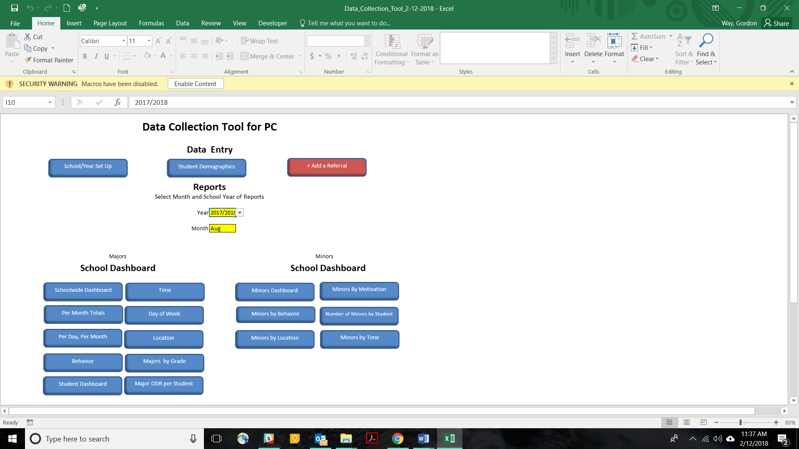
Figure 2
Enabling content allows the user to use the navigation buttons, as well as other features in the Data Collection Tool.

Main Menu
The “Main Menu” page is divided into two sections: “Data Entry” and “Reports.” The Reports section is further divided into “Select Month and Year,” a “Majors School Dashboard,” a “Minors School Dashboard,” and “Additional Reports.” Each section includes hyperlinked buttons that allow ease of navigation to the different data entry and reporting pages.

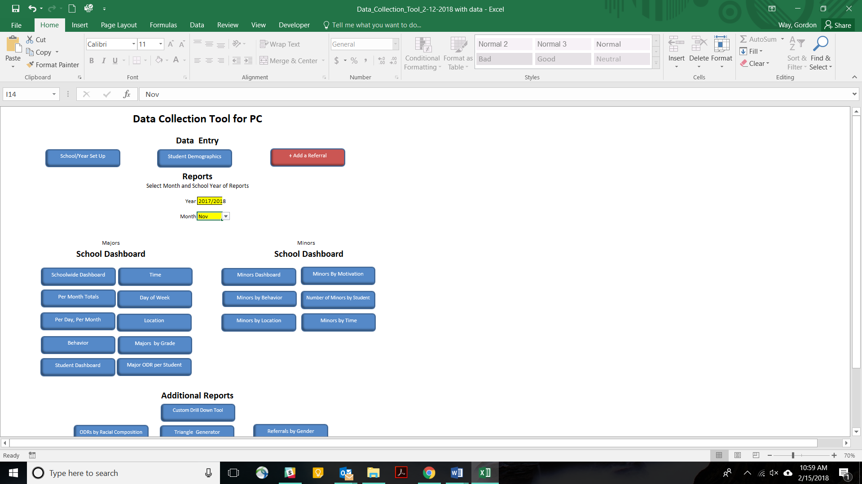
Data Entry
Reports
Reports
Reports
Figure 3

Data Entry
Figure 4
There are three data entry pages in the Data Collection Tool, the “School/Year Set Up,” “Student Demographics,” and “+Add a Referral.” Each is important for the proper functioning of the various reports.

School/Year Set Up
For many of the reports to work properly, you must enter the requested information in the “School/Year Set Up” page prior to using the spreadsheet each year. This information includes the following:
- School year
- Total enrollment
- Enrollment by ethnicity
- Enrollment by race
- Enrollment by disability status
- Staff names
- Days that school is in session each month

In addition, there are three buttons:
- “Back to Main Menu”
- “Reset for School Year”
- “Undo School Year Reset”

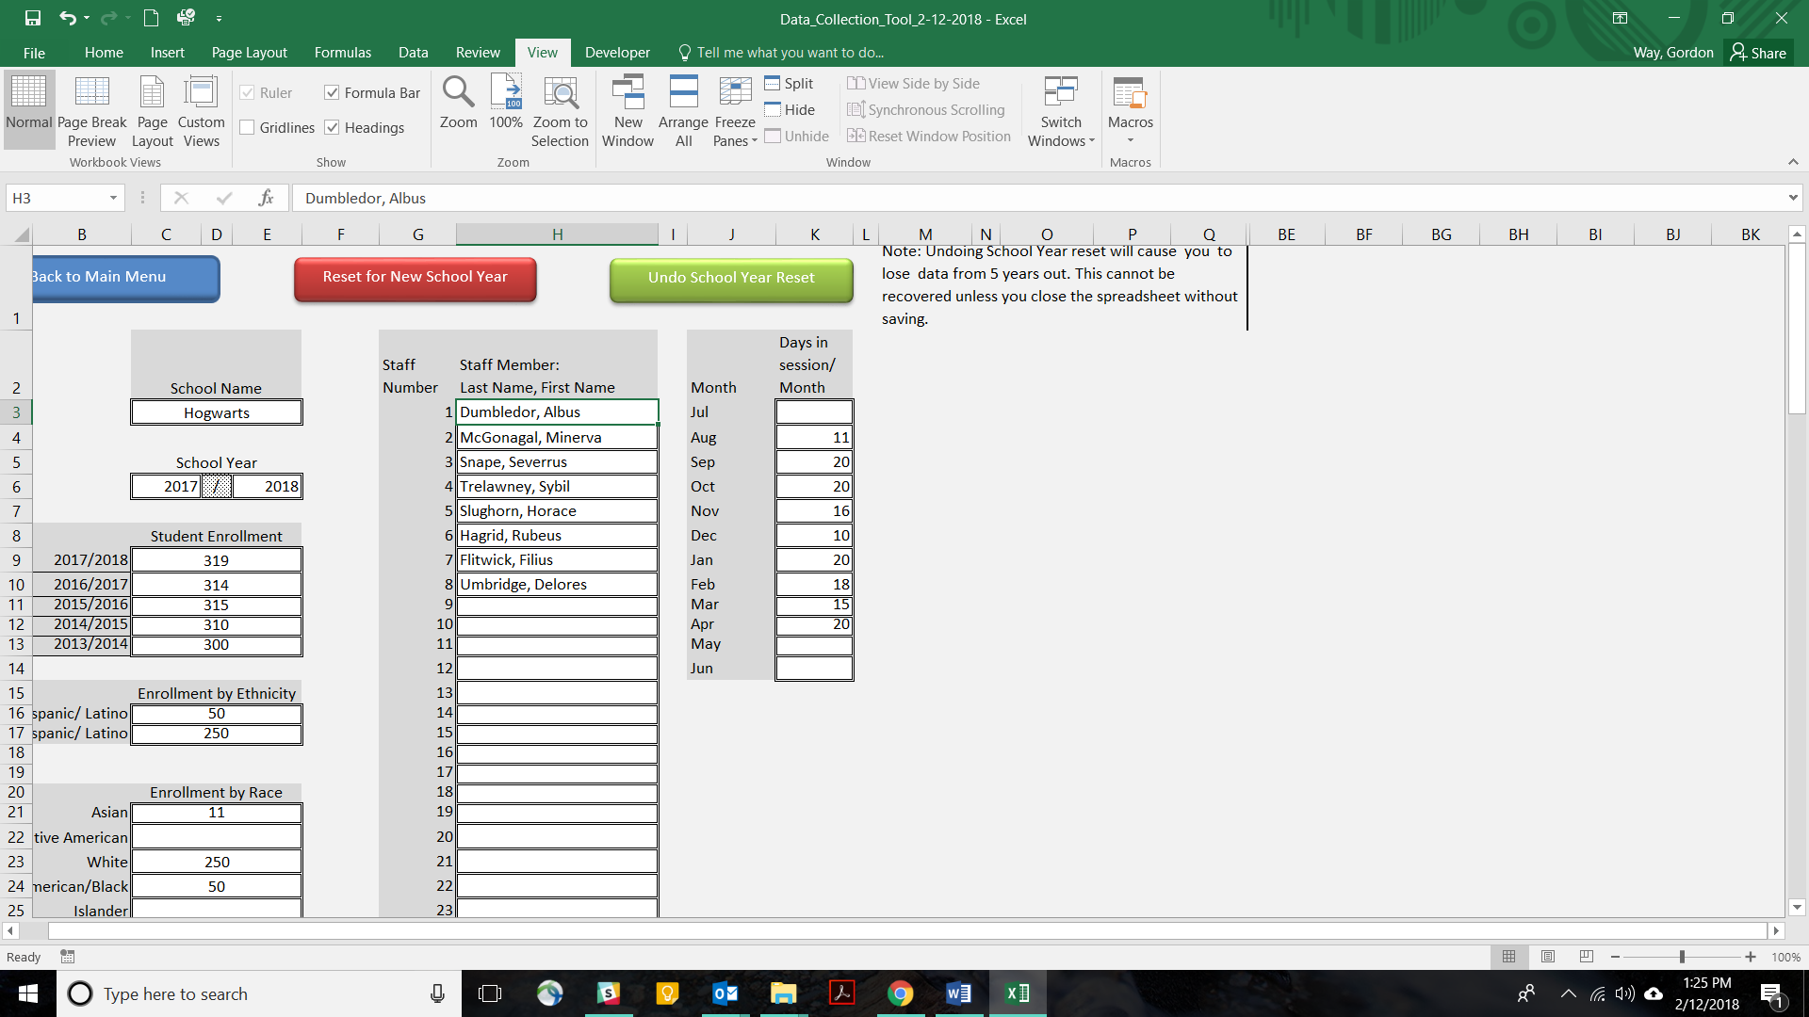
Figure 5

Enrollment, Race and Ethnicity
Total student enrollment is required for calculating the triangle chart and disproportionality metrics. Enter total student enrollment in the cell provided for the current school year. There is no need to enter enrollment for past school years, as this information is archived when you click on “Reset for New School Year” button.
MO SW-PBS strongly recommends that schools monitor disproportionality in discipline by race, ethnicity, and disability status. The DCT includes features that assist school teams in monitoring for disproportionality. These include composition, risk indices, and risk ratios. For the spreadsheet to complete disproportionality calculations, enrollment by race, ethnicity, and IEP status must be entered into the “School/Year Set Up” page.
For total enrollment, and enrollment by race and ethnicity, MO SW-PBS recommends that you use the September enrollment numbers as reported to the State Education Authority (SEA). Consider revising these numbers only if there is a moderate to large turnover of 10-20% or more students during the school year.
Figure 6

“Back to Main Menu,” “Reset for School Year,” and “Undo School Year Reset”
The “Back to Main Menu” button is a navigation button that takes you back to the main menu. The “Reset for School Year” archives school set up information from the current school year, and prepares the “School/Year Set Up” page for data entry of information specific to the new school year.
If you mistakenly click on the “Reset for School Year” button, you can recover archived information by clicking on “Undo School Year Reset.” However, the spreadsheet only holds one year of current school set up information, and four years of archived school set up information. Therefore, if you have four years of data already archived, and click “Reset for New School Year,” the fourth year of archived data will removed from the spreadsheet. Even clicking on the “Undo School Year Reset” button will not bring this fourth year of data back into the archives. In this case, it might be best to either click the “undo” icon at the top of the spreadsheet, or close the spreadsheet without saving. Furthermore, it is wise to periodically save a backup of copy the spreadsheet.

Staff
Entering staff names in the School/Year Set Up page will add the names to a dropdown menu that is used to select staff for entering ODRs in the “+Add a Referral” page. This makes data entry easier, and allows teams to identify staff that may need additional support. It also increases the integrity of the reports.
Figure 7

Days in Session/Month
Enter the days that school is in session for students for each month into the “Days in Session/Month” column. The DCT uses this information to calculate the Per Day, Per Month report.

Figure 8

Student Demographics
The Student Demographics page allows teams to enter demographic information for individual students once, typically when the student receives his or her first ODR. The spreadsheet will pull this information into the record of each referral, allowing this data to be used as independent variables for the different reports. Each row of the “Student Demographics” page is a record for each individual student. A unique student number is required for each student. All of the student’s demographic information and ODR information are associated with this number. This number maintains data integrity, and the DCT will not work properly without it. Furthermore, when the number is entered into “+Add a Referral,” the student’s demographic information automatically loads into the record of the ODR. An easy way to ensure that the number is unique to the student is to use the student’s district identification number.

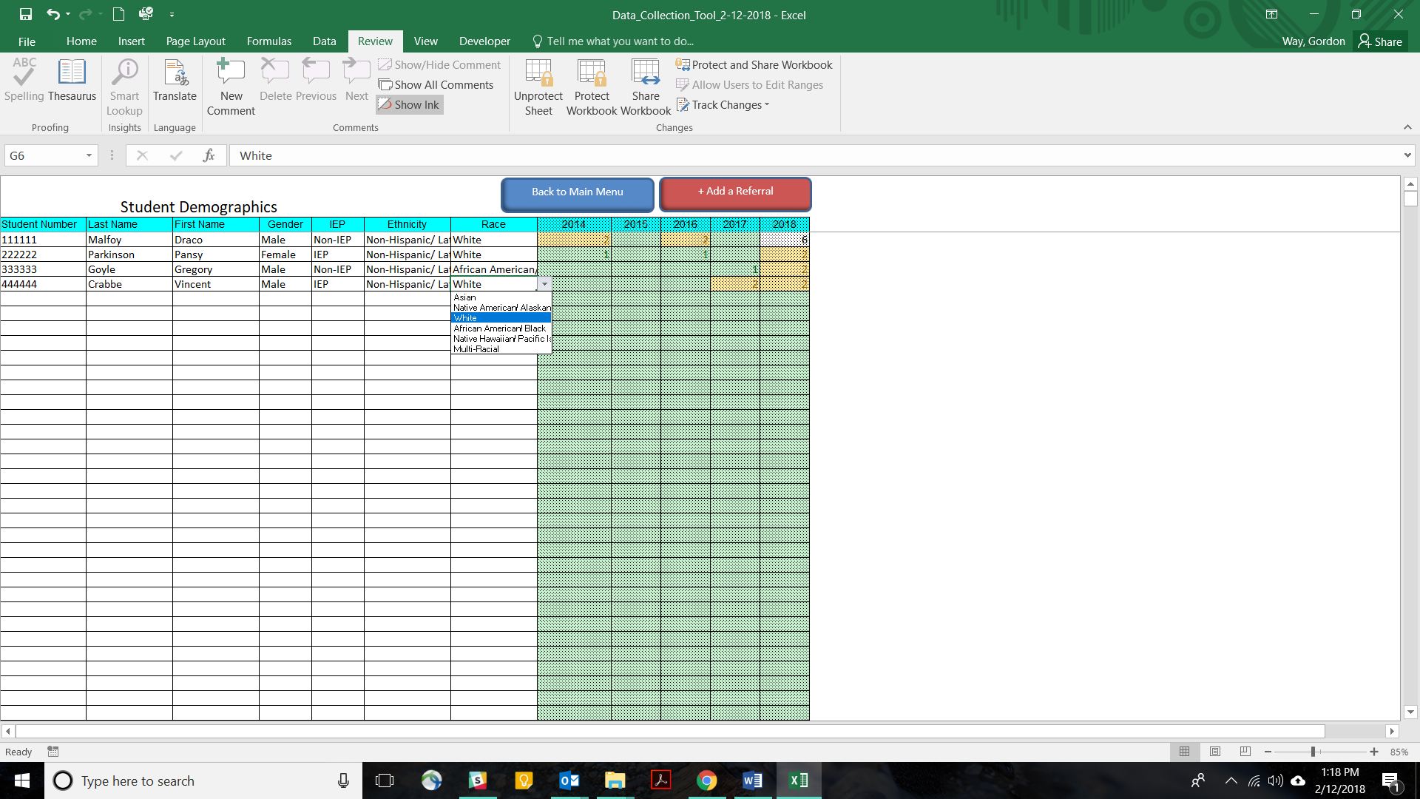
Figure 9

Dropdown lists are used to enter data for Gender, IEP Status, Ethnicity, and Race. Dropdowns are used to maintain data integrity. “Grade” level is not included in the student’s demographic information, since a student’s grade level changes from year to year.
Notice that there are shaded columns for each school year for which the team has data, with the current year farthest to the right. As a student accumulates office referrals, the number of ODRs per year are recorded in these columns. These cells are conditionally formatted so that they are green if the student has 0-1 ODRs, yellow once the student has 2-5 ODRs, and red when the student has 6 or more ODRs. This can assist the team to quickly identify students who may benefit from Tier 2 or Tier 3 interventions.

+Add a Referral
If a student receives an ODR, but is not yet in the system, first enter the student’s information on the student demographics page. Then, click on the “+Add a Referral” button. This takes you to a page where you can log ODRs. ODR records are entered on subsequent rows. Enter the student’s number in the first cell of the row. Click the “tab” button on your keyboard. This will move the cursor to the “Grade” cell, and fill in the student’s demographics information in the intervening cells. Fill in the remaining information from the referral. Although some cells can be left blank, the DCT counts Major Offenses and Minor Offenses. One or the other must be marked for each referral. Finally, you will notice that there are freeze frames on the page. This means that ODR records will scroll under the column headers as you scroll down. This is intended to help the user to enter the correct data in the appropriate column. Just be aware that records may be hidden beneath the column headers.
Note: If the student demographic information does not pull up, make sure the student has been entered into the “Student Demographics” page. Also, verify that the number entered into the Student Demographics page matches the number entered into the “+Add a Referral” page.
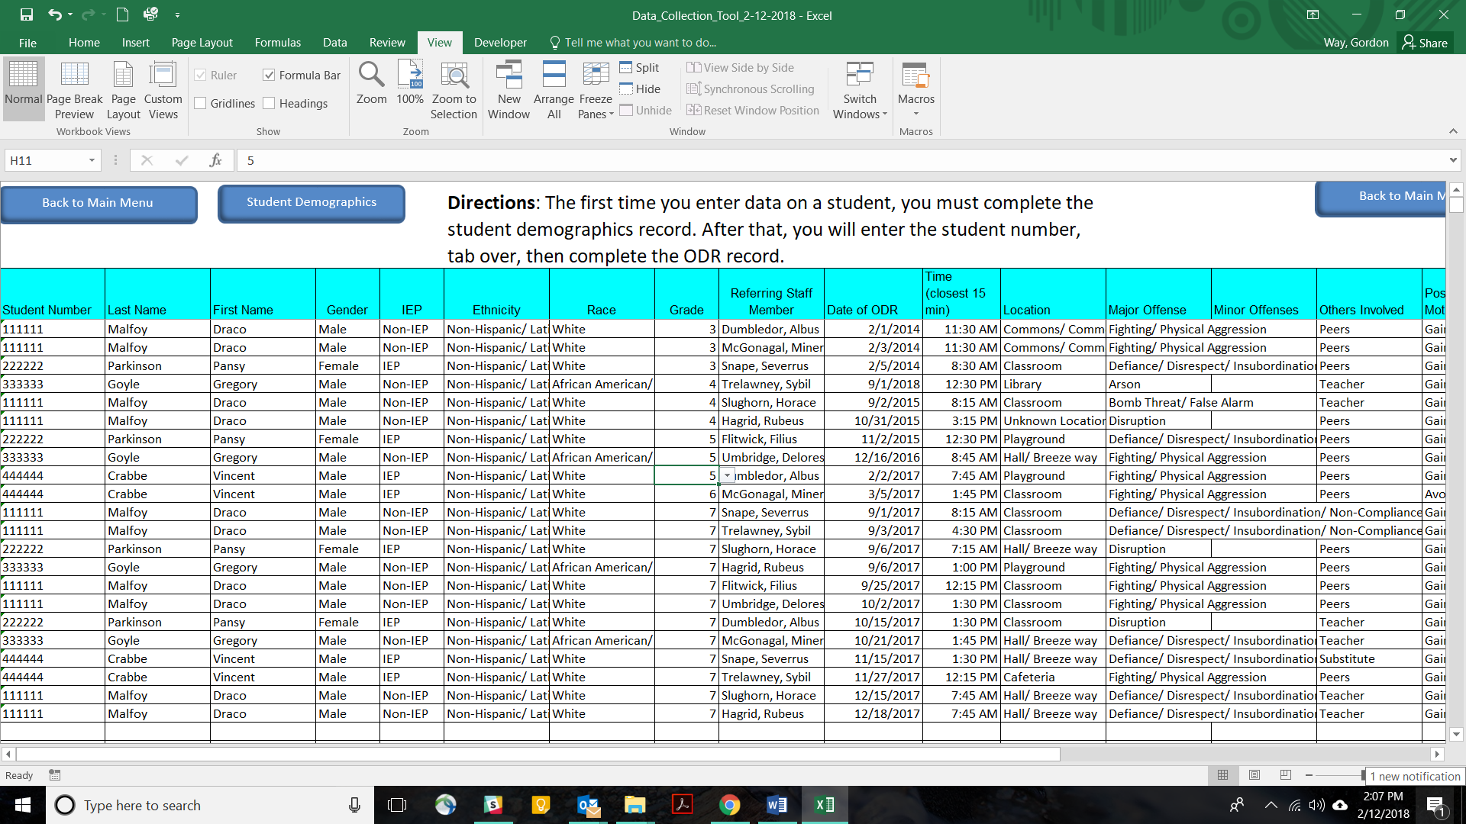
Figure 10

Reports
Most of the reports in the DCT include a chart for a specific month and year, and a cumulative chart for the same school year. Select the month and year for all charts using the dropdown menus in the yellow cells on the main menu page.

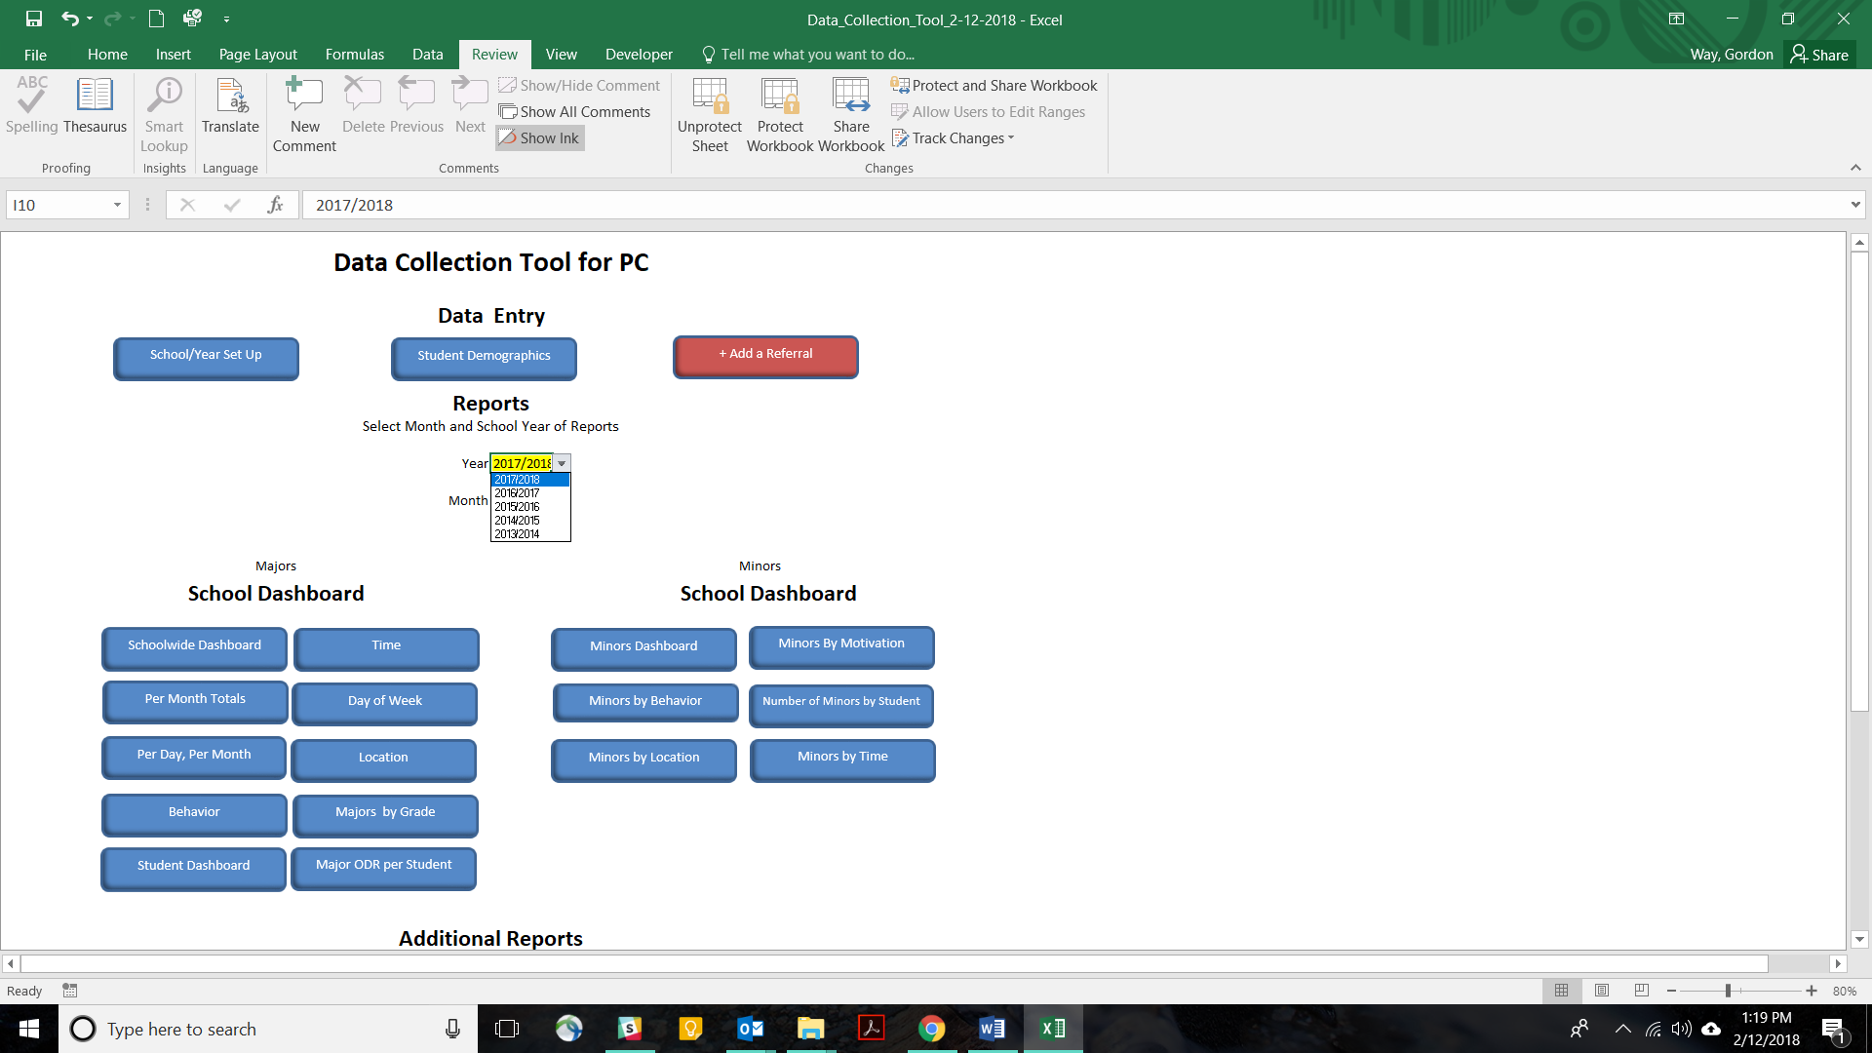
Select School Year
Figure 11

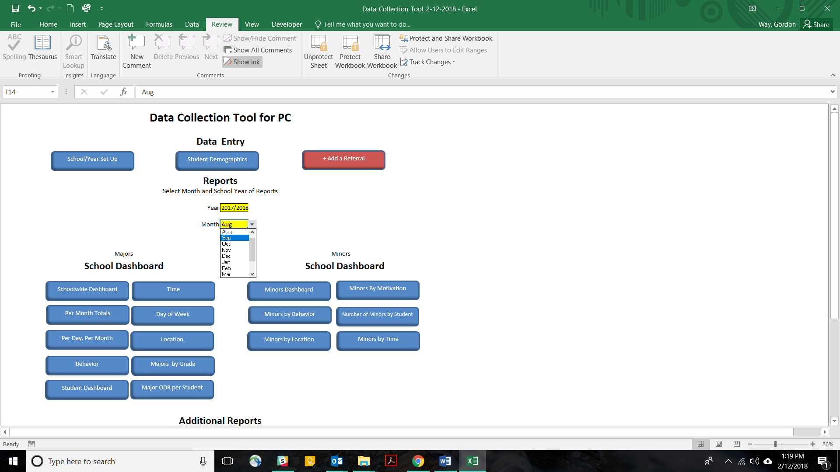
Select Month
Figure 12

The School Dashboard offers a quick way to look for monthly and cumulative charts that answer the Big-5 questions of 1) what (behavior), 2) where (location), 3) when (month, week, and time of day), 4) who (student), and how often (per day/per month, and all charts).
Figure 13

Also in the School Dashboard section of the Main Menu, seven buttons take you to reports that are preloaded with monthly and cumulative charts for a specific category. These include 1) Per Month (absolute count), 2) Per Day Per Month (multi-year), 3) Behavior, 4) Time, 5) Day of Week, 6) Location, and 7) Grade. Figure 14 shows the Behavior page, and is an example of a report that includes both monthly and yearly cumulative charts. Figure 15 is the Per Day Per Month report, and is an example of a report that shows both month and school year on the same chart.

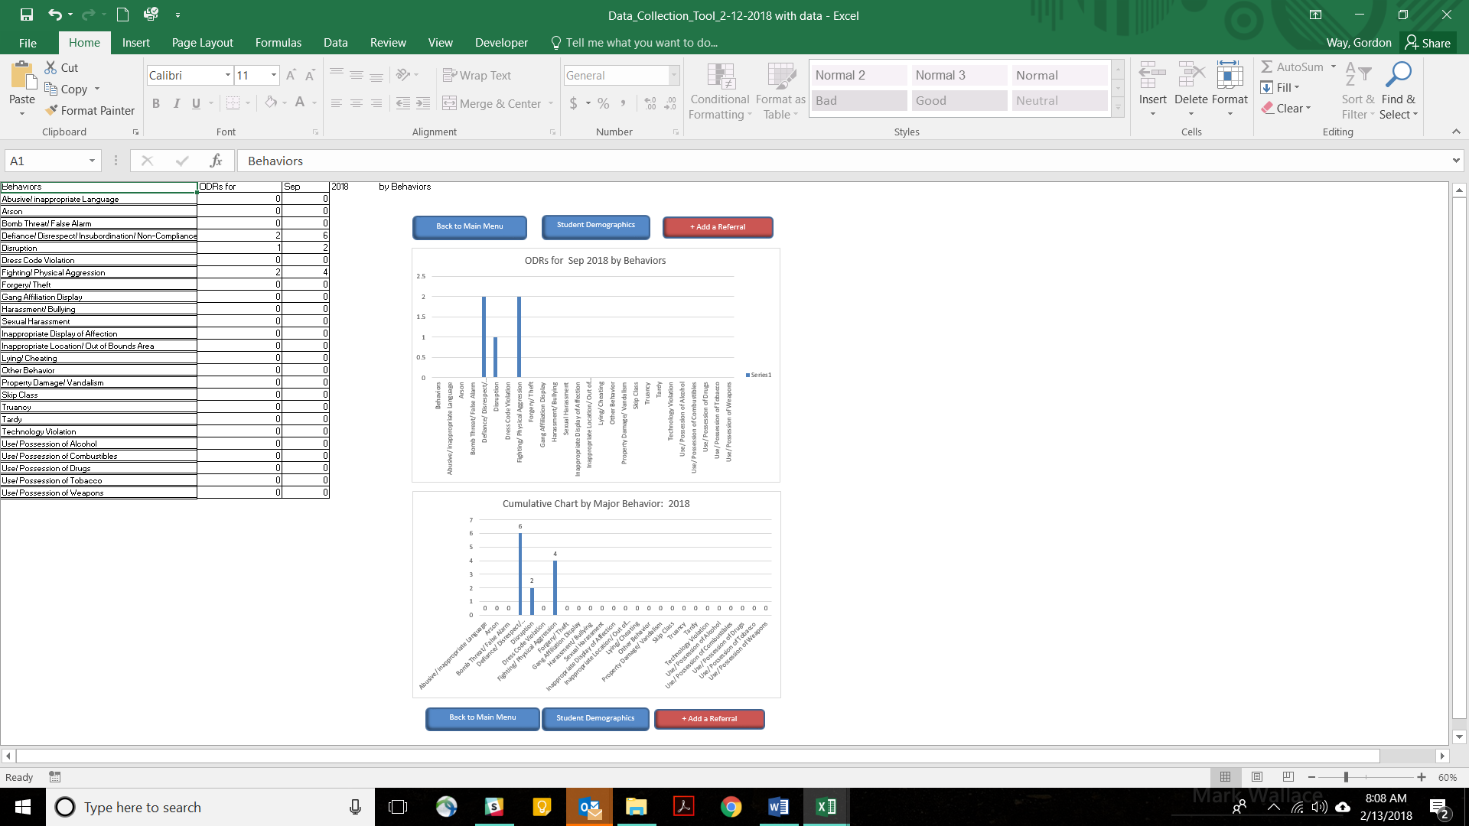
Figure 14

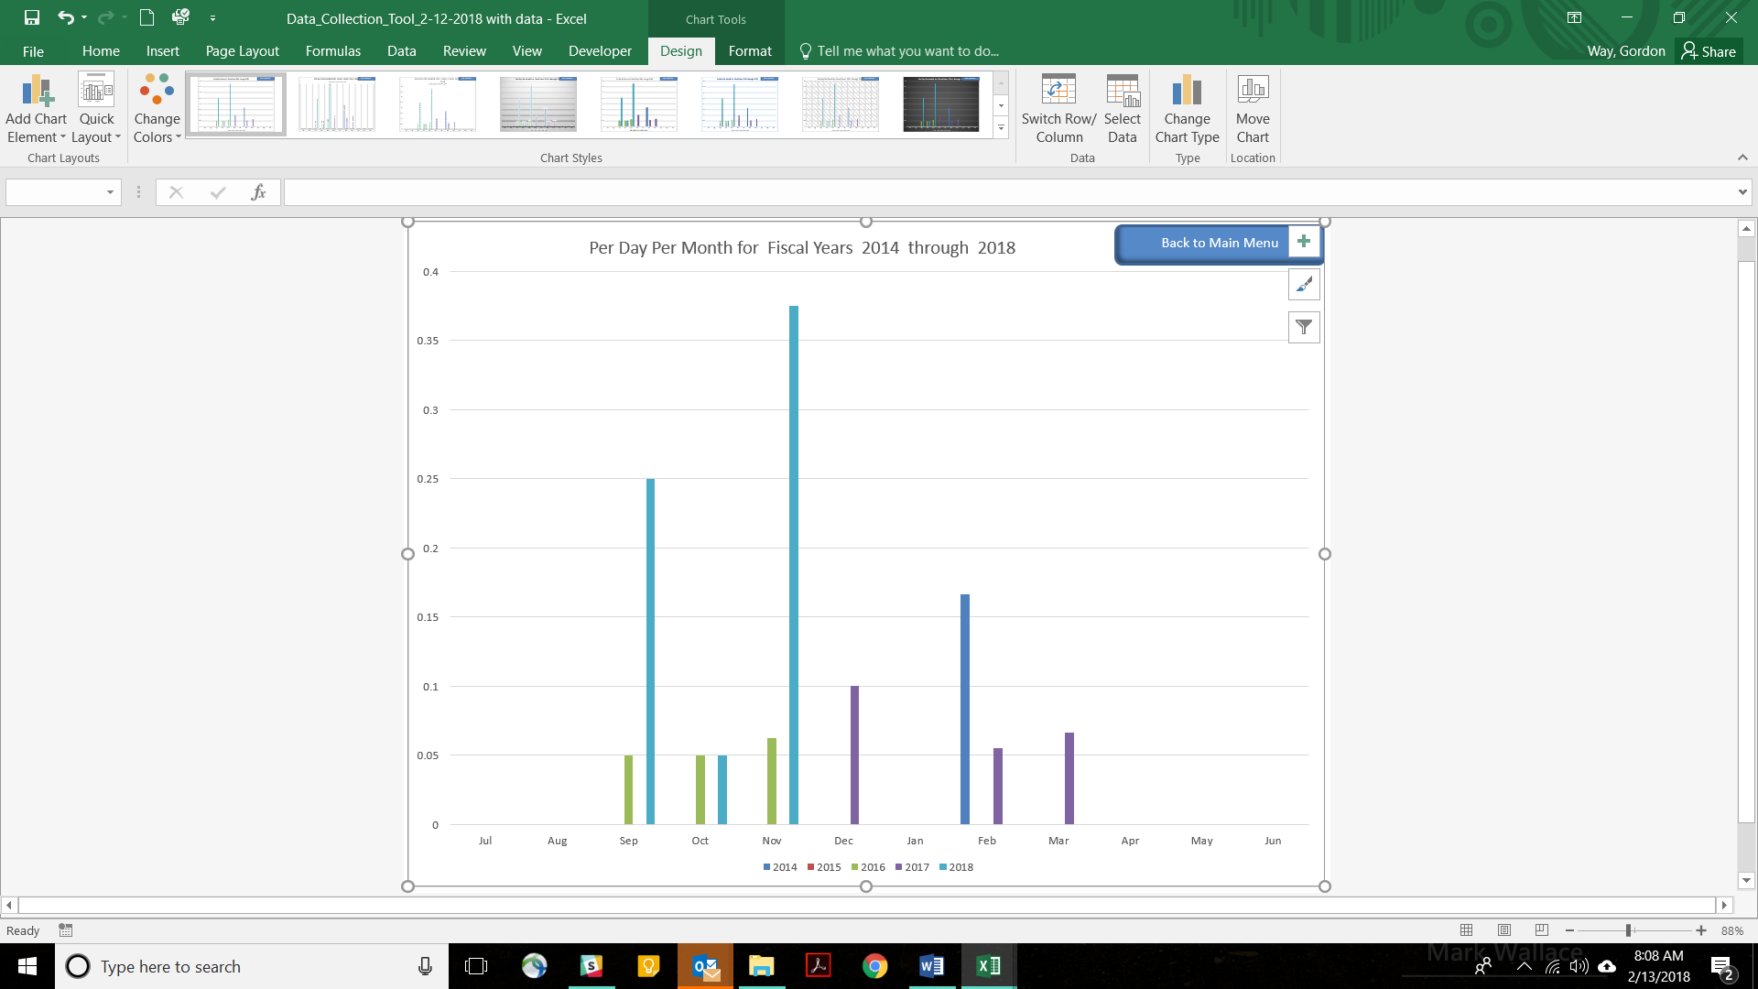
Figure 15
There are two additional reports that require more explanation. First, is the “Major ODR by Student” report. This report uses a pivot table because pivot tables are responsive to the addition of new data records (i.e., a new student is added to the referrals page). Although a more detailed description of how to use a pivot table will be provided, later, there are three things that a user needs to be aware of to use this report. First, while most features of the DCT should work on most computers, the features that depend on pivot tables may not work properly on computers using Microsoft Excel for Apple.
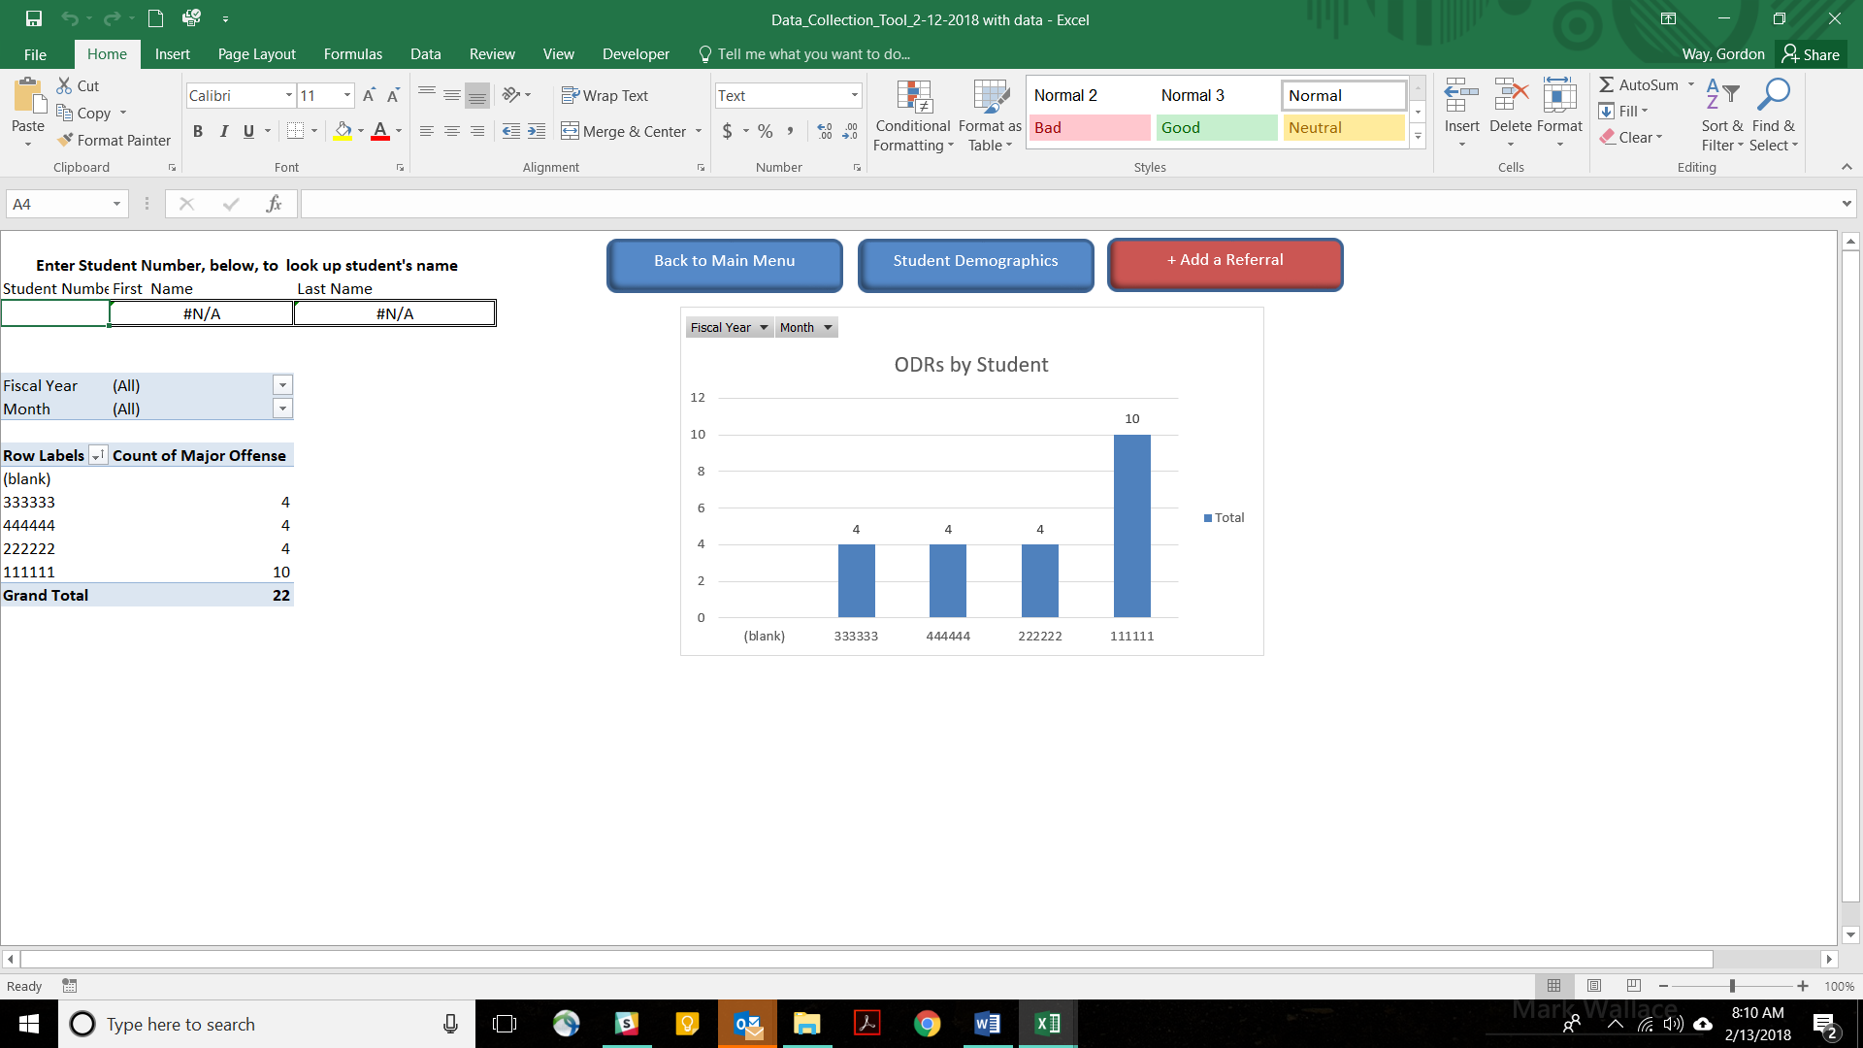
Pivot Table
Filters
Student Lookup
Filters
Pivot Table Chart
Figure 16
Second, there are filters for “Month” and “Fiscal Year” on both the pivot table and a pivot table chart. Users can use the dropdown menus on these filters to narrow analysis to a specific month and a specific year.
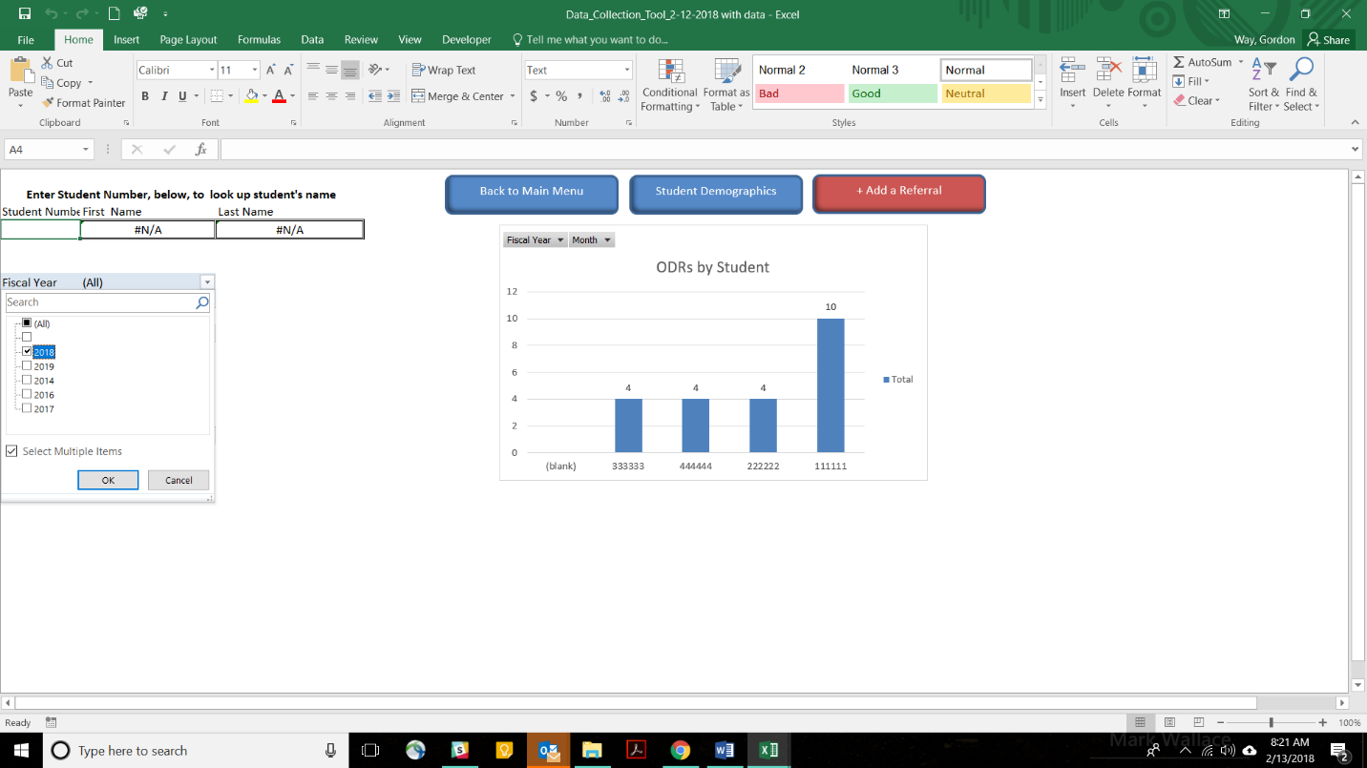
Figure 17
Filter by Month
Filter by Year
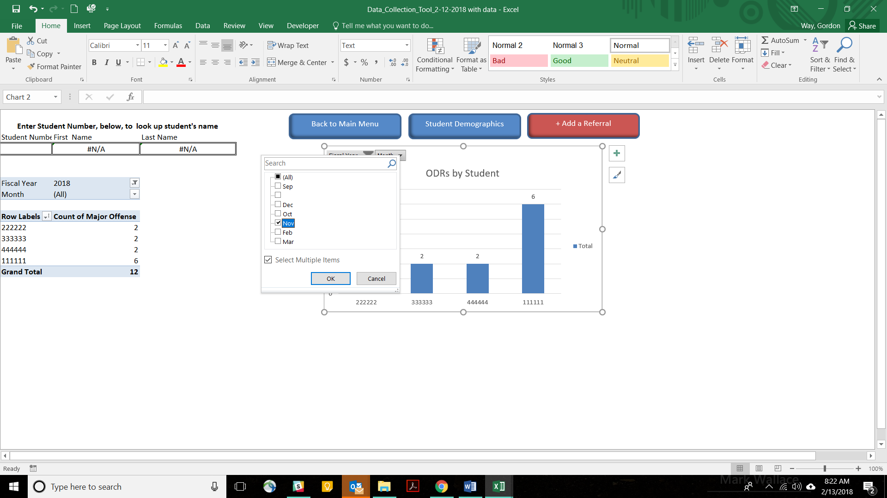
Figure 18

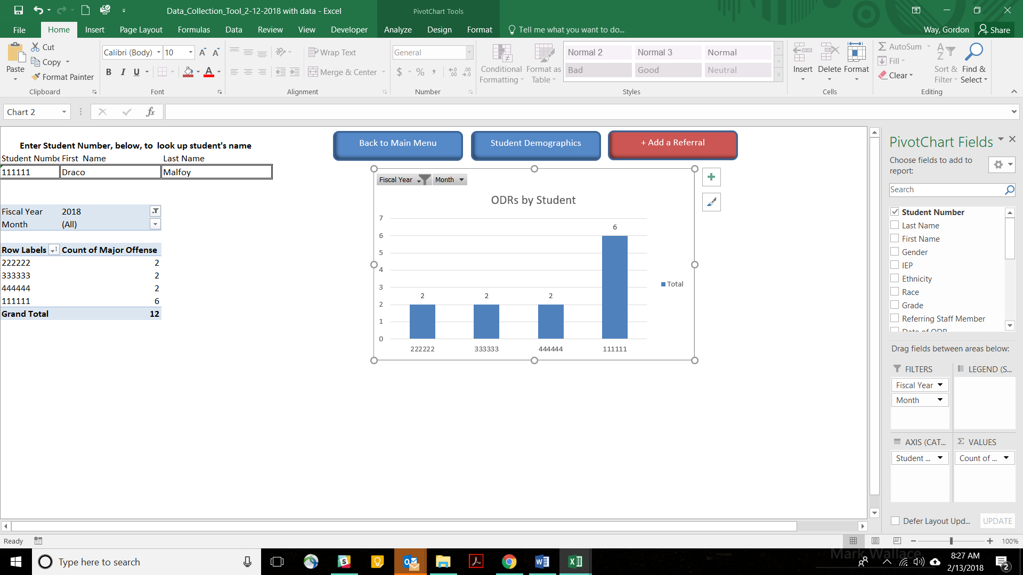
Student Lookup
Figure 19

Also, there is a section in the upper left-hand corner of the page that allows users to look up a student’s name, using their student number. For example, on the chart depicted in figure 19, student number 111111 has six ODRs, meeting the team’s decision rule for evaluation for a Tier 3 intervention. By typing the student’s number into the student lookup, the feature returns the student’s name.

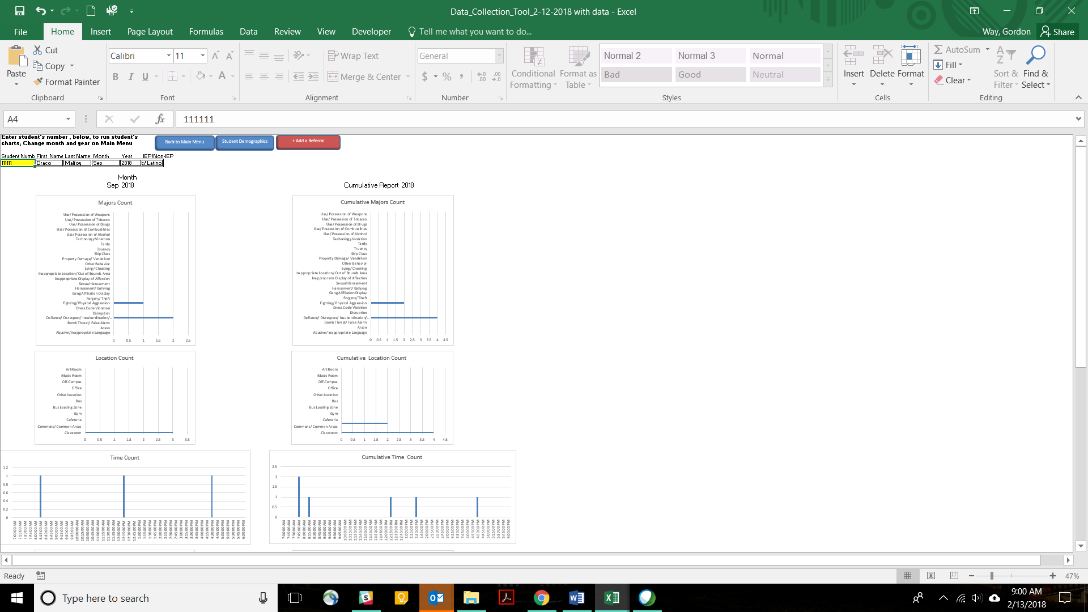
Select Student
Figure 20
The second report that requires additional explanation is the Student Dashboard. This screen allows the team to run a report on an individual student. Reports include Monthly and Annual Cumulative reports by Behaviors, Location, Time, Possible Motivation, Others Involved (by role), and Number of Days Suspended. The student’s IEP status is also indicated. This is to assist administrators to determine whether a student requires a manifestation hearing.
To pull up a student’s discipline data, simply enter the student’s number in the yellow cell below the “Student Number” label. The student’s discipline data will then appear in the graphs. Please note that the month and year for the student dashboard are also set on the Main Menu page.

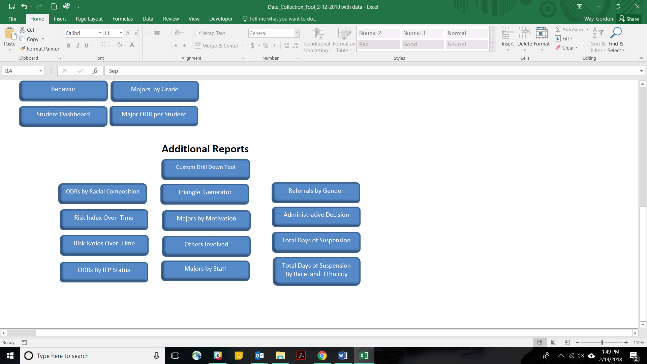
Figure 21
Below the School Dashboard section of the Main Menu page are links to 13 Additional Reports. These include: 1) Custom Drill Down Tool; 2) ODR by Racial Composition; 3) Risk Index Over Time; 4) Risk Ratios Over Time; 5) ODRs by IEP Status; 6) Triangle Generator; 7) Majors by Motivation; 8) Others Involved; 9) Majors by Staff; 10) Referrals by Gender; 11) Administrative decision; 12) Total Days of Suspension; 13) Total Days of Suspension by Race and Ethnicity.

Additional Reports
Most of the Additional Reports chart monthly and cumulative major ODRs by specific variables. Exceptions include the “Racial Composition,” “Risk Indices,” “Risk Ratios,” “ODRs by IEP Status,” the “Triangle Report,” and the “Custom Drill Down Tool.” The disproportionality reports each chart their respective indicator by year. The “Triangle Report” and “Custom Drill Down Tool” require further explanation. Figure 22 shows the how the Risk Ratio report depicts multi-year risk ratios for different demographic groups.
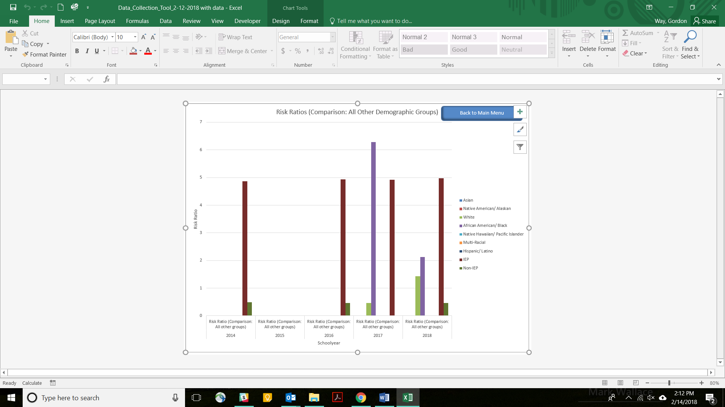
Figure 22

The “Triangle Report” includes two charts: a triangle chart for the current year, and an area graph charting triangle data over time. The triangle chart for the current school year charts the number of students with 0-1 ODRs, 2-5 ODRs, and 6 or more ODRs. This report actually contains two triangles. The triangle on the right shows the school’s data, and updates automatically as new referrals are entered into the system. The triangle on the left offers a comparison of a similarly configured school based on SWIS data from 2016-2017 school year. To change the comparison data to match your school’s configuration, use the dropdown menu above the triangle chart.
SWIS Norms
School Data
Select School Configuration
Figure 23
Below the triangle chart for the current school year is an area chart that shows how response to intervention data changes over up to five years.

Custom Drilldown
The DCT uses Excel Pivot Tables to drill down into the data. As mentioned earlier, some versions of Excel for Apple computers do not support pivot tables. Therefore, if you have an Apple computer, the custom drilldown feature may not work properly.
The Custom Drilldown allows the user to count ODRs by a variety of contextual factors, such as behavior, location, time of day, grade level, student number or any other factor recorded in the “+Add a Referral” and “Student Demographics” pages. The user can then apply filters to narrow the focus even further in order to zero in on the context surrounding a specific problem. This assists the user to select narrowly focused schoolwide and individual student interventions, increasing the likelihood that the intervention will be successful.
Before going into how to conduct a drilldown, it is important to know your way around the Custom Drill Down page. The components with which you should be familiar include:
- Pivot Table
- Filters
- Pivot Table Fields
- Pivot Table Tools
- “Analyze” button on the Main Menu Ribbon
- Pivot Table Tools (Main Menu Ribbon)
- Field List on the Analyze Button of the Main Menu Ribbon
  - Fields
  - Columns
  - Values
  - Rows
  - Filters
- Chart that is linked to the pivot table

Pivot table Tools
Field List
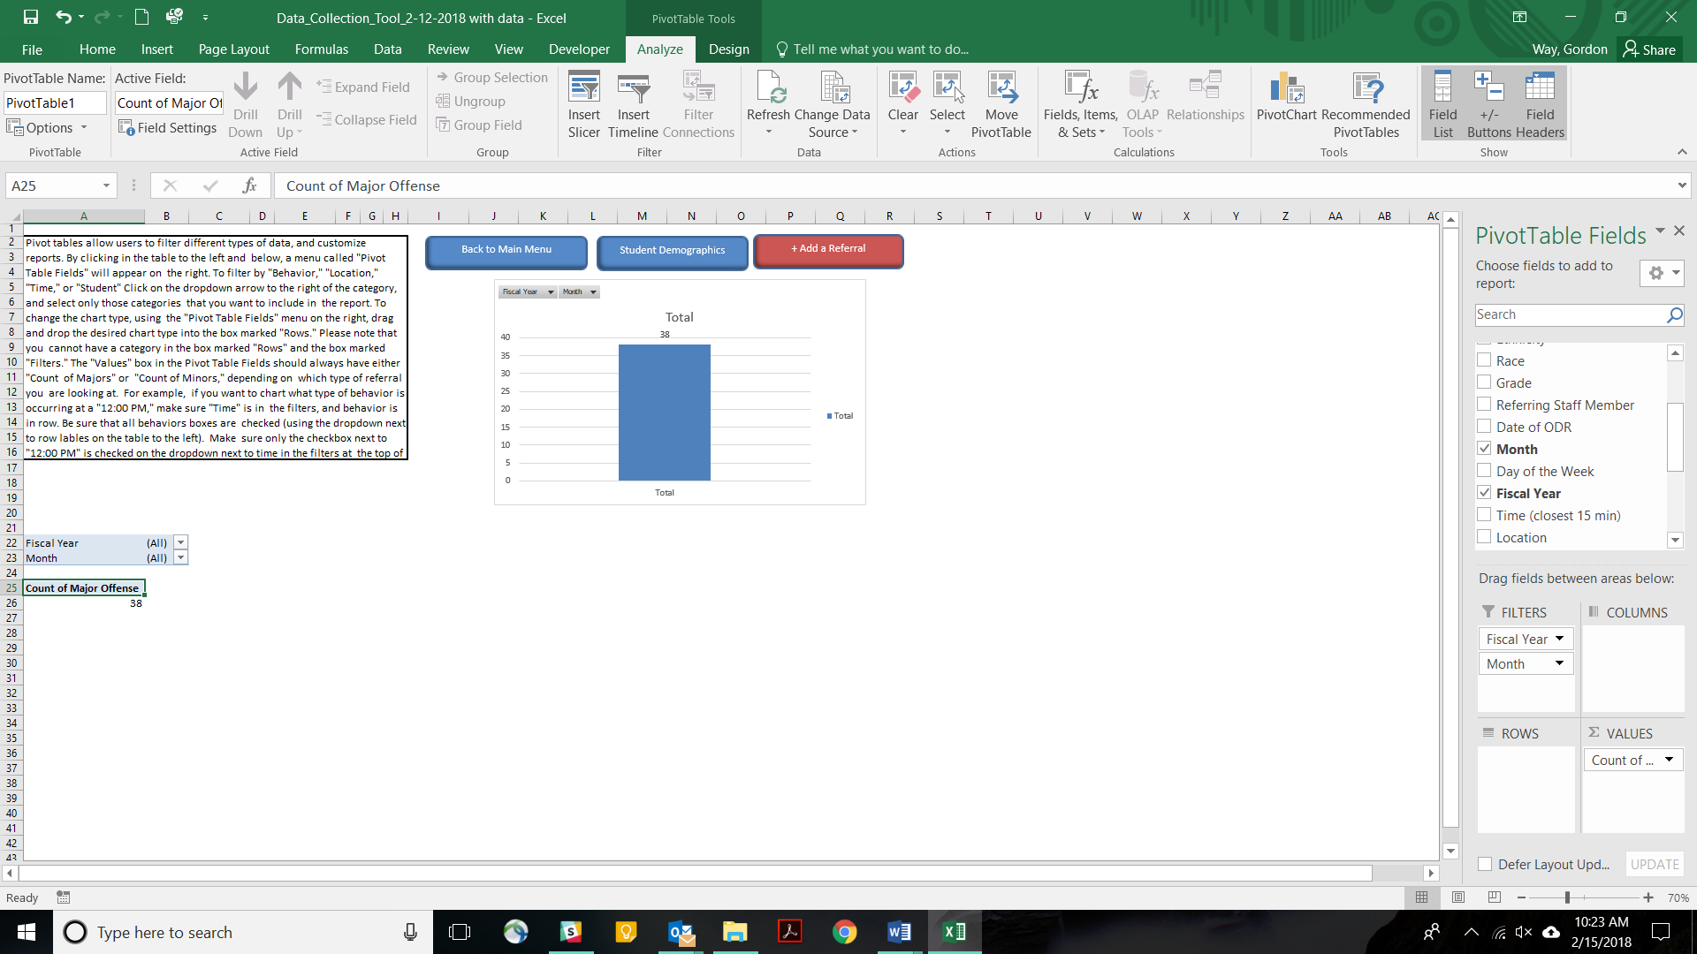
Columns
Values
Pivot Table Fields
Fields
Analyze
Filters
Rows
Linked Chart
Filters
Pivot Table
Figure 24

To use the Pivot Table, the Pivot Table Fields box must be visible. If it is not, click on either the pivot table, or the linked chart. This should cause the Pivot Table Fields to appear. If the Pivot Table Fields still does not appear, clicking on the pivot table or the linked chart should also make a “Pivot Table Tools” tab appear on the main menu ribbon. Click on the “Analyze” tab under the “Pivot Table Tools” tab, then click on the “Fields List.” This will cause the Pivot Table Fields to appear when you have clicked on either the pivot table or the linked chart.
On the Pivot Table Fields, the pivot table will count whatever is in the “Values” box. For the purposes of the DCT, the “Values” box defaults to “count of Major Offenses.” You can also count minor offenses by dragging the “Count of Major Offenses” box from the values section and drop into the “Fields List.” Then, drag “Minor Offenses” from the fields list into the Values list. The pivot table is now set to count minor problem behaviors.
Whatever is in the “Rows” section will form the rows of the pivot table. For example, if you want to know the count of major offenses by the type of behavior, you can drag “Major Offenses” from the Fields List into the Rows box.
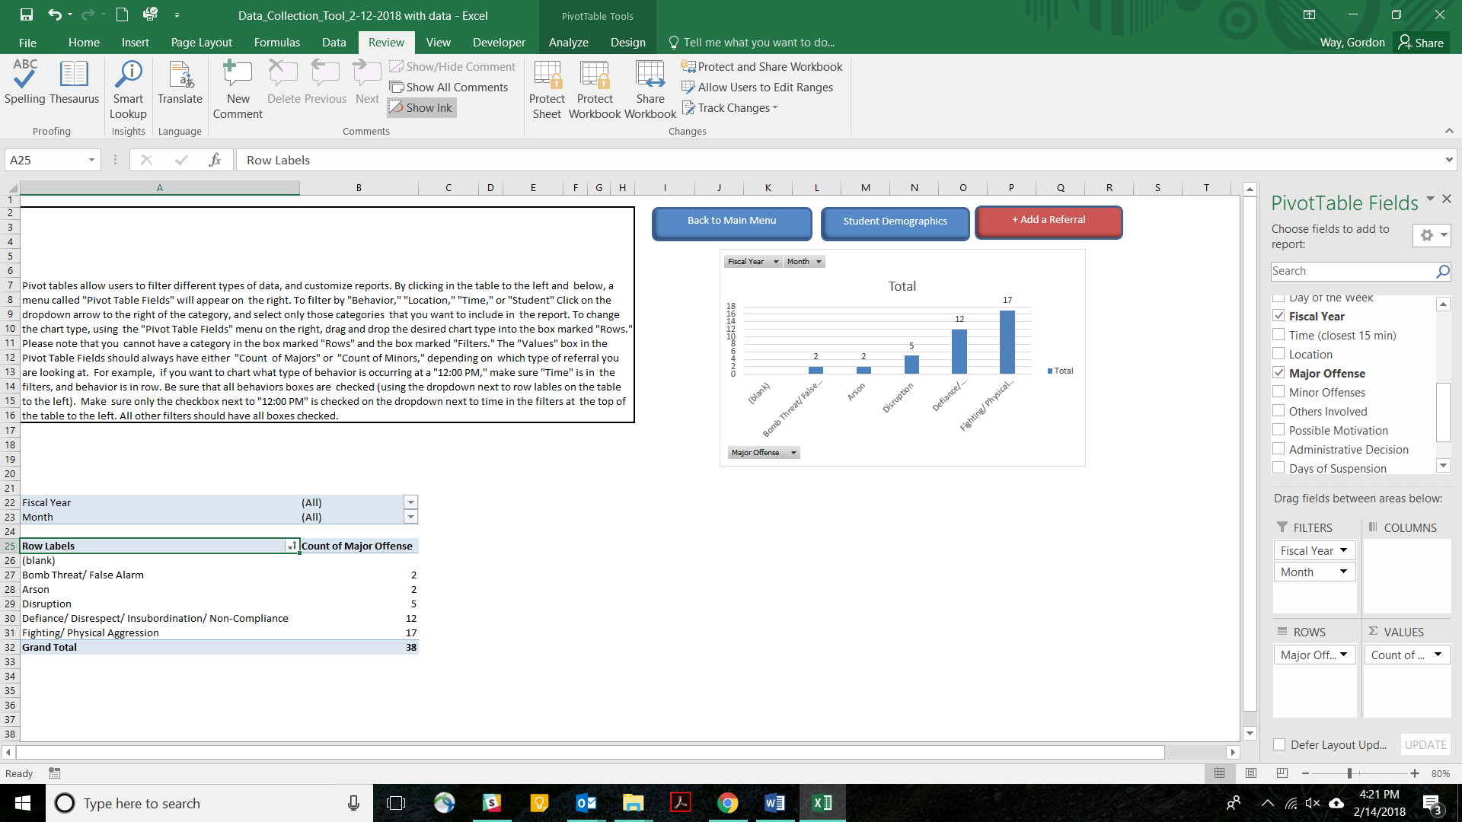
Rows
Rows
Values
Fields List
Figure 25

The field that is in the columns section will form the columns of the pivot table. For example, if you want to view the type of behavior by month, drag the “Month” field into the Column section. Notice that the table has now added columns enabling the team to view the count of referrals by behavior, per month.
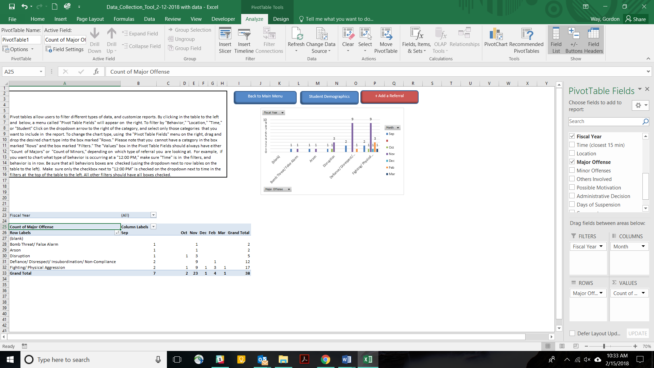
Columns
Columns
Figure 26

Now, suppose you want to view behaviors for a specific school year. You can use the filters to limit the focus to the data from one year. To do this, drag the “Fiscal Year” Field from the Fields List into the Filters box. Fiscal Year will now appear in the grey filters section of the pivot table. Notice that there is a dropdown arrow next to fiscal year. Click on the dropdown menu, and make sure that you check only the box for the desired school year.
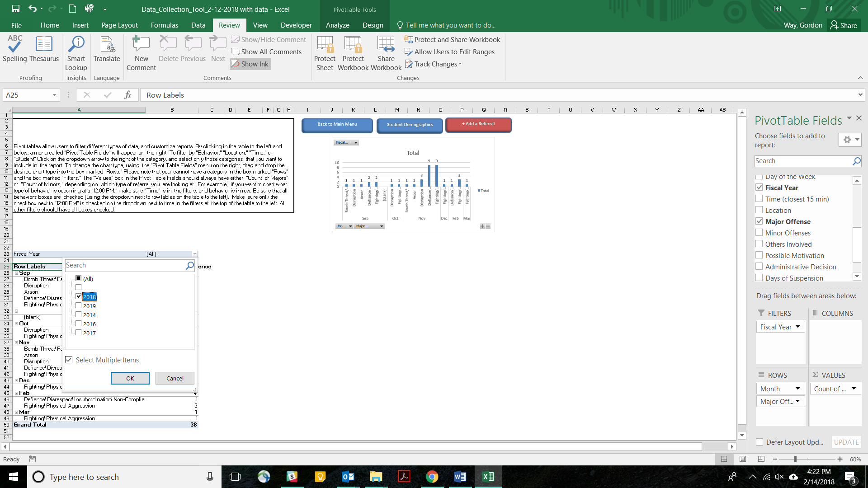
Fields List
Filters
Filters
Figure 27

The chart now only shows behaviors for the current school year.
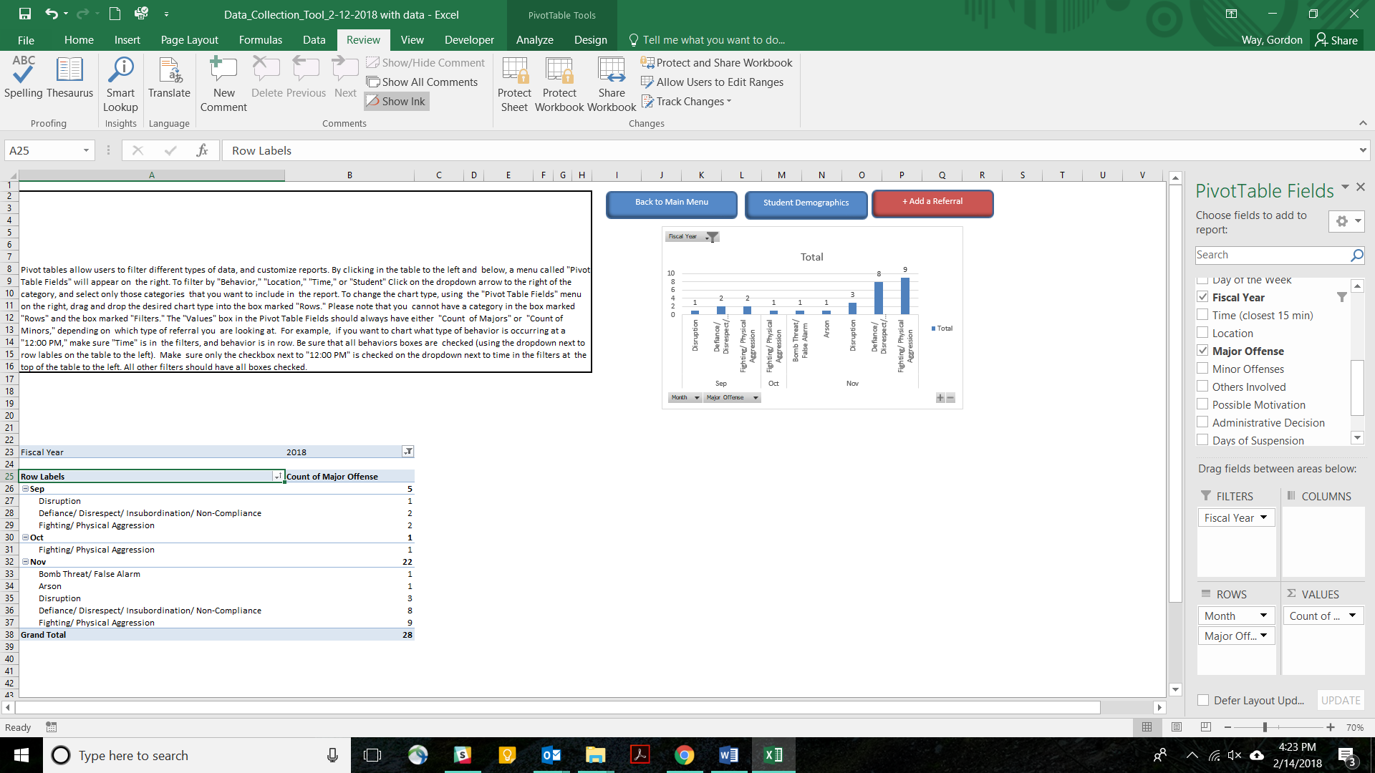
Figure 28

Suppose you want to develop a plan for December that focuses on your most frequent problem behavior. If we look at the schoolwide dashboard for November 2017 (FY 2018), we notice that Fighting/Physical Aggression is the most frequent problem behavior. Most ODRs are coming from the classroom. And most ODRs are occurring at 7:30 AM and 1:45 PM. You could focus your intervention efforts on addressing Fighting/Physical Aggression in the classroom at 7:30 AM and 1:45 PM. However, depending on how the ODRs are distributed, this may or may not be based on a valid assumption. You therefore decide to disaggregate the Fighting/Physical Aggression ODRs according to when they are occurring and where they are occurring. To do this, you use the Custom Drill Down Tool.
First, drag the “Month” field into the Filters box. Then, select November from the Month filter.
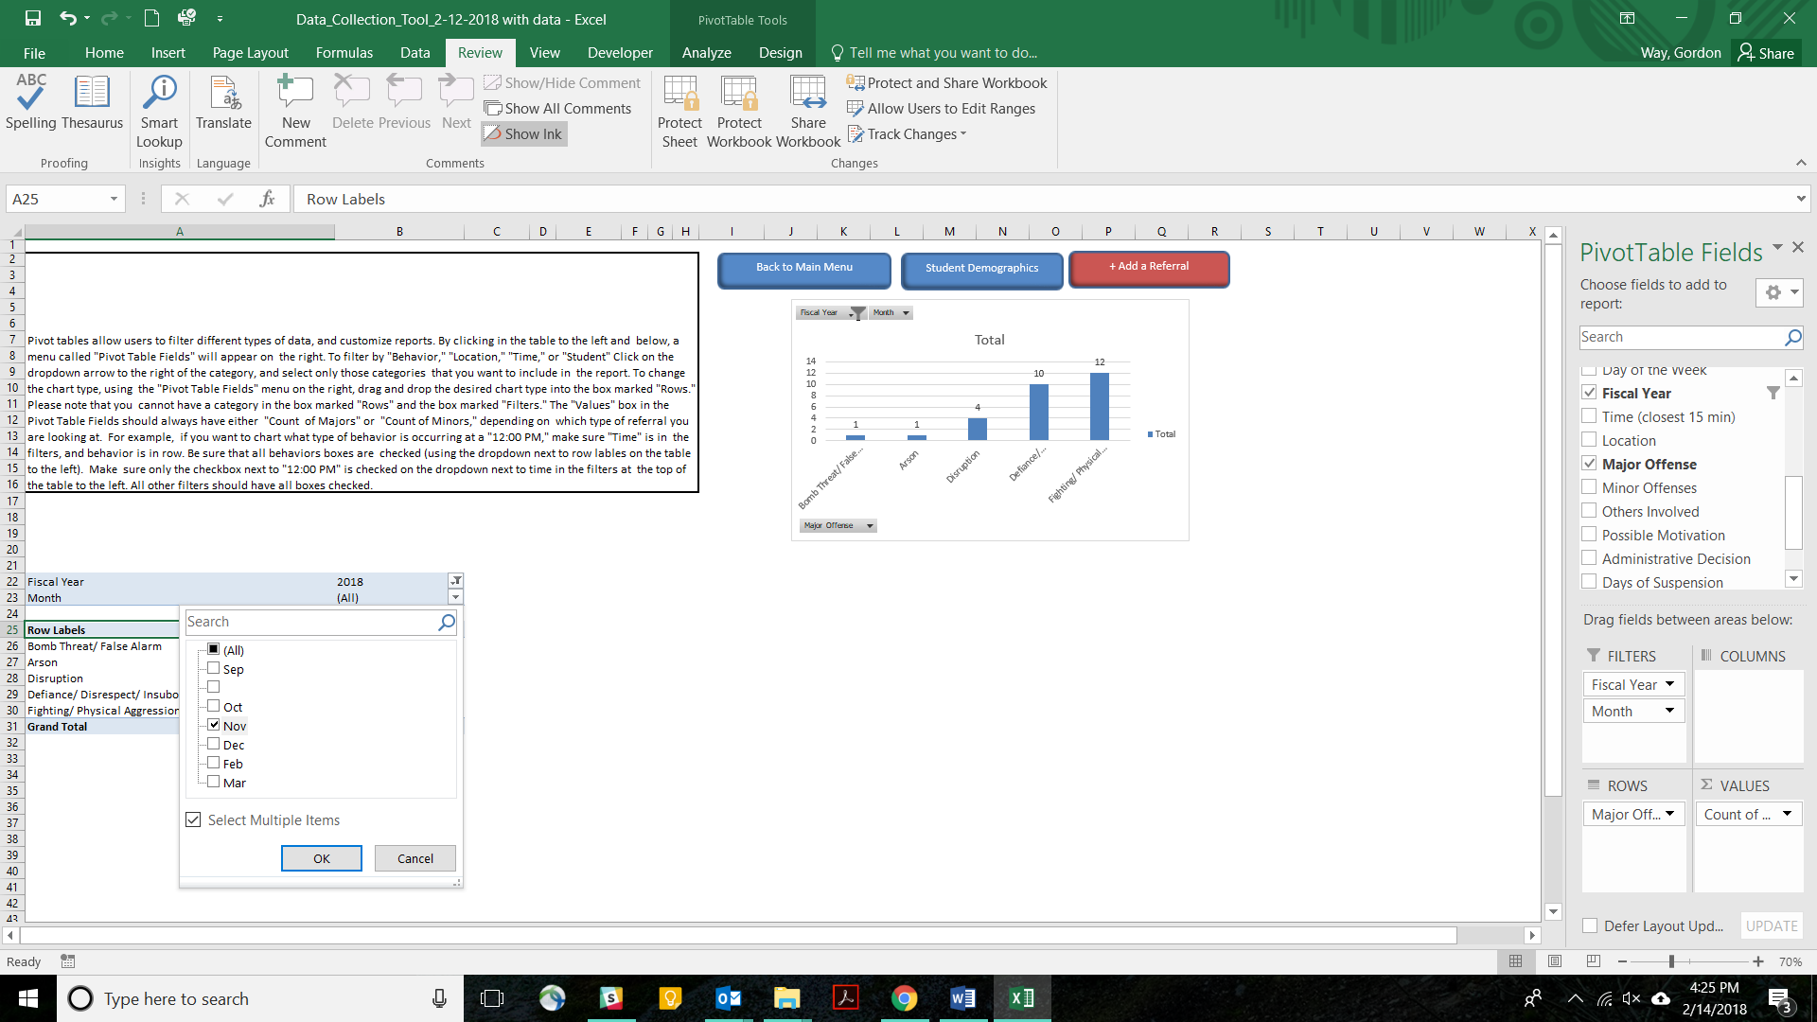
Filters
Figure 29
Next, drag the Fiscal Year field from the Fields List into the Filters box. From the filters on the pivot table, make sure that the desired fiscal year is checked.
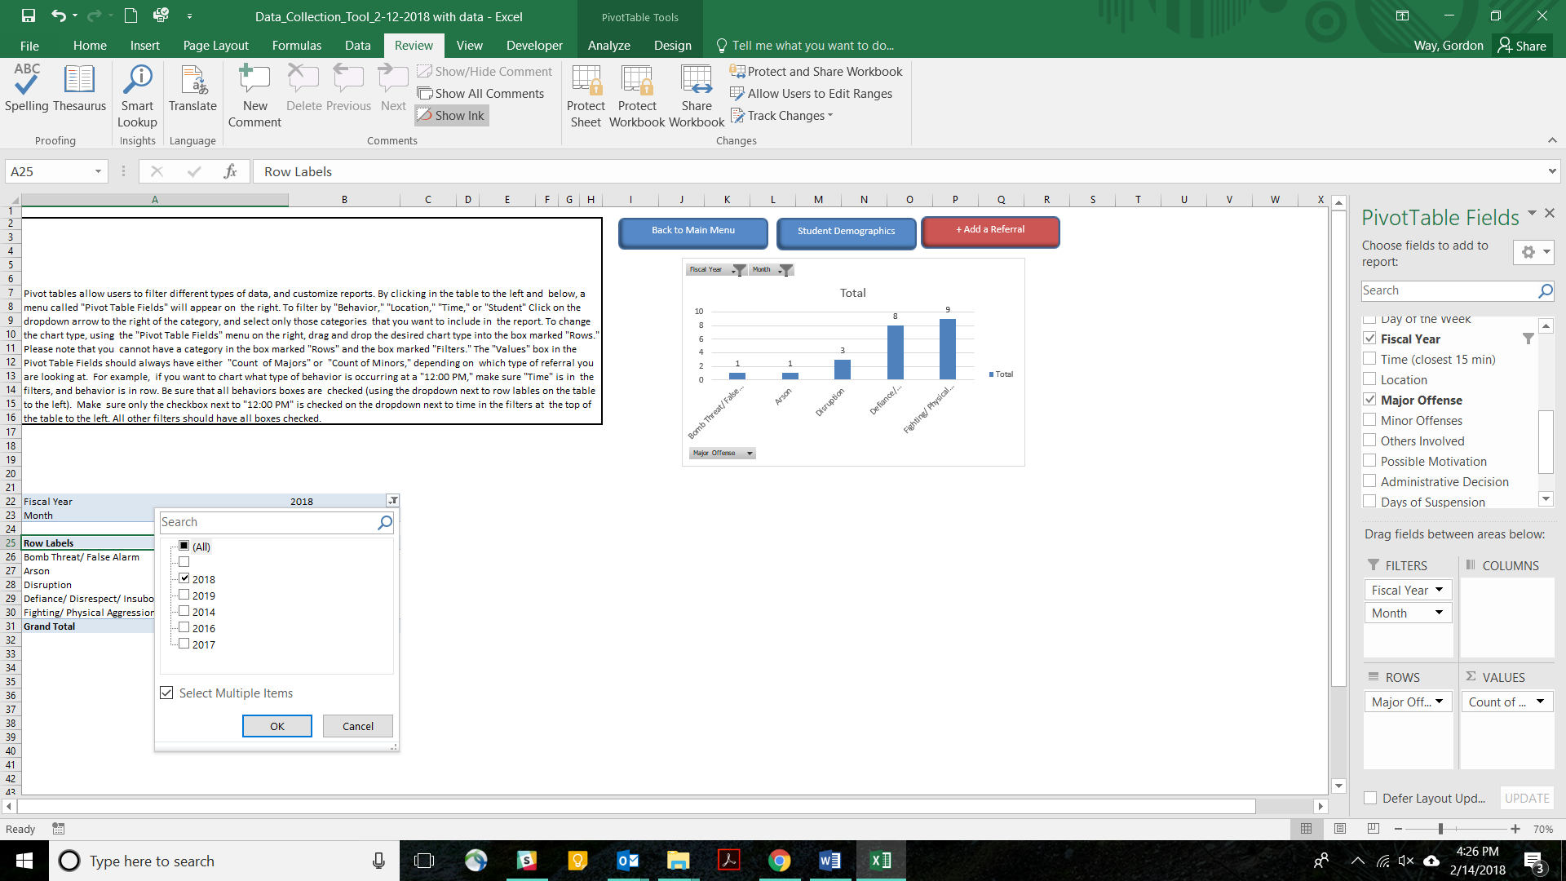
Figure 30

Next, drag the “Major Offense” field into the filter, and select only Fighting/Physical Aggression.
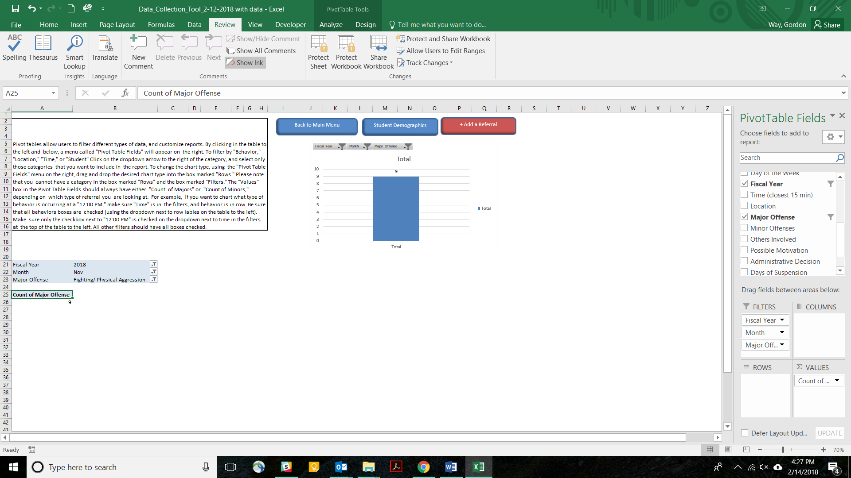
Filters
Figure 31

To determine where the Fighting/Physical Aggression is occurring, drag the “Locations” Field from the Field List into the Rows box. Notice in Figure 32 that most of the Fighting/Physical Aggression is occurring in the Halls/Breezeways.
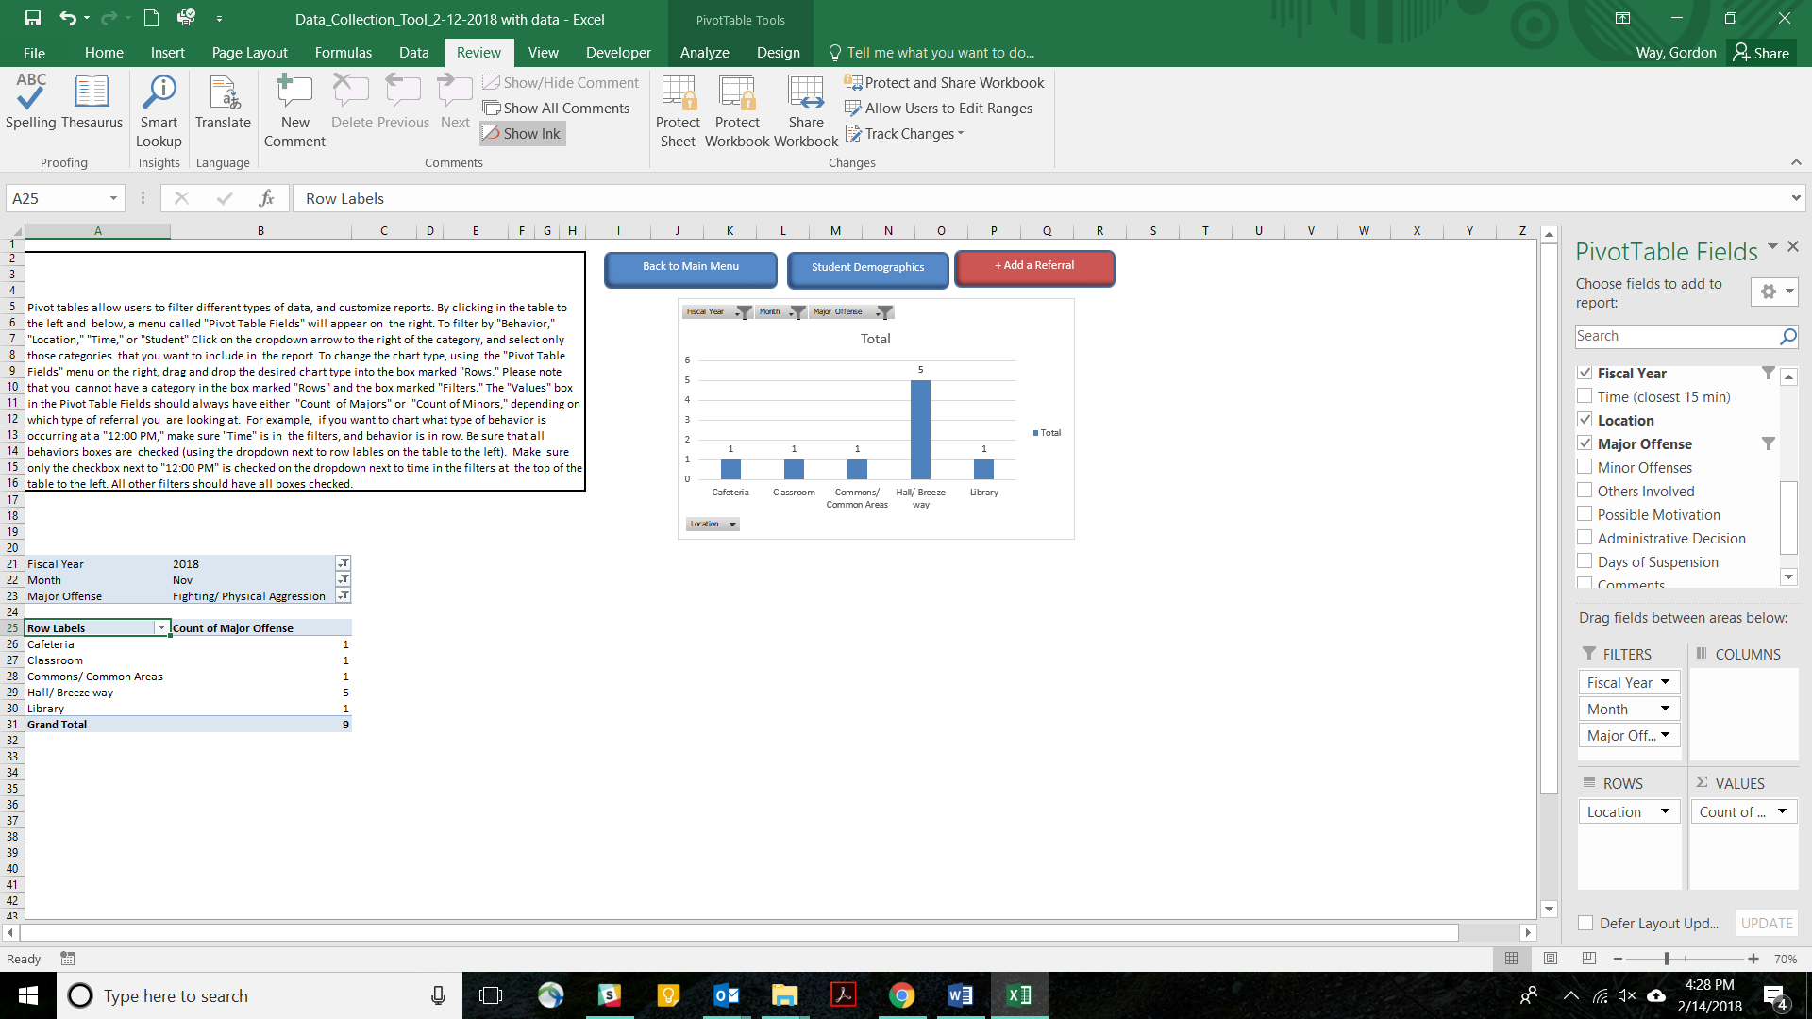
Rows
Rows
Figure 32

Next, drag the Location field from the Rows box back into the Field List, and Time from the Fields List into the rows section.
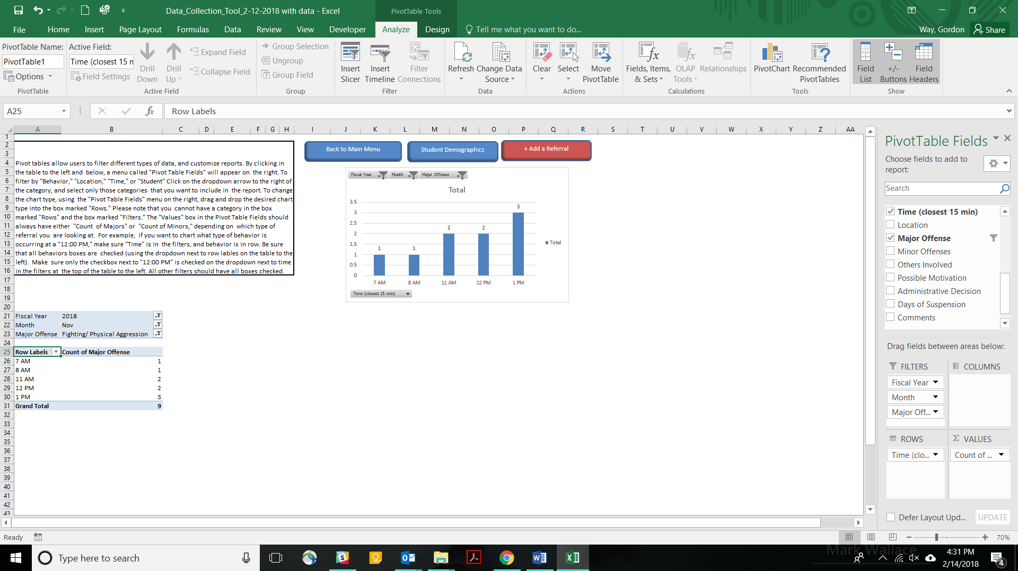
Rows
Rows
Figure 33

Notice that most of the Fighting/Physical Aggression is occurring at 1:00 PM.
Finally, you can determine who are the students involved by dragging Time back into the Field List, and Grade into the Rows box. By doing this, you see that seventh graders are engaged in the Fighting/Physical Aggression behaviors.

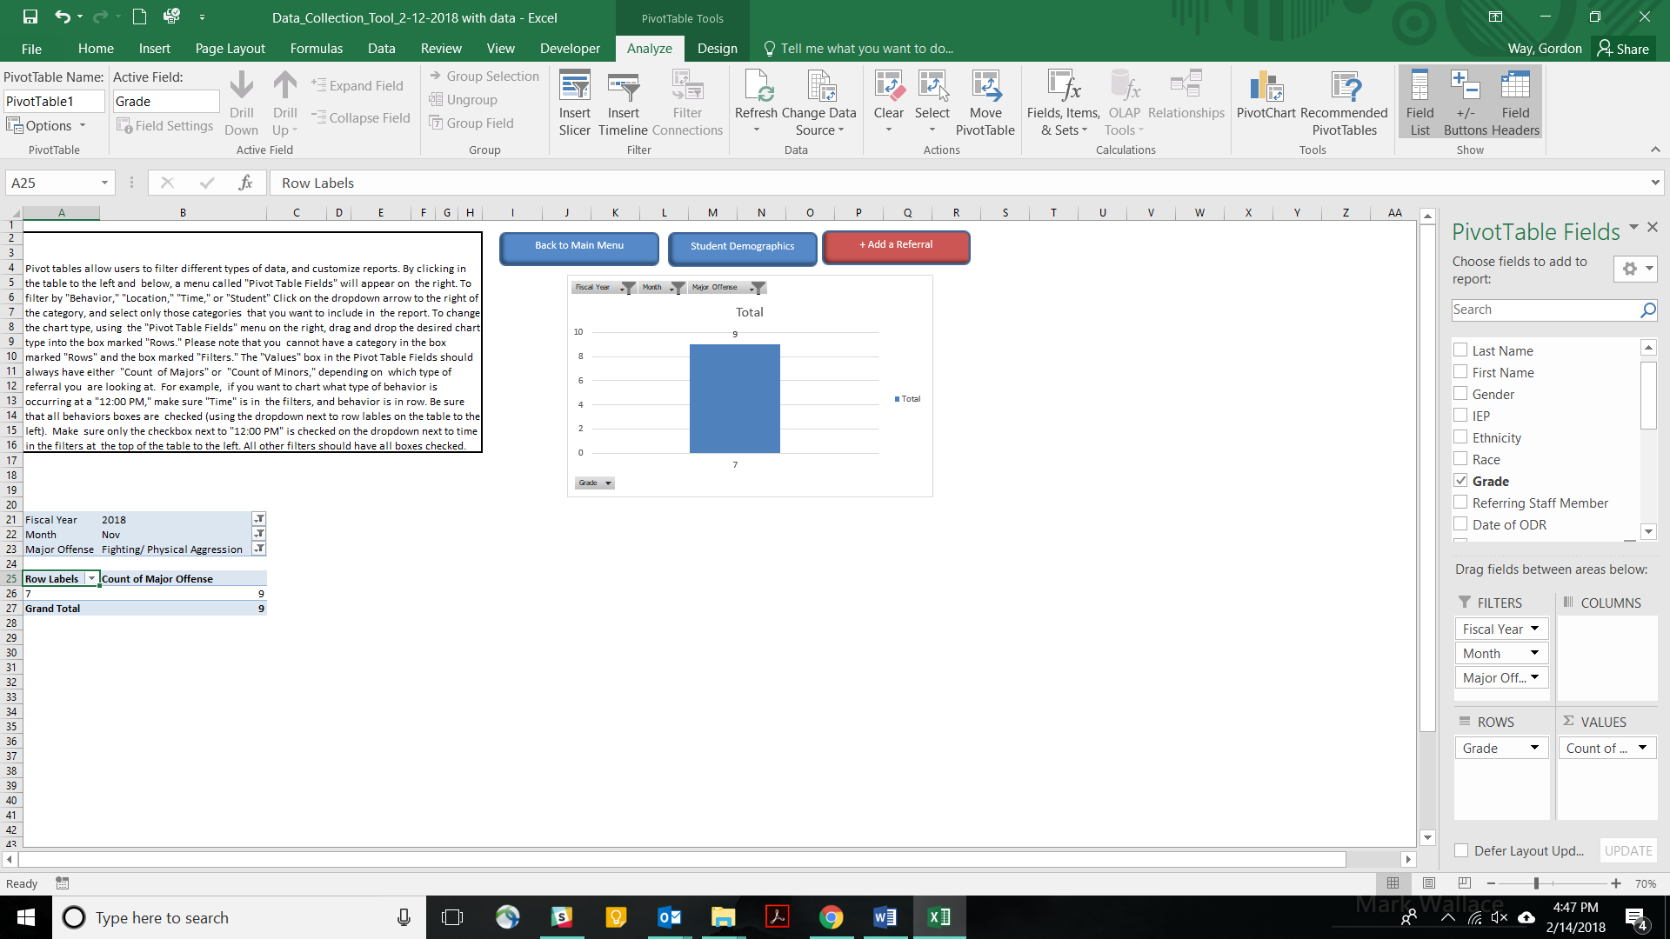
Rows
Rows
Figure 34
From your drill down, you now know that physical aggression is not a problem in the classrooms, nor is it occurring at 7:45 and 1:30. Instead, Fighting/Physical Aggression is occurring in the Halls/Breezeways at 11:00 AM, 12:00 PM, and 1:00 PM. Therefore, you select increasing active supervision in the Halls/Breezeways at 11:00 AM, 12:00 PM and 1:00 PM as one of your strategies to address Fighting/Physical Aggression. You also decide to focus your reteaching efforts on the 7th grade.

Minors Schoolwide Dashboard
The final section on the Main Menu is the Minors School Dashboard. If you choose to collect and enter data on minor classroom behaviors, the spreadsheet will produce 6 charts. These include a Minors Dashboard, which includes monthly and cumulative yearly charts for each of the Big 5 questions on one page. They also include a separate report for each of the individual Big-5 questions that include 1) Frequency, 2) behavior, 3) location, 4) time, and 5) students. Finally, there is one chart for possible motivation for minor behaviors.

Figure 35
The Minors Dashboard has each of the Big 5 charts in one report. This can provide a quick way for the team to define the context surrounding minor problem behaviors at the school. Please note that the minors dashboard includes a pivot table for monitoring which students are engaged in minor problem behaviors. This feature may not work properly on some versions of Excel for Apple.
Figure 36
In addition to the dashboard, each of the Big 5 reports are featured on separate pages. As with the major ODR reports, most of the minors reports include both a monthly and annual cumulative chart, as well as a data summary table.
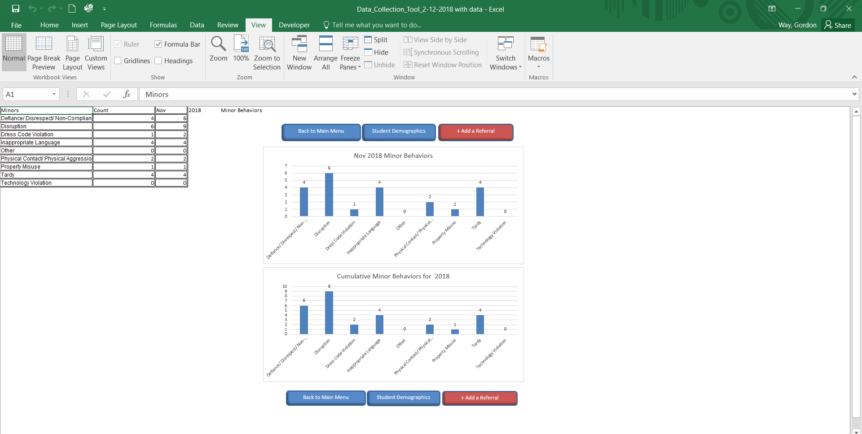

In addition, there is a report of minor ODRs per student. This report uses Excel’s pivot table feature. As with other reports that rely on pivot tables, this feature may not work properly on some versions of excel for Apple.
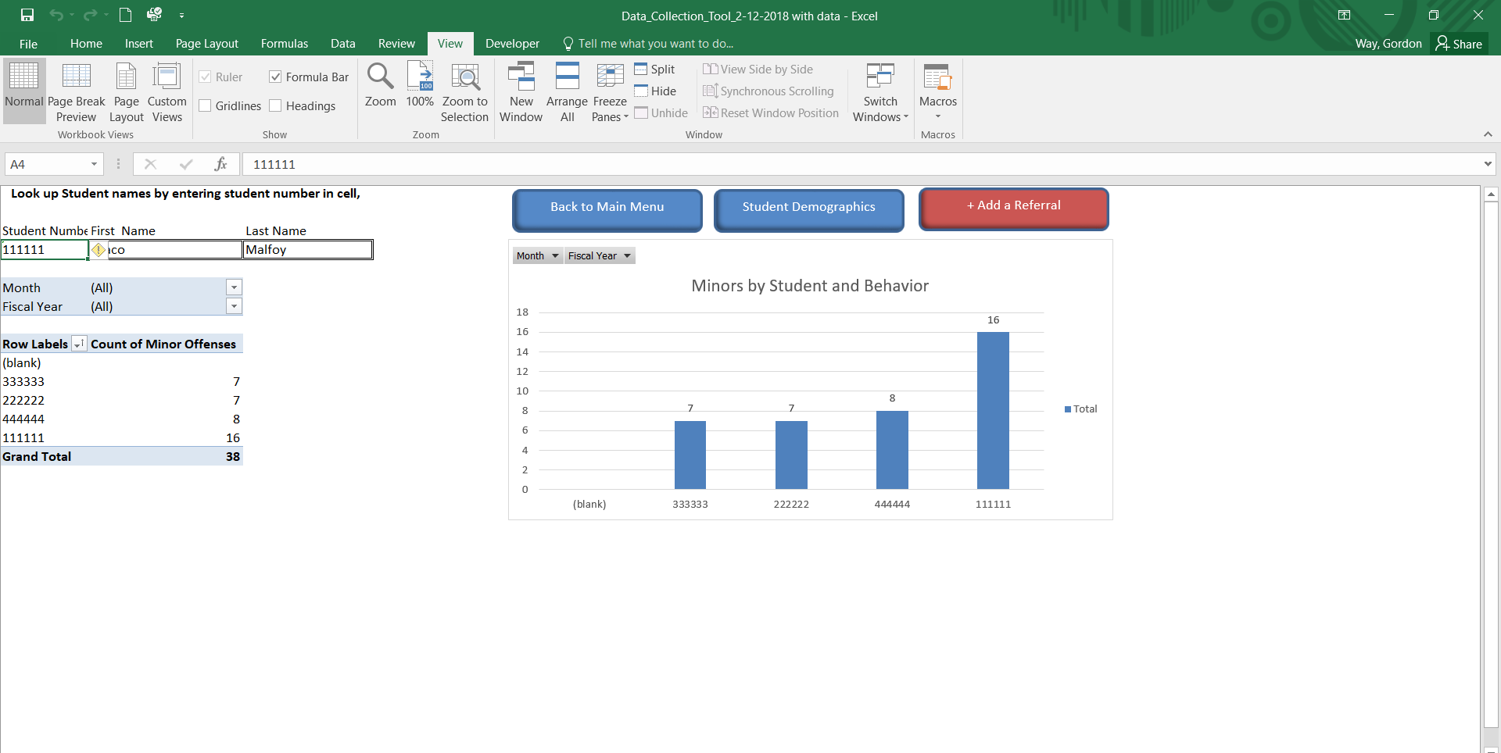

You can access a free copy of the MO SW-PBS Data Collection Tool by visiting http://pbismissouri.org/. Go to Tier 1, and click on Tier 1 data tools. Or, click on the direct link to the Data Collection Tool at http://pbismissouri.org/wp-content/uploads/2018/02/Data_Collection_Tool_2-12-2018.xlsm.
In addition to the Data Collection Tool, the Early Childhood Data Collection Tool has been specially adapted for use in Early Childhood settings. This spreadsheet can be found by visiting http://pbismissouri.org/. Go to Tier 1, and click on Tier 1 data tools. Or, click on the direct link to the EC Data Collection Tool at http://pbismissouri.org/wp-content/uploads/2017/06/EC_Data_Collection_Tool_2017-2018_11-17-2017.xlsm.

