Project ReACT
Data Analysis Worksheet & Action Planning Tool: School Teams

Instructions: This form can be used in conjunction with the disproportionality data guidebook (Using Discipline Data within SWPBIS to Identify and Address Disproportionality: A Guide for School Teams, at http://www.pbis.org/school/equity-pbis) for school teams to assess, address, and monitor discipline disproportionality (as well as other forms of disproportionality, such as in achievement).

School: ________________________________ Date: ______________________________

Steps in the equity problem-solving process:
1. Problem Identification: Is there a problem?
2. Problem Analysis: Why is it happening?
3. Plan Implementation: What should be done?
4. Plan Evaluation: Is the plan working?
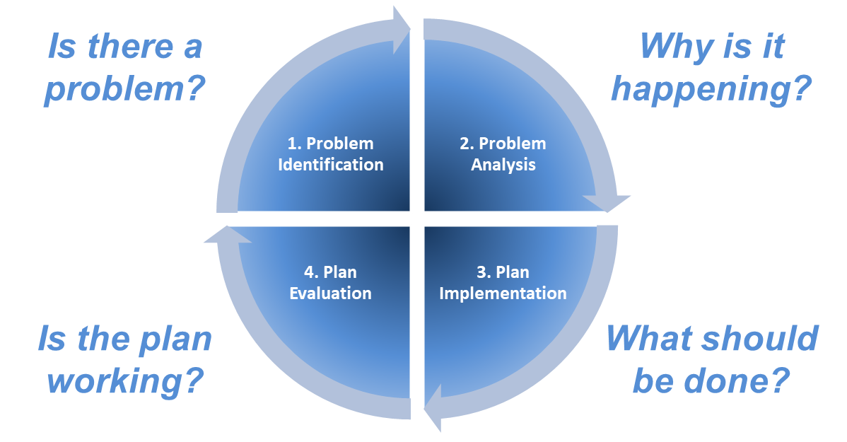

STEP 1. PROBLEM IDENTIFICATION: Is there a problem?

1. Select and Calculate Key Discipline Outcomes
Recommended discipline metrics:

- ODR risk index (i.e., % of students w/ODR; absolute)
- ODR risk ratio (relative)
- ODR rates per subgroup (absolute)

Outcome 1: Office Discipline Referral (ODR) Risk Index
Outcome 2: Office Discipline Referral (ODR) Risk Ratio
Outcome 3: Office Discipline Referral (ODR) Rates per Subgroup
Reference Group for relative metrics (usually All Other students): All Other Students
Note: if your school is over 90% the same race/ethnicity, use state averages

Calculating ODR risk indices and ratios (note: automatically calculated in SWIS Ethnicity Report):
- Log in to www.swis.org
- Click on “View Reports” and “Ethnicity Report.” The first two charts include the risk index and risk ratio (default comparison: All Others).
- Scroll down to the second (Referral Risk Ratio) chart.
- Click the “Data Table” tab to get the numbers for the ODR risk index and risk ratio columns.
- Add the numbers in the columns below.

 | ODR risk index | / | ODR risk index for comparison group (e.g., All Other) | = | ODR risk ratio
American Indian/Alaska Native |  | / |  | =
Asian |  | / |  | =
Black/African American |  | / |  | =
Latino/a |  | / |  | =
Pacific Islander |  | / |  | =
White |  | / |  | =
Multiracial |  | / |  | =

In 2018-19, which group had the highest ODR risk ratio?

Group: _________________________________________ ODR Risk Ratio: __________

Interpretation

In 2018-19, students who were _________________ were ____________ times more likely than (group) (risk ratio)
other students to receive at least one ODR.

How does this line up with what you predicted?

_______________________________________________________________________________

_______________________________________________________________________________

Calculating ODR rates per subgroup:
- Log in to www.swis.org
- Click on “Drill Down.”
- Click on “Generate” to start.
- On the right side, click on “Graph Type” and select “Ethnicity - Rates” from the menu.
- Just below the Graph Type, click the “Show Values on the Graph” checkbox.
- Add the numbers in the ODRs per Student column.
- OPTIONAL: Complete the calculations to get ODRs/100 students/school day.
 | ODRs per student | x | 100 | = | ODRs/100 students | / | School Days | = | ODRs/100 students/day
American Indian/Alaska Native |  | x | 100 | = |  | / |  | =
Asian |  | x | 100 | = |  | / |  | =
Black/African American |  | x | 100 | = |  | / |  | =
Latino/a |  | x | 100 | = |  | / |  | =
Pacific Islander |  | x | 100 | = |  | / |  | =
White |  | x | 100 | = |  | / |  | =
Multiracial |  | x | 100 | = |  | / |  | =

2. Compare to and Set Goals
Set goals for each of the metrics. Common options include:

- National median (e.g., 25th %ile of 2011-12 SWIS Black/White Risk Ratio = 1.38)
- Federal criteria (e.g., EEOC 4/5ths rule is a Risk Ratio no more than 1.25)
- National median ODR rates (2017-18 elementary ODRs/100 students/school day = .20)
Metric | 2018-19 Status | Ultimate Goal | 2019-20 Goal
ODR Risk Ratio for Group
ODR Rates for Group

STEP 2. PROBLEM ANALYSIS: Why is it happening?

1. Identify Vulnerable Decision Points for Disproportionate Discipline
Is there more or less disproportionality depending on the situation?

National ODR Data: Common VDP situations for Black-White ODRs include:
Behavior:
Location:
Time of Day:
Day of Week:
Grade Level:

Your School Data: What are common VDP situations for ODRs?

Use your school’s drill down data to find the most common situations for ODRs, first for the group of concern (left), then for all other students (right).

For Group |  | All Others
Behavior: |  | Behavior:
Location: |  | Location:
Time of Day: |  | Time of Day:
Day of Week: |  | Day of Week:
Grade Level: |  | Grade Level:

Provide the Vulnerable Decision Points:

ODRs are most commonly issued to _____________ students for ______________________
(group of concern) (behavior)
in _______________________ during _____________________ in ____________________ .
(location) (time of day) (grade level)

ODRs are most commonly issued to ALL OTHER students for ______________________
(behavior)
in _______________________ during _____________________ in ____________________ .
(location) (time of day) (grade level)

Where do you see differences?
___________________________________________________________________________

___________________________________________________________________________

2. Assess School-wide PBIS Systems
Do teachers, administrators, staff, and students have a clear understanding of behavior expectations? Are students who engage in the expected behaviors regularly positively acknowledged?

Fidelity of Implementation (if applicable)
Use a research-validated measure to assess the quality of implementation. Common measures:
Measure | Criterion for Adequate Implementation
Schoolwide Benchmarks of Quality (BoQ) | 70%
SWPBIS Tiered Fidelity Inventory (TFI) | 70%

List the most recent fidelity assessment here.

Measure: ___________________________ Date: ____________ Score: __________
From this assessment, provide the overall level of quality of implementation of the following components of effective behavior systems:
- Expectations for student behavior and routines in classrooms are:
- Clearly defined (TFI 1.3, 1.8)
- Positively stated (TFI 1.3, 1.8)
- Taught and practiced (TFI 1.4)
- Consistent with student, family, and community culture (TFI 1.11)

- Students engaging in expected behaviors are:
- Regularly acknowledged (TFI 1.9)
- Acknowledged in ways meaningful to them (TFI 1.11)

Could any gaps in fidelity of implementation of these critical features be related to patterns of disproportionality?
_______________________________________________________________________________

_______________________________________________________________________________

_______________________________________________________________________________

Add these critical features to the action plan.

3. Assess School Climate Survey Data
Is disproportionality related to perceived safety, support, or positivity?

Student School Climate Survey Results

What are two positive areas?
- _______________________________________________________________________

- _______________________________________________________________________

What is an area for growth?
- _______________________________________________________________________

Parent School Climate Survey Results

What are two positive areas?
- _______________________________________________________________________

- _______________________________________________________________________

What is an area for growth?
- _______________________________________________________________________

STEP 3. PLAN IMPLEMENTATION: What should be done?

1. Solution Development
Copy your precise problem statement for your Group of Concern here for reference:

ODRs are most commonly issued to _____________ students in ______________________
(group of concern) (grade level)
for _______________________ in _____________________ during ________________________ .
(behavior) (location) (time of day)

Identify strategies to implement based on your precise problem statement:
Solution Components | Possible action steps
Prevention
Teaching
Recognition
Extinction
Corrective Consequence
Data Collection

2. Create a Detailed Action Plan
Take the strategies that have been identified and design a plan for implementation that includes specifics on WHAT, WHO, WHEN, and WHETHER IT WAS DONE.

Activity | Who is Responsible | Target Start Date | Target Completion Date | How will we know if it’s working?

STEP 4. PLAN EVALUATION: Is the plan working?

1. Identify the Time Periods for Evaluation
We recommend that teams assess plan implementation monthly and disproportionality outcomes quarterly.

Time Periods for Implementation Evaluation: _________________

Time Periods for Outcomes Evaluation: _________________

2. Assess Implementation Progress (from Step 3: PLAN IMPLEMENTATION)
Review implementation tasks completed since the last evaluation period and quality of implementation. Troubleshoot any barriers faced.

Number of Tasks Scheduled: ______________

Number of Tasks Completed: ______________

Percent of Tasks Completed: ______________

3. Calculate Outcome Metrics and Compare to Goals (from Step 1: PROBLEM IDENTIFICATION)
Calculate and share all outcome metrics since the last evaluation period.

Metric | Goal | Previous Period | Current Period

4. Share Results with Relevant Stakeholders
Share results with important groups, such as the whole school staff, families, community groups, and
district administrators.

