Urban Schools RDQ
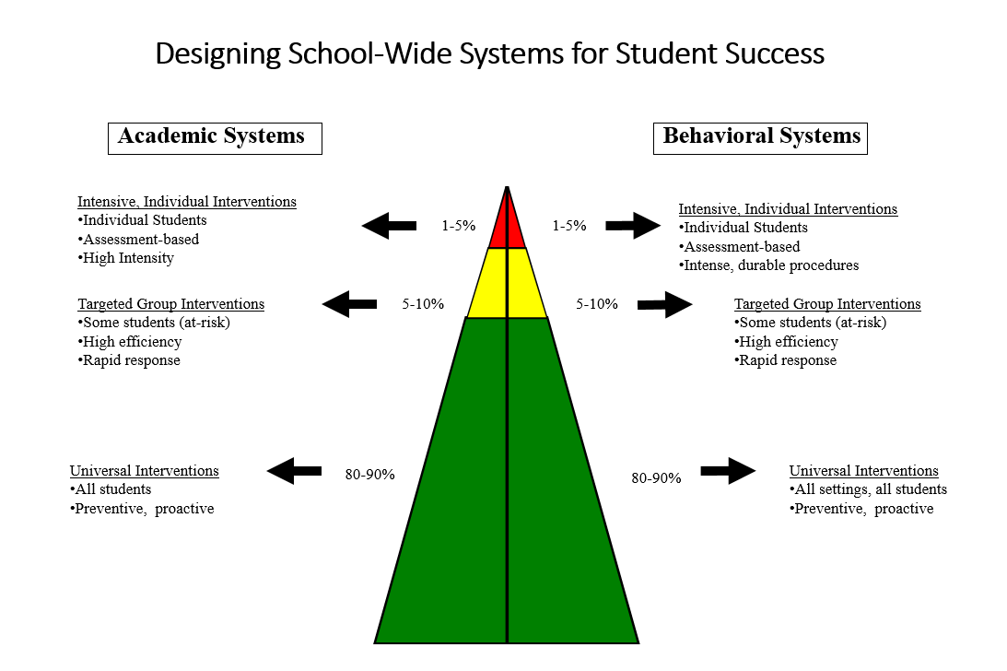
Part 1: Roundtable Q&A with the Philadelphia Public School District
The following are meant to stimulate thought; please feel free to ask your own questions:
- Share your demographics and organizational structures. What are you most proud of?
- What is your why connected to PBIS?
- What are your biggest challenges and how did you address them?
- What student outcomes have you experienced?
- What have you learned along the way you would repeat or adjust?
- How did you meet the cultural context of students and families in your district?
- How did you expand and plan for sustainability?
- How did you align or coordinate additional initiatives?
- What supports/partnerships did you find most helpful?
- What would you recommend for MO?

Notes
Part 3: Guided Networking
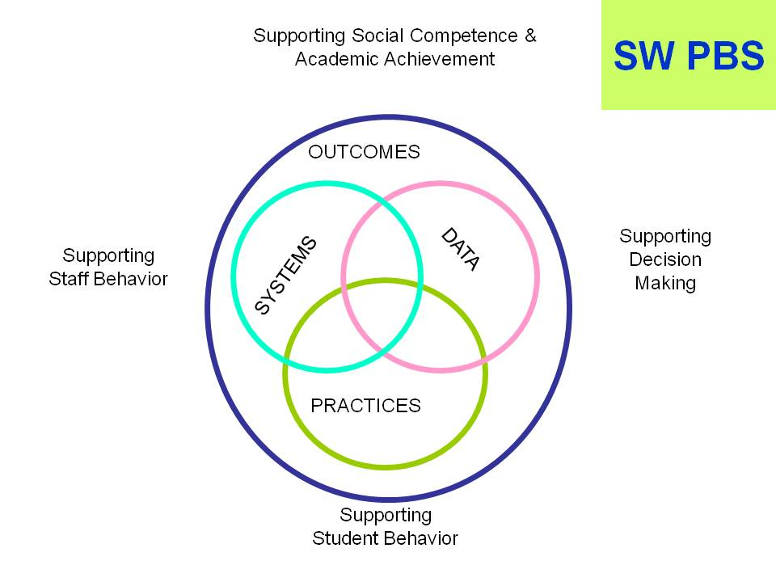
Notes:

Contacts:
Name | District | Email | Phone

To add thoughts regarding how Regional Professional Development Centers can best serve your needs, visit https://forms.gle/EcGrGWCuhBUcZVrbA

