MO SW-PBS Student Progress Monitoring Guide

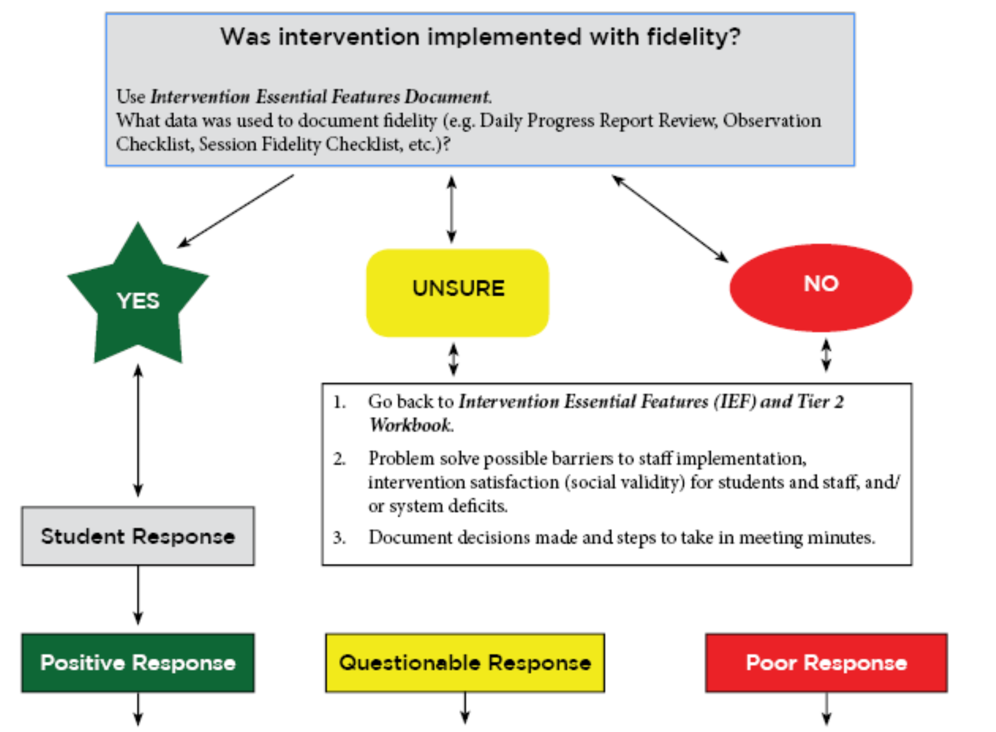
Review the Pre-meeting Organizer. Answer the questions below for each student requiring action by the team.

- What data was used to inform progress made in the intervention?  - Daily Progress Report  - Weekly Progress Report  - Check social validity (Student interview, Intervention Acceptability Rating, etc.)  - Did the team follow decision rules to identify student (s) who will continue in the intervention?  - Continue with Goal  - Increase Goal  - Fade  - Graduate | - What data was used to inform progress made in the intervention?  - Daily Progress Report  - Weekly Progress Report  - Check social validity (Student interview, Intervention Acceptability Rating, etc.)  - Did the team follow decision rules to identify student (s) requiring modifications?  - Reconsider Function  - Reconsider Goal  - Provide More Frequent Feedback  - Individualize Feedback Procedure  - Individualize the Reinforcer | - Check social validity (Student interview, Intervention Acceptability Rating, etc.)  - Was the primary problem behavior identified correctly and addressed on the student’s Daily Progress Report?  - Is the intervention aligned with the function of the student’s behavior?  - Are there other functions to consider?  - When the team is confident with the behavior identification, the alignment of intervention and function, and that no additional functions should be considered, the team should discuss:  - Changing the Tier 2 Intervention  - Considering the student for Tier 3 Intervention

