School Safety Survey (SSS)

Sprague, Colvin & Irvin, 2002

PURPOSE: The School Safety Survey is an annual survey that provides an assessment of Risk and Protection Factors for students at school and in the surrounding community. The survey provides information that can help teams to determine training and support needs related to school safety and violence prevention (Sprague, Colvin, Irvin & Strieber, 1998).

WHEN: Annually in the fall.

WHO: MO SW-PBS strongly encourages all staff, students, and family members to complete the survey, if possible. A minimum of five specific staff members are required to take the SSS.

The new PBIS Assessments links for taking multi-user surveys will make it easier for teams to engage all stakeholders, including parents and students. Students as young as 5th grade should be able to complete the survey. Teachers can take advantage of classroom computers and the computer lab to make it easier for students to participate in the SSS. Actively engaging students in informing the SW-PBS initiative increase feelings of ownership in SW-PBS among students

TO TAKE THE SURVEY: The survey can be taken using a paper copy, or on PBIS Assessments using a multi-user survey link. For more information about taking the survey on PBIS Assessments, visit https:// www.pbisapps.org/Pages/Default.aspx.

REPORTS: Currently, reports can be pulled by either a regional consultant, or an individual with Team Member level access on PBIS Assessments. For more information regarding pulling reports, visit https:// www.pbisapps.org/Pages/Default.aspx.

The following charts are available through the school’s PBIS Assessments account:

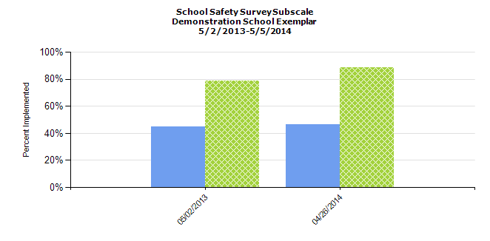
SUBSCALE

Figure 7.27
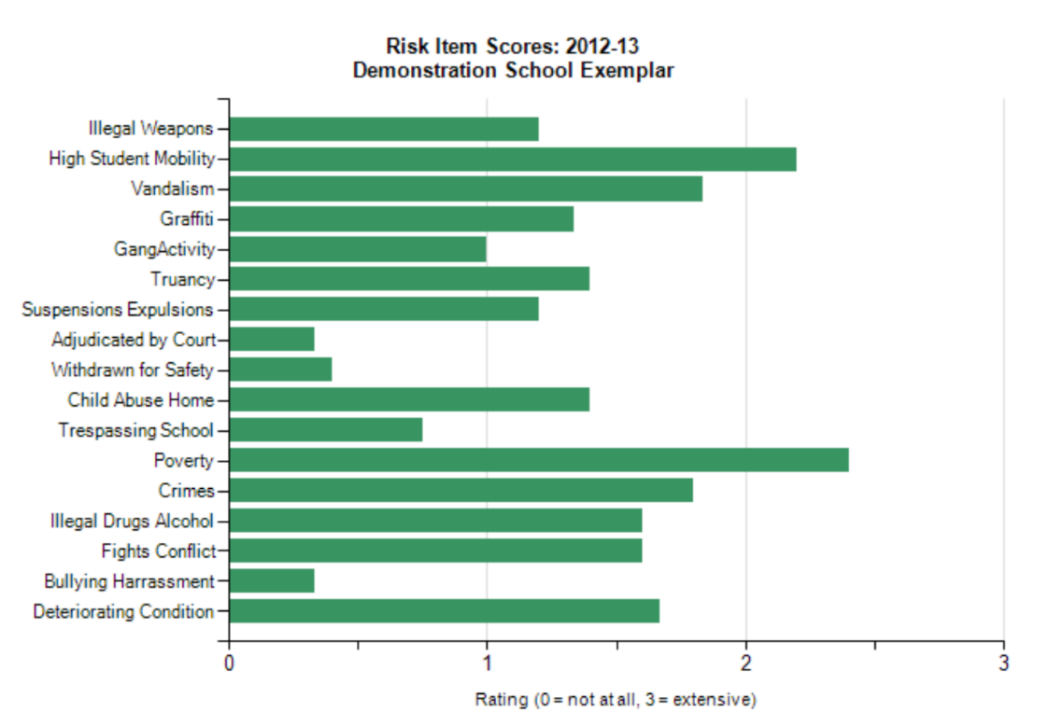
ITEMS

Figure 7.28
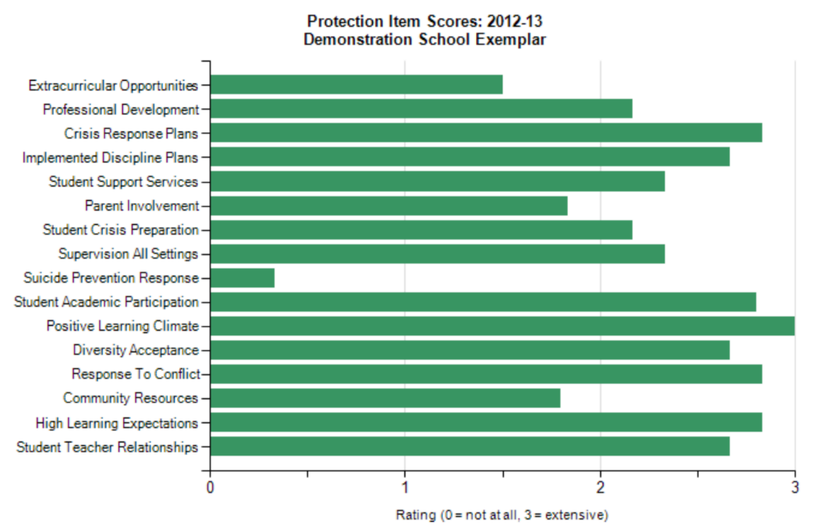
Figure 7.29

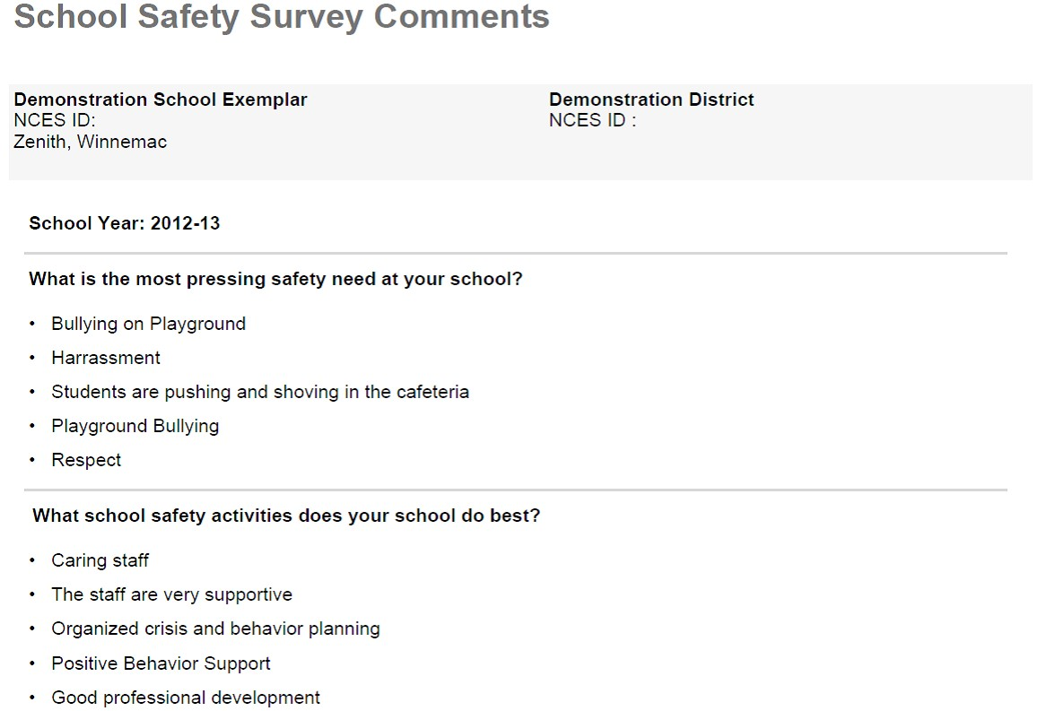
COMMENTS

Figure 7.30

