Self-Assessment Survey (SAS)

Sugai, Horner, & Todd, 2003

PURPOSE: A research validated survey that measures staff perceptions of the status and priority for improvement of SW-PBS systems at the following levels of analysis: 1) schoolwide discipline, 2) non- classroom management (e.g., cafeteria, hallway, playground), 3) classroom management, and 4) individual students engaging in chronic problem behaviors (Safran, 2006). Used for awareness building with staff, action planning and decision-making, assessment of change over time, and team validation. Used initially with all staff; can be used subsequently with all staff, a representative group, or a focus group for ongoing planning. Also sometimes referred to as the Effective Behavior Support Self-Assessment Survey (EBS/SAS).

Recent research by Kent McIntosh (Mathews, McIntosh, Frank, & May, 2014) found the SAS to be predictive of measures of sustainability after 3 years. In particular, they found that items measuring classroom systems related to acknowledging expected behaviors, matching instruction and materials to student ability, and access to assistance were predictive of fidelity of implementation over time.

WHEN: Annually in the spring; new teams may also wish to complete during their first fall as a pre- assessment.

WHO: MO SW-PBS strongly encourages that all certified and non-certified staff members complete the survey. Other stakeholders, including parents, may also take the survey.

TO TAKE THE SURVEY: The Self-Assessment Survey can be taken using a paper copy (see end of chapter), or by sending a link from PBIS Assessments to all who will take the SAS. For more information about taking multi-user surveys on PBIS Assessments, visit https://www.pbisapps.org/Pages/Default.aspx.

REPORTS: SAS reports can be run by an individual with “Team Member” level of access from PBIS Assessments. For more information regarding running SAS reports, visit https://www.pbisapps.org/Pages/ Default.aspx.

IMPLEMENTATION CRITERIA: 80% (Mercer, McIntosh & Hoselton, 2017) The following SAS charts are available from PBIS Assessments:

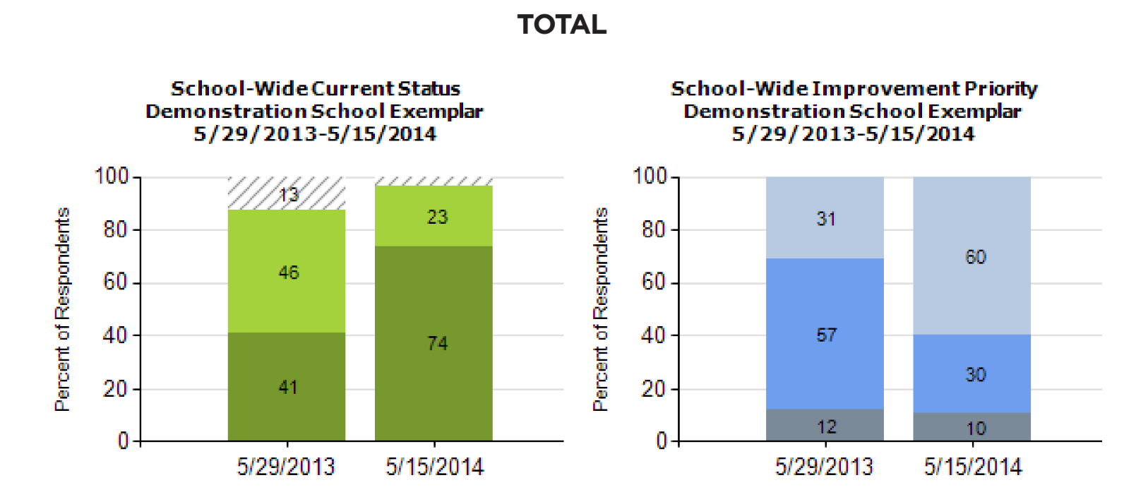

Figure 7.23

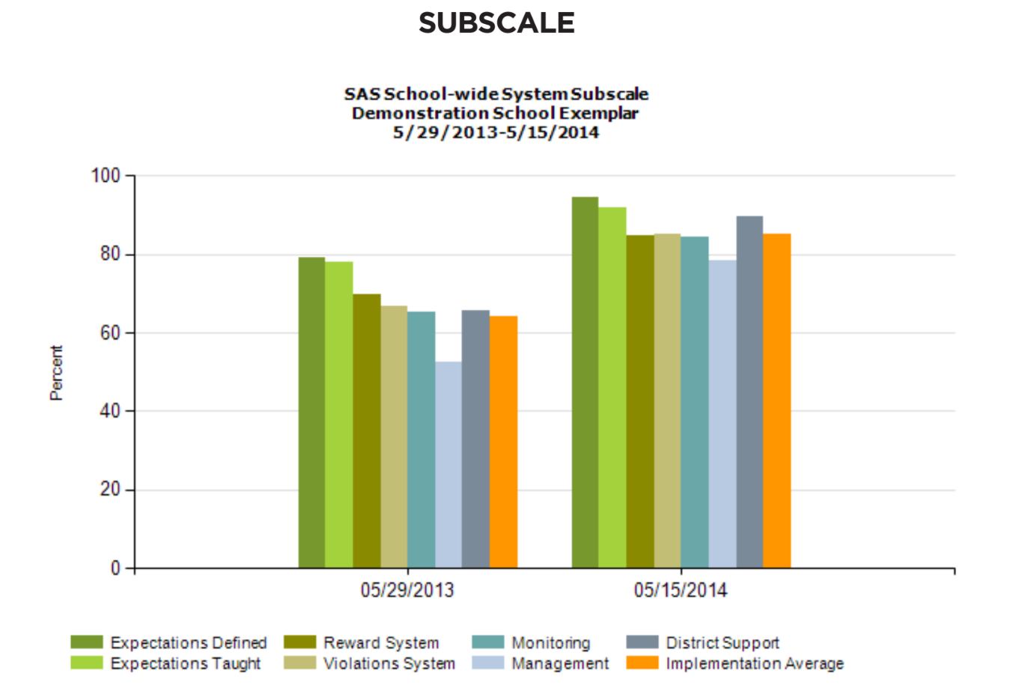

Figure 7.24

ITEM

Demonstration School Exemplar  NCES ID:  Zenith, Winnemac |  |  |  | Demonstration District  NCES ID
School Year |  |  | Number of Responses | Date Completed
2012-13 |  |  | 48 | 05/29/2013
Current Status |  |  | Feature | Improvement Priority
In Place | Partial | Not | System: schoolwide | High | Medium | Low
63 % | 33 % | 4 % | - A small number (e.g. 3-5) of positively and clearly stated student expectations or rules are defined. | 2 % | 60 % | 38 %
60 % | 35 % | 4 % | - Expected student behaviors are taught directly. | 7 % | 52 % | 40 %
44 % | 52 % | 4 % | - Expected student behaviors are rewarded regularly. | 9 % | 52 % | 39 %
32 % | 62 % | 6 % | - Problem behaviors (failure to meet expected student behaviors) are defined clearly. | 19 % | 62 % | 19 %
27 % | 65 % | 8 % | - Consequences for problem behaviors are defined clearly. | 29 % | 48 % | 24 %

Figure 7.25

