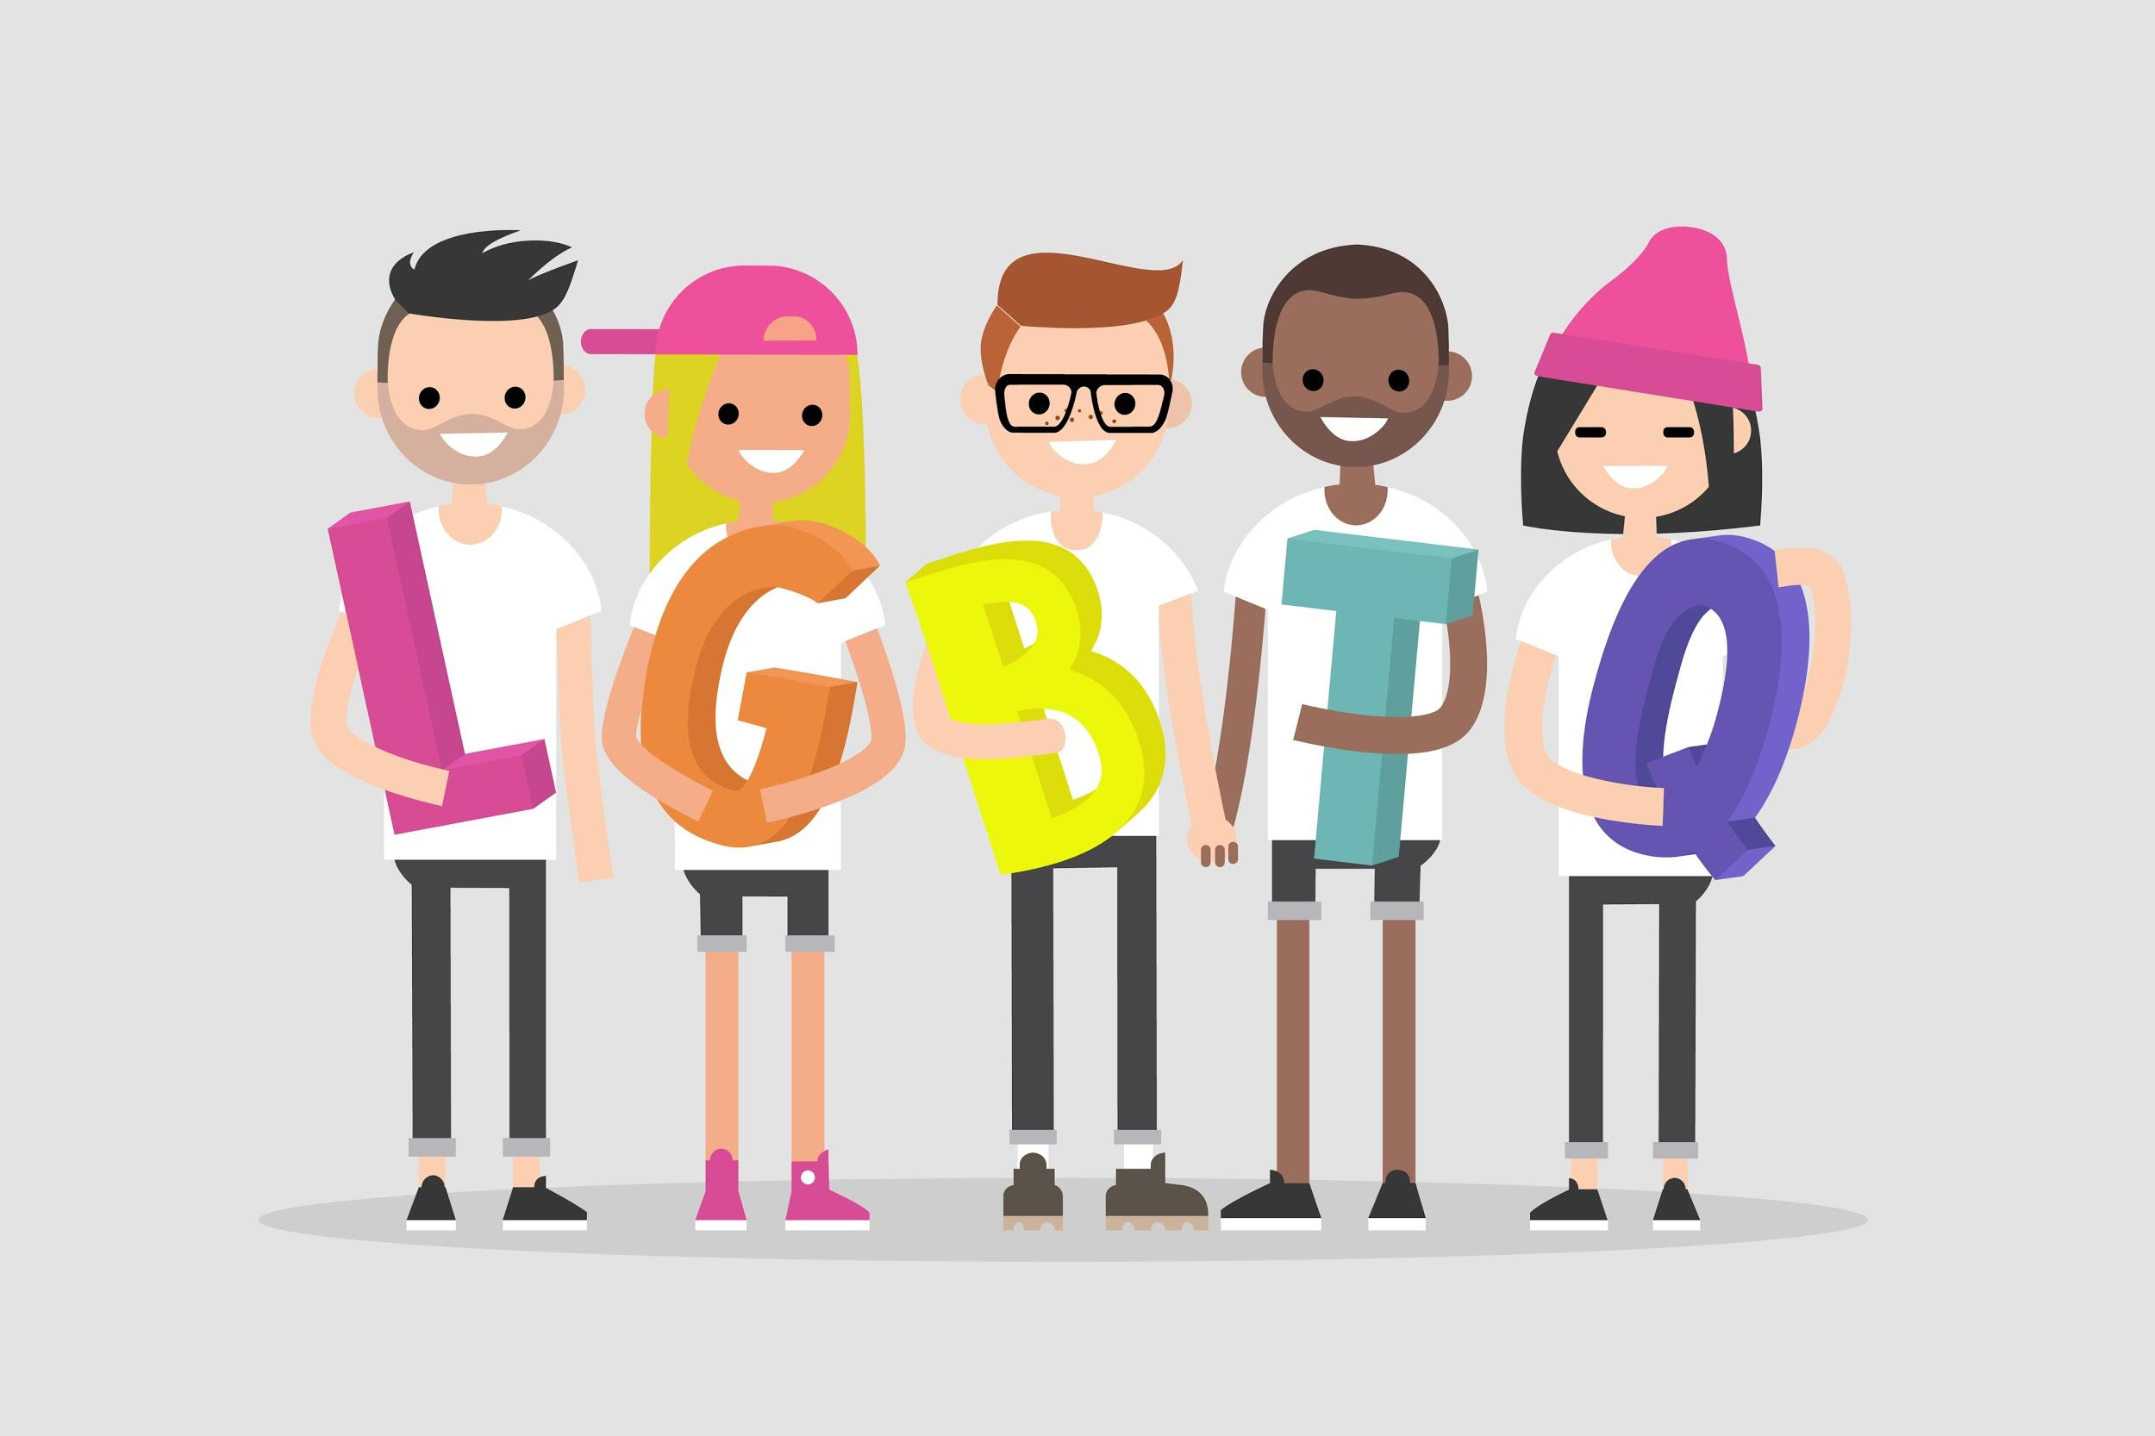
LGBTQ Theme and Character Book List

Elementary

- The Family Book (Parr, 2003) and All Families are Different (Gordon, 2000) address how families are alike and different, with sexual minority headed families among the many different types of families discussed.
- Antonio’s Card (La Tarjeta de Antonio) (Gonzalez, 2005) is written in both English and Spanish and presents the ways in which a young boy who lives with his mother and her partner manages teasing at school.
- Molly’s Family (Garden, 2004) is about a Kindergarten girl with two moms who is trying to understand her family structure as compared to that of the other students.
- My Two Uncles (Vigna, 1995) addresses a girl’s confusion when her favorite uncle and his partner are excluded from a family celebration.
- King & King (de Haan & Nijland, 2004) and King & King & Family (de Haan & Nijland, 2004) are about a prince who falls in love with and marries a prince (King & King) and then they decide to adopt a baby together (King & King & Family).
- And Tango Makes Three (Richardson & Parnell, 2005) tells the true story of two male penguins who build a nest together and care for an egg (and subsequent baby penguin) from another penguin couple who laid an extra egg.
- Best Best Colors (Los Mejores Colores) (Hoffman, 1999) is about colors and diversity and features a boy with two mothers.

Middle/High School

- Commonly used texts that would be appropriate to explore in terms of characters’ LGBQ sexuality or sexual encounters:
  - Celie’s lesbian relationship in The Color Purple (Walker, 1982)
  - Brick’s possible homosexuality and Big Daddy’s homophobia in Cat on a Hot Tin Roof (Williams, 1954)
  - Holden going to Mr. Antonelli’s house in Catcher in the Rye (Salinger, 1945)
  - The possibility of Tom being gay in Glass Menagerie (Williams, 1945)
  - Homoerotic subtext in Shakespeare’s Julius Caesar

- Books with gay and lesbian characters, as well as those questioning their sexuality:
  - If It Doesn’t Kill You (Bechard, 1999) is about a ninth grade boy struggling to come to terms with his father’s disclosure that he is gay.
  - The Year They Burned the Books (Garden, 1999) is centered on a high school senior trying to understand the controversy over the school’s new sex education curriculum that includes information on sexual minority individuals while she is trying to understand her own sexuality.
  - Holly’s Secret (Garden, 2000) is about a girl adopted by lesbian mothers who creates a new identity for herself and her family upon moving to a new town.
  - Name Me Nobody (Yamanaka, 2000) deals with many life issues, including parental abandonment, weight and dieting, and sexuality.
  - The Blue Lawn (Taylor, 1994) is set in New Zealand and tells the story of two teen boys discovering that they are gay.

- Books that have characters exploring the range of sexuality, including bisexuality and questioning:
  - Split Screen: Attack of the Soul-Sucking Brain Zombies/Bride of the Soul-Sucking Brain Zombies (Hartinger, 2007) is the same story told from the perspective of his best friend Min, who is attracted to both boys and girls.
  - Empress of the World (S. Ryan, 2001) is about a girl attending a girls’ school trying to understand her feelings for her best friend.
  - Ash (Lo, 2009) showcases a main character who experiences attractions to both a male and a female character.

