This pyramid shows the various behavioral intervention programs available at L.H.S. Levels should be kept in sequence. For more information contact the P.B.I.S. team.

Positive Behavioral Interventions and Supports Pyramid of Interventions
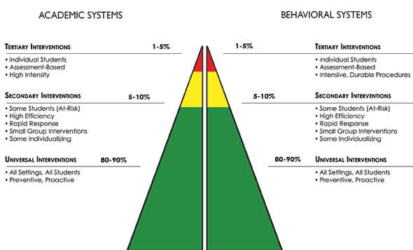
Lebanon High School
Special Education
504
Alternative School
Missouri Options
Alternative Suspension Center
In School Suspension
Block of In School Suspension / Detention
Self-Management Center (Short Term)
SAT (Student Assistance Team) Referral
SOS (Save One Student)
- Counselor Watch P.A.L.S.
Tardy Sweep PBIS Team Services

- Night School Required Summer School
Attendance Recovery (Seniors Only Credit Recovery
SAT (Student Assistance Team) Referral SOS (Save One Student)
Counselor Watch P.A.L.S.
Academic Lab RIB (Resource in Basics)
Tutoring Before/After School (At Risk) HOT Sheets
Required Tutoring (Administrator Referral) Academic Resource Center

Preferred Seating
Altered Assignments
Student Conferences
Teacher Proxemics
A+ Peer Tutoring
Bridges Mentors (Freshmen Only)
- General Dept Monitor
- Yellowjacket Code
- PBIS Matrix

Preferred Seating
Altered Assignments
Student Conferences
Teacher Proxemics
A+ Peer Tutoring
Bridges Mentors (Freshmen Only)
- General Dept Monitor
- Yellowjacket Code
- PBIS Matrix

Out of School Suspension
Social Worker Referral
Juvenile Justice Referral
Mental Health Counseling
PBIS Team Services

