MO SW-PBS Tier 2 Student Identification Process Guide

Did the student receive instruction on Schoolwide and Classroom Expectations, Rules, and Procedures? Did the student receive recognition recently for following Schoolwide and Classroom Expectations, Rules, and Procedures?

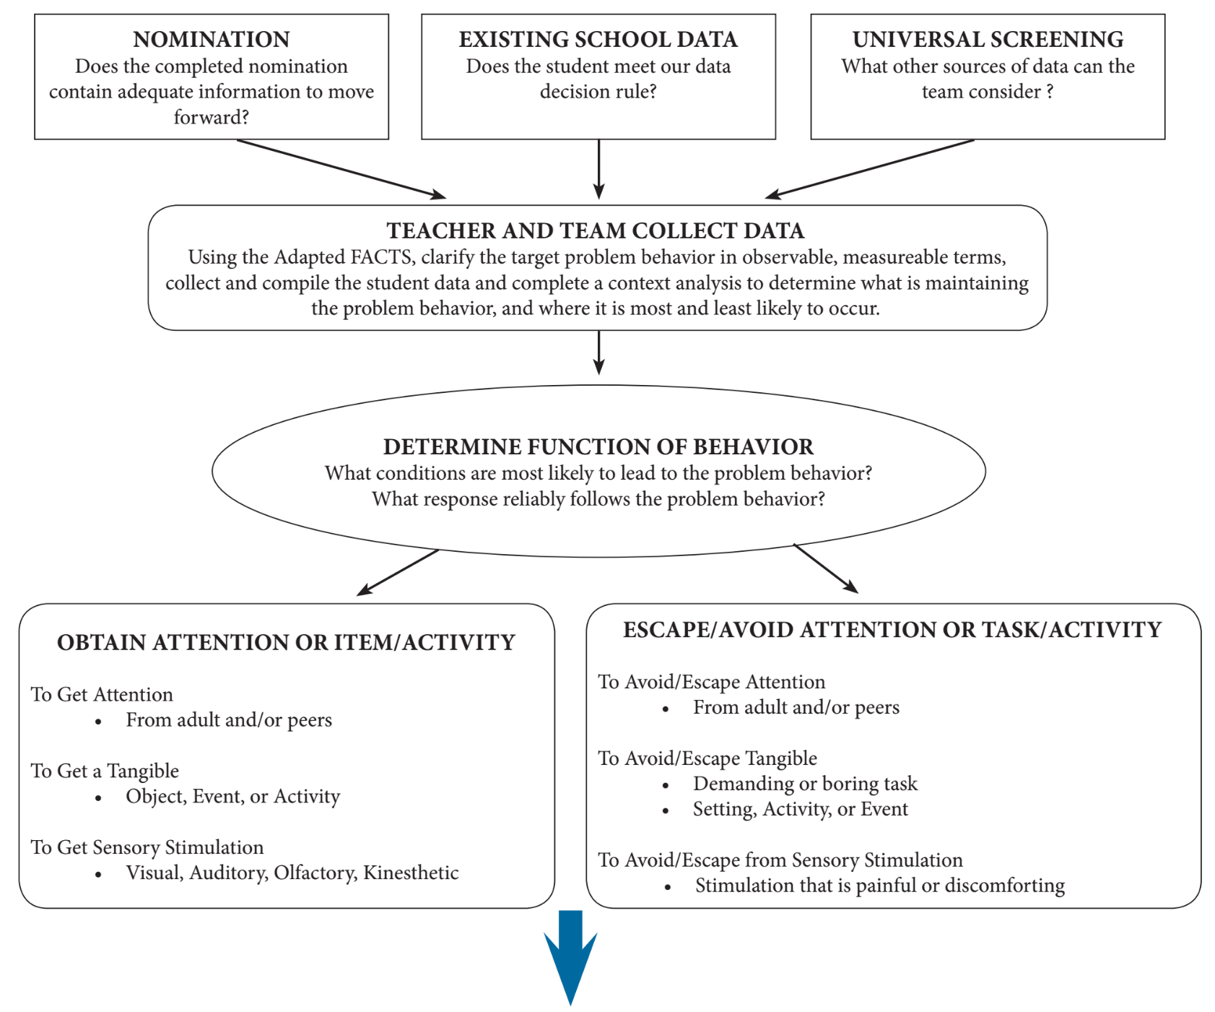
 | Check-In, Check-Out | Social Skill Groups Intervention Groups | Self- Monitoring | Check & Connect | FIRST STEP Next | Academic Intervention
Get Adult Attention | X | X | X |  | X | X
Get Peer Attention |  | X | X |  | X | X
Avoid Adult Attention |  | X | X | X
Avoid Peer Attention |  | X | X | X
Avoid Tasks |  | X | X | X
Access to Activities or Tangibles |  | X | X
Adapted from Umbreit, Ferro, Liaupsin, and Lane, 2007

Add student to Advanced Tiers Spreadsheet

