SCHOOL CLIMATE SURVEYS

La Salle, McIntosh, & Eliason (2016)

PURPOSE: The School Climate Surveys are valid and reliable measures of school climate. There are two versions of the survey: an elementary version, and a middle/high school version. The elementary version measures student perceptions of school climate along four dimensions: school connectedness, school safety, school orderliness, and peer and adult relations. The middle/high school version measures student perceptions of school climate along three dimensions: teaching and learning, relationships, and safety.

WHEN: Annually in the fall. As of the 2018-2019 school year, MO SW-PBS teams may take the School Climate Survey, the School Safety Survey (SSS), or both.

WHO: MO SW-PBS strongly encourages teams to have students in grades 3-12 take the survey

TO TAKE THE SURVEY: Students take the surveys using a multi-response link from PBIS Assessments, during the school day, and using campus computers. Students in grades 3-5 take the elementary version, and students in grades 6-12 take the middle/high school version. The National Technical Assistance Center recommends that elementary schools serving up to the 6th grade can allow 3-6th graders to take the survey. However, if an elementary school serves students in the 6th grade or beyond, National Center recommends that the students take the version of the survey validated for their grade level.

REPORTS: Reports can be pulled by an individual who has Team Member Level access in PBIS Assessments, or by your MO SW-PBS Regional Consultant. For more information, visit https://www. pbisapps.org/Pages/Default.aspx.

Elementary Reports are as follows:

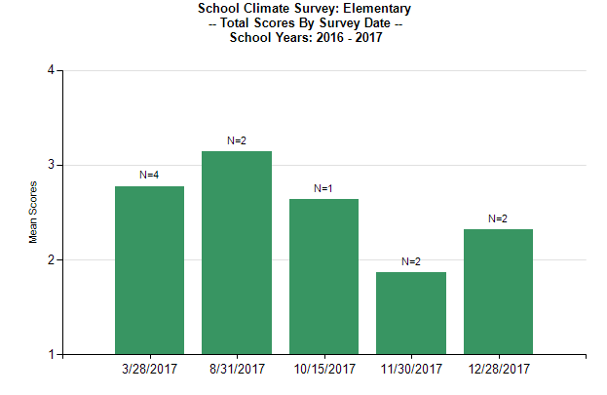
TOTAL SCORE REPORT
Figure 7.31

SCORES BY GENDER
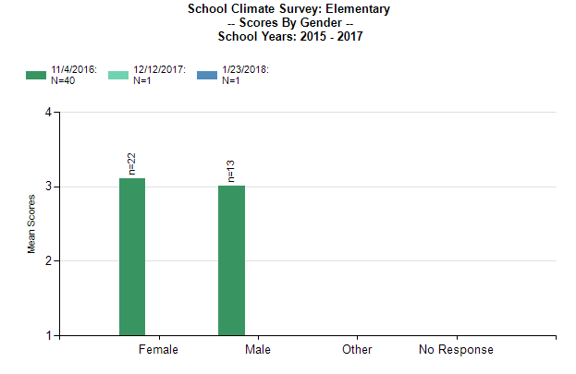

Figure 7.32

SCORES BY GRADE
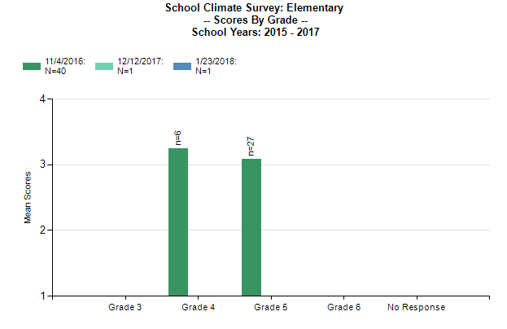

Figure 7.33

SCORES BY ITEM
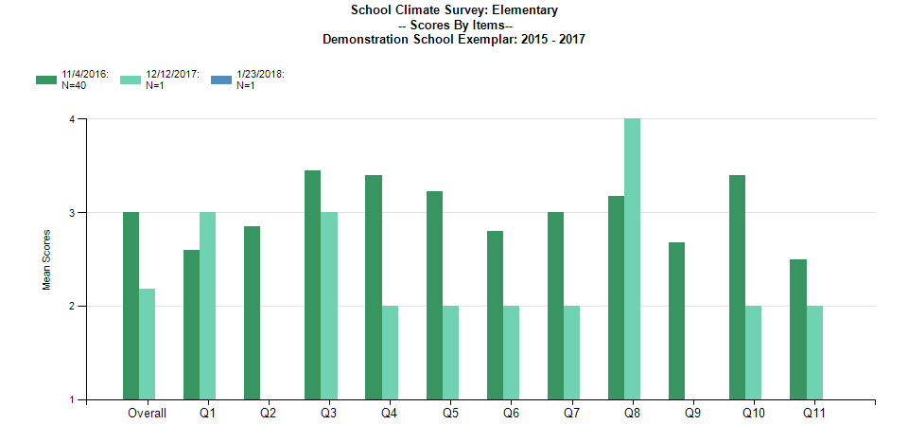

Figure 7.34

SCORES BY RACE AND ETHNICITY
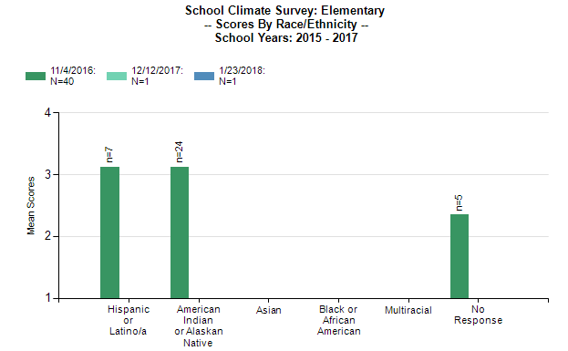

Figure 7.35

ITEMS REPORT
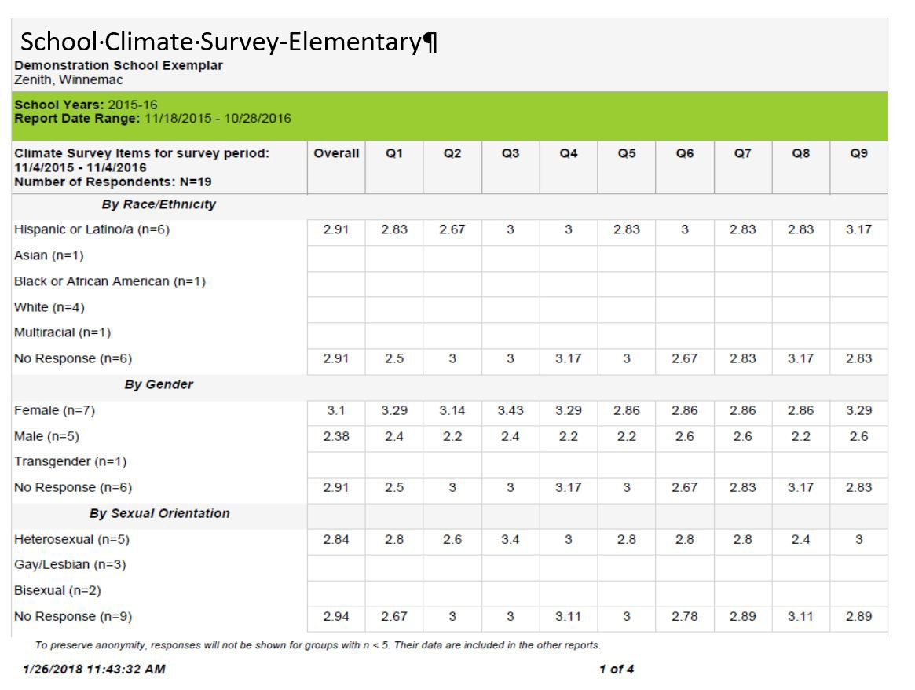

Figure 7.36

Middle/ High School Reports are as follows:

TOTAL SCORE REPORT
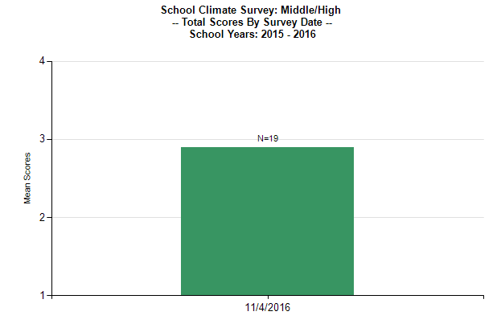

Figure 7.37

SCORES BY GENDER
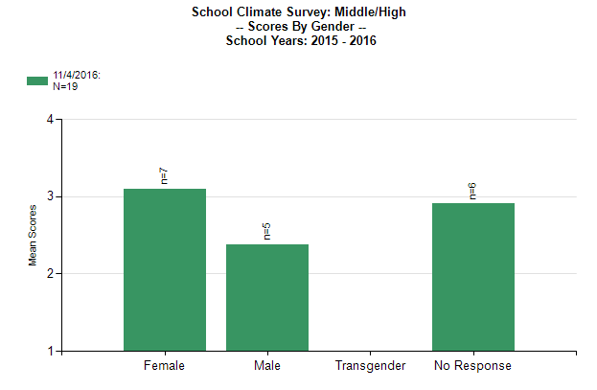

Figure 7.38

SCORES BY SEXUAL ORIENTATION
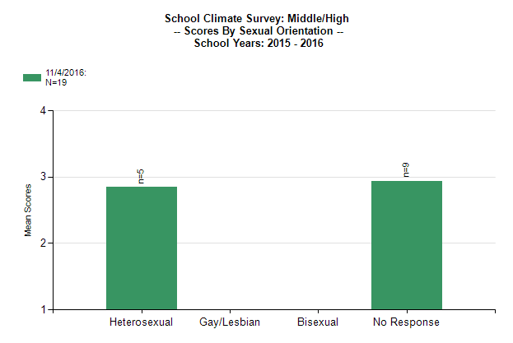

Figure 7.39

SCORES BY GRADE
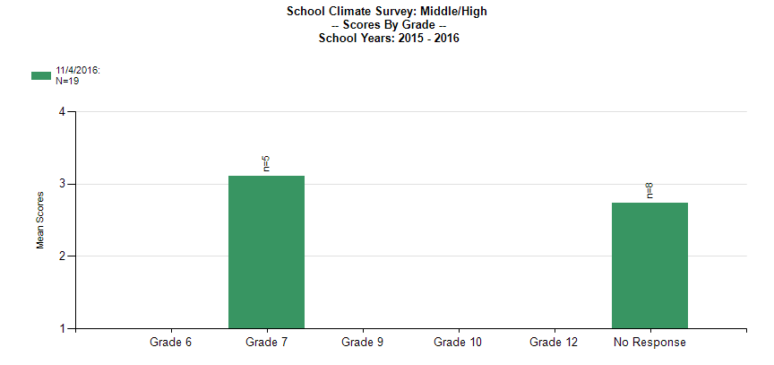

Figure 7.40

SCORES BY RACE/ETHNICITY
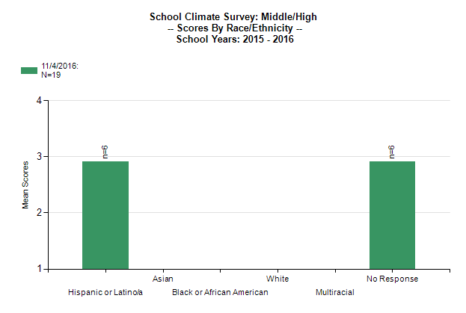

Figure 7.41

SCORES BY ITEMS
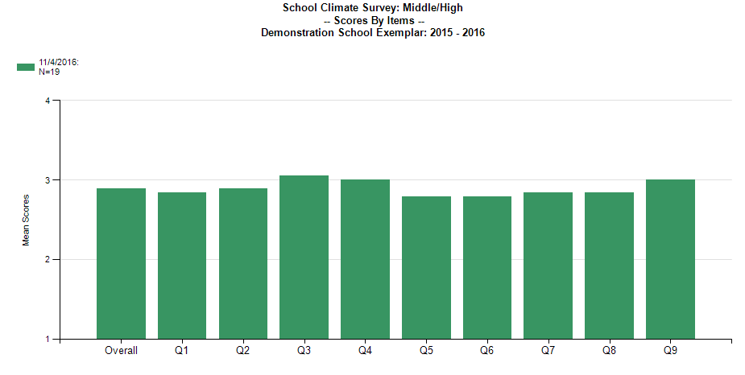

Figure 7.42

SCORES BY ITEMS
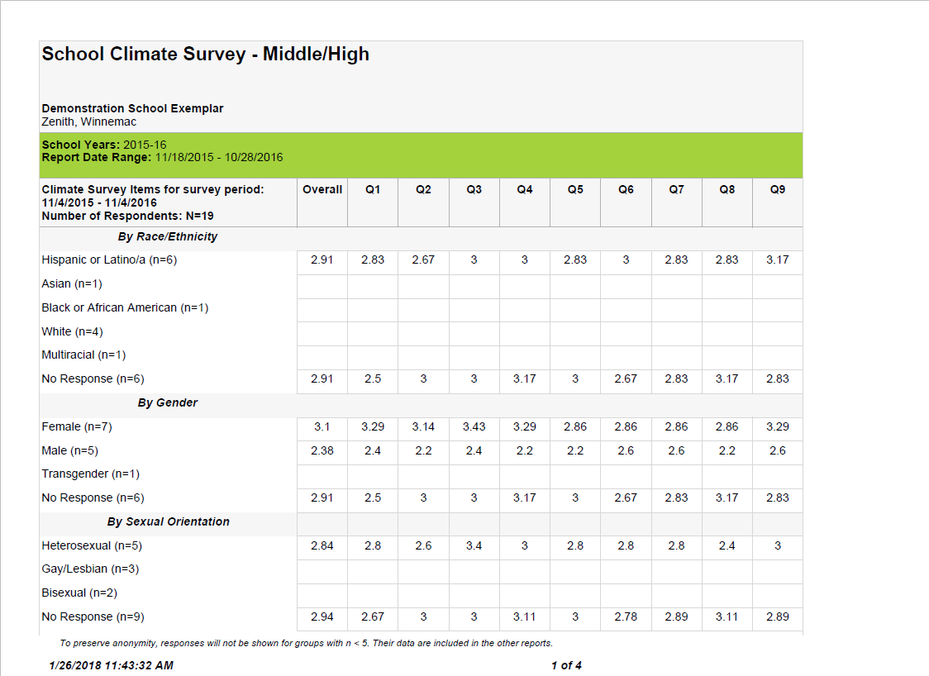

Figure 7.43

