Schoolwide Evaluation Tool (SET 2.0)

Todd, Lewis-Palmer, Horner, Sugai, Sampson, & Phillips, 2005

PURPOSE: The SET is a research-validated tool for assessing the fidelity of implementation of SW-PBS. It is conducted by a trained external evaluator. The SET uses administrator, staff and student interviews, observations, and products to assess the level of SW-PBS implementation across 7 essential features. Each of the essential features are scored by calculating the percentage of possible points earned. The average of these 7 scores are the overall implementation score. Schools are considered to be implementing with fidelity when they achieve an overall implementation score of 80%, and a score of 80% on Essential Feature B: Expectations taught. Schools are encouraged to have a SET until they have achieved two consecutive years of 80% Overall Implementation/ 80% Expectations Taught (usually written 80%/80%). After this, schools may choose to continue having SETs, or to take the TFI.

WHEN: Once annually

WHO: External evaluator

ENTER DATA: Data is entered into PBIS Assessments by a regional consultant or the external evaluator.

REPORTS: Reports can be pulled by an individual with Team Member Level access in PBIS Assessments. For more information, visit https://www.pbisapps.org/Pages/Default.aspx.

Reports are as follow:

SUBSCALE

Figure 7.26

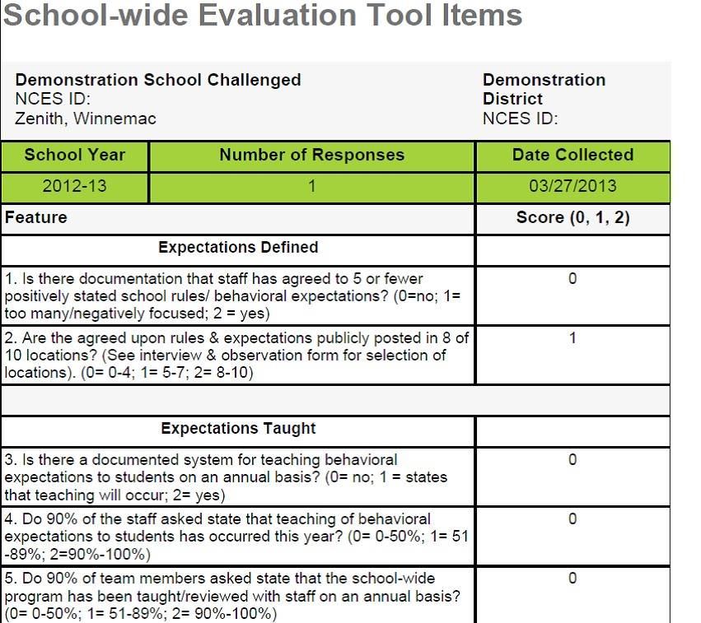
ITEMS

Figure 7.27

As with the TFI and the SAS, the item analysis is useful for pinpointing areas for action planning.

