Tiered Fidelity Inventory (TFI)

Algozzine, Barnett, Eber, George, Horner, Lewis, Putnam, Swain-Bradway, McIntosh, & Sugai (2014)

PURPOSE: The purpose of the TFI is to provide an efficient tool for measuring implementation fidelity at all three tiers. It was designed to ultimately replace several of the assessment tools currently used by PBIS schools, including the Benchmarks of Quality (BoQ) (Kincaid, Childs, & George, 2010) and at least one survey MO SW-PBS schools take at Tier 2 and 3 (The Benchmarks for Advanced Tiers). Recent research demonstrates that scores on the TFI have strong content validity, and are strongly correlated to other fidelity measures at all three tiers (McIntosh, et al., 2017). MO SW-PBS does not require participating schools to take the TFI until they have achieved two consecutive 80/80 scores on the SET, or they have begun their first year of training at Tier 2. Schools will take the TFI at least once annually in the spring, but may take it more frequently for purposes of progress monitoring. The tool is divided into three sections, or scales, one for each tier. Each scale has 15-17 items. MO SW-PBS recommends the Tier 1 Leadership Team only complete the Tier 1 scale. Each item is scored 0 (not in place), 1 (partially in place), or 2 (fully in place). The team votes on how to score each item, and the score with the majority of votes is entered into the PBIS Assessments site. PBIS National Center recommends that teams only take those sections pertaining to tiers at which they are currently implementing. In addition, it is recommended that teams take the TFI once per quarter until they achieve 80% fidelity across three consecutive administrations.

Walkthrough. Prior to taking the TFI as a team, it is recommended that an individual familiar with PBIS and either the TFI or SET walkthrough conduct a TFI walkthrough. This walkthrough will help the team to answer three of the items in the TFI Tier 1 scale. MO SW-PBS also recommends that the individual who conducts the walkthrough, as well as the individual who facilitates the administration of the TFI with the team be someone external to the school. Research by McIntosh, et al., (2017) shows that validity is higher when an external facilitator is present. This external facilitator can be a regional consultant, a district staff member, or a staff member assigned to another building. Regardless of who facilitates the team meeting, this individual should have familiarity with SW-PBS and the TFI.

WHEN: At least once, annually, in the spring

WHO: Tier 1 Leadership Team

ENTER DATA: One team member will enter the responses into PBIS Assessments

REPORTS: School team members with Team Member level access can run reports from the school’s PBIS Assessments account.

FIDELITY CRITERION FOR TIER 1: 70% (Mercer, McIntosh & Hoselton, 2017)

Reports are as follows:

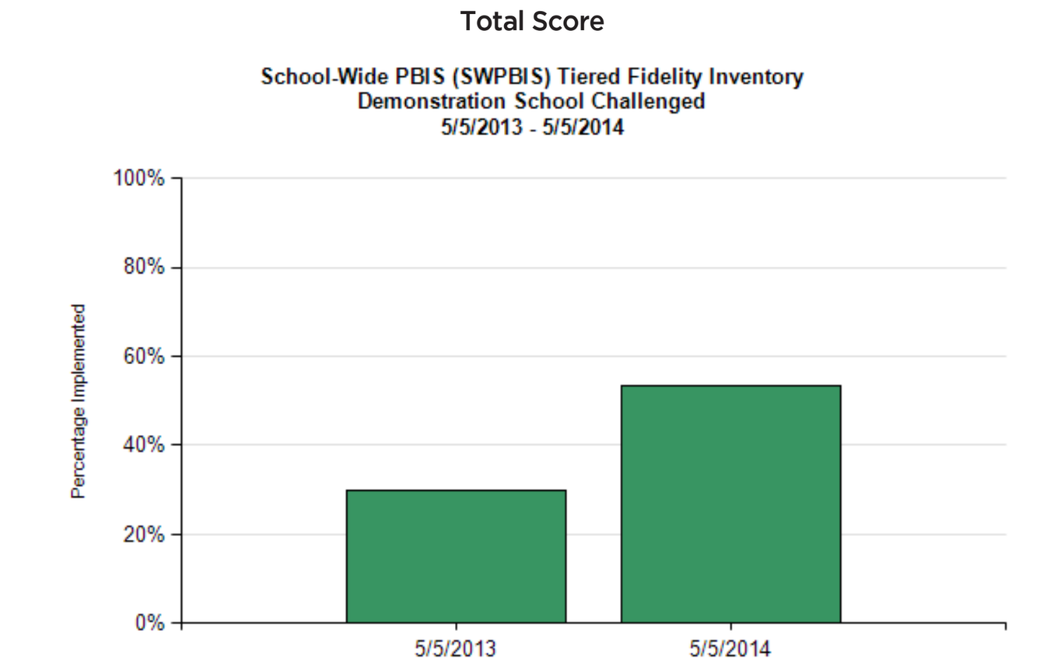

Figure 7.19

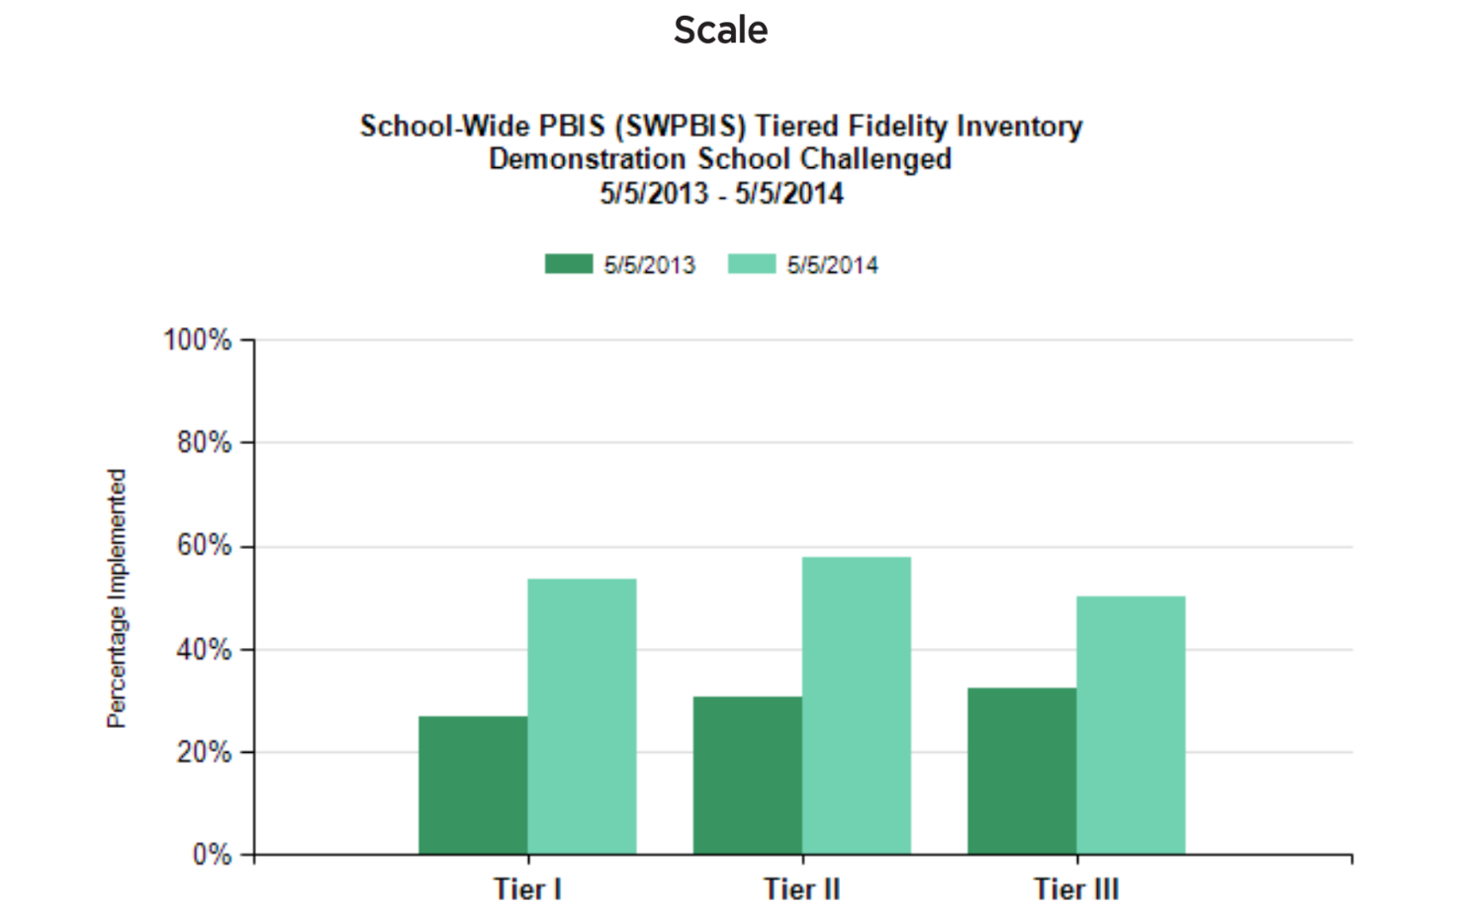

Figure 7.20
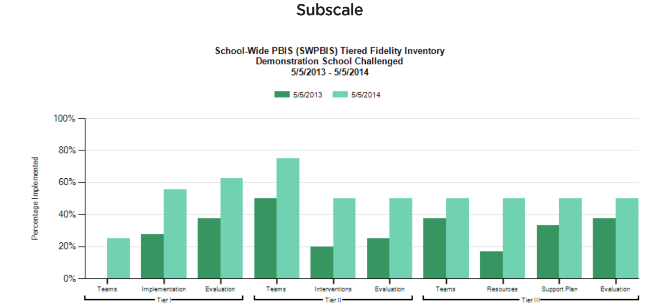
Figure 7.21

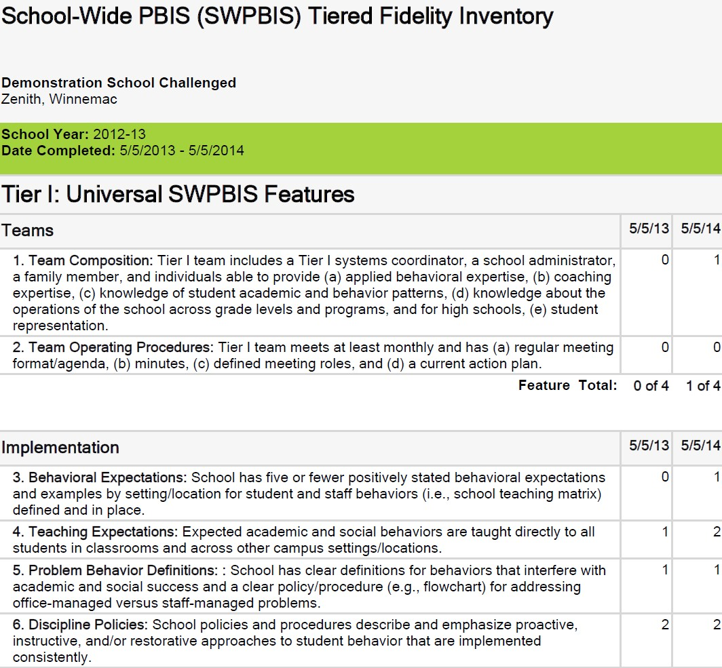
Items
Figure 7.22

