Schoolwide System to Discourage Inappropriate Behavior
Flowchart

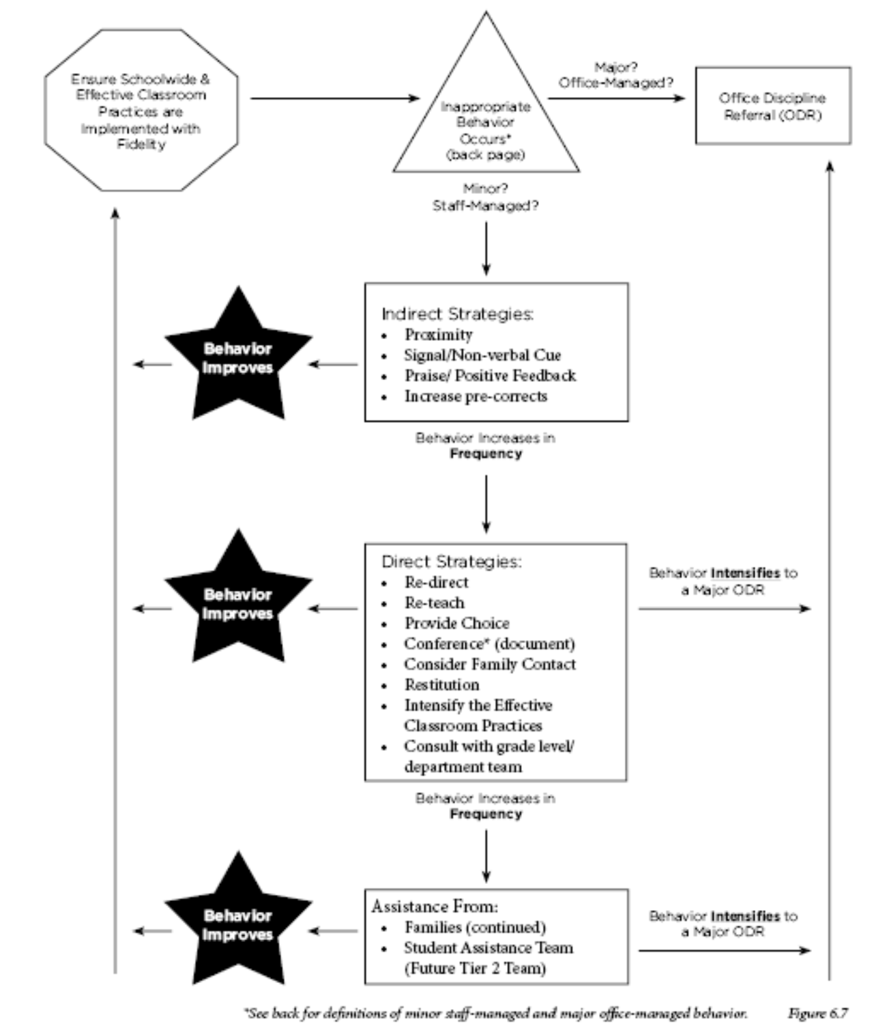

*See back for definitions of minor staff-managed and major office-managed behavior.
Schoolwide System to Discourage Inappropriate Behavior
Staff-Managed and Office-Managed Behavior Definitions

Minor/Staff-Managed | Definitions
Defiance, Disrespect, Noncompliance | Brief or low-intensity failure to respond to adult requests.
Disruption | Low-intensity but inappropriate disruption
Inappropriate Language | Low-intensity instance of inappropriate language
Physical Contact | Non-serious but inappropriate physical contact
Property Misuse | Low-intensity misuse of property
Tardy | Arrives at class after the bell
Technology Violation | Non-serious but inappropriate use of technology

Major/Office-Managed | Definitions
Abusive, inappropriate language | Swearing, name-calling, use of word in inappropriate way
Defiance, Disrespect | Refuses to follow directions, talks back, rude
Fighting, Physical Aggression | Serious physical contact where injury might occur
Inappropriate Display of Affection | Inappropriate verbal or physical gestures or contact, sexual nature to another student or adult
Property Misuse, Vandalism | High-intensity misuse, destruction of property
Technology Violation | Serious inappropriate use of technology
Theft | In possession of or removes someone else’s property
Use, Possession of Alcohol, Drugs, Tobacco | Possesses or uses alcohol, drugs or tobacco
Use, Possession of Weapon | Possession of knives, gun or other objects (real or look alike) that might injure others
Verbal assault, threat | Inappropriate, threatening language directed at someone

Page 2

