Action Plan Development
Questions for school-based teams:
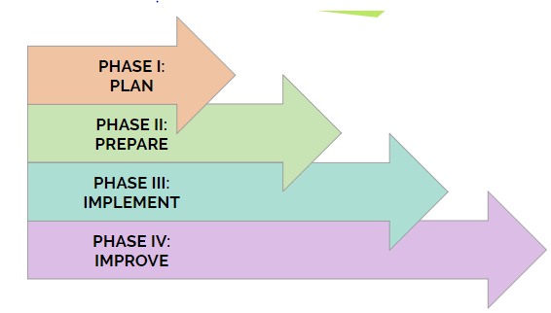
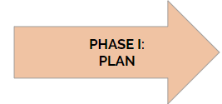
What is our end goal for Phase I? (i.e. how to present ideas for combining initiatives for simplified implementation to stakeholders in the district)

- Identify current initiatives and clarify specific problems that need to be addressed using analyzed data and information
  - What are the current initiatives in your district?

  - What was the driving force for determining your current initiatives? What needs did your district identify that brought the initiative into your district (This could be legislation, data, building pilots/models)?

  - What ways does your district measure the effectiveness of current initiatives? What data is collected? (Behavior data/ODRs, survey data, observations/checklists, etc.)

  - What are initiatives that your district may be considering adding or you/your team is/are interested in adding?

- Determine priorities, starting points, possible solutions
  - What are my school district’s priorities?

  - Is there an opportunity to pilot with certain schools, grade levels, etc…?

  - What are the priorities at the building level?

- Identifying your “champions” (stakeholders) for each initiative
  - Who within your school district are key stakeholders in your current initiatives?

  - Who within your district could be a “champion” or advocate to support the merging of initiatives?

- Select and develop your solution – consider readiness, capacity, and resources
  - Using the crosswalk developed earlier, what are some ways you can integrate initiatives in daily practice?

  - Does capacity need to be expanded or adapted in order to begin the implementation stage? What are some ideas for what that will look like?

  - What ways can you integrate initiatives through training for staff?

  - Are there other ways to integrate initiatives in your district (district website? School-based teams?)

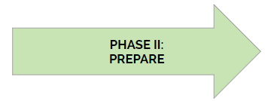
What is our end goal for Phase II? (i.e. knowing what in currently in place and steps need to be taken)

- Design your solution (can be a single or multiple strategies)
  - Consider “big picture” for how you will integrate initiatives.

  - Set a timeline for initiative integration (Will you integrate all initiatives at once? Will you integrate initiatives over time? Are there certain initiatives that are long-term/contracted?)

- Determine the “nuts and bolts” – what is needed and what needs to happen to put the solution in place (information, logistics, partners, materials, data to collect, and more)
  - Set a time to meet with identified key stakeholders to discuss initiative integration and discuss future planning -- It is essential to know your audience and what information will have the most impact (If your stakeholders frequently examine data, have data prepared. If your stakeholders are mindful of budgetary constraints, consider costs/savings from your integration plan.)

  - Determine ways to measure progress with combining initiatives (Will you examine already available data collected? Create surveys? Utilize other data collection tools?)

- Prepare for implementation (i.e. get people, materials, locations, etc. ready)
  - How will you communicate integration with buildings?

  - How will you communicate integration with staff?

  - How/when will training be provided?

  - What should this look like at the building level? (i.e. Combining/aligning building committees)

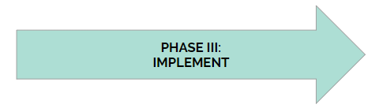
What is our end goal for Phase III? (i.e. implementing with fidelity and consistency)

- Implement your solution
- What initiatives will be implemented?

- How are we documenting the initiatives across levels? (i.e. are some pieces level specific? Consider developmental appropriateness)

- How are we providing support to implementers? (i.e. monetary, planning time)

- Monitor to ensure full implementation
  - In what ways can we ensure fidelity? (if you have questions, go to the fidelity document)

  - How can we support buildings who are integrating initiatives?

  - How can we communicate questions/concerns from the building level with stakeholders/leadership? How will we document/note what is going well?

  - Utilize district-available data, when possible

  - Get feedback from staff, when possible (climate surveys, school-based teams surveys, etc.)

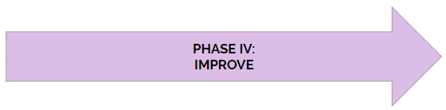
What is our end goal for Phase IV? (i.e. determine what we are missing and how to revisit the gap )

- Keep a pulse on progress & Make mid-course corrections, when needed
  - Who is spearheading which pieces of integration?

  - How often is integration occurring (In practice, through trainings, or full immersion)?

  - What could we be missing?

  - How can we improve this?

- Evaluate results
  - How will we utilize valid data to make decisions?

  - Are we sharing information with the right stakeholders? How?
    - Community-level (Families) -- consider sharing at parent or community meetings

    - Building-level (Teachers & Administrators) -- consider sharing at all staff meetings

    - District-Level (Directors & Superintendents) -- consider having standing meetings with key stakeholders at the district level for updates and feedback

  - What resources are needed to continue the rate of growth?

- Determine long-term improvements & enhancements
  - Consider logistics around implementing during summer/break implementation -- Should planning meetings be scheduled over summer break to prepare for the following school year?

  - How can we build capacity within our current system? -- Consider identifying strong leaders in training & utilizing efficiently

    - Do we have a systematic training for ongoing staff, incoming staff, playing on individual's strengths? (i.e. Train the Trainer model, specific roles within functioning)

    - Review the benefits of incorporating additional systematic programs/initiatives

  - Review our partnerships
    - Who are we currently working with? How is that going?

    - Long term considerations for partnerships (If there is an end date of partnership, what will that hand off look like to ensure sustainability?)

    - What areas do we still need support in?

  - How will you you document long term goals/outcomes to ensure consistent growth over time?

