Positive Behaviour for Learning
3 Tiered Continuum of Support

Academic Enhancements & Interventions
Behaviour Enhancements & Interventions

Intensive & Individualised Interventions
- Individual Students
- Assessment-based
- Intense durable procedures

Intensive & Individualised Interventions
- Individual Students
- Assessment-based
- Highly intensive

Targeted Enhancement & Intervention
- Some students (at risk)
- High efficiency
- Rapid Response
Universal Enhancement & Prevention
- All settings, all students
- Preventative, proactive

1-5%
5-10%
80-90%

Universal Enhancement & Prevention
- All settings, all students
- Preventative, proactive
Targeted Enhancement & Intervention
- Some students (at risk)
- High efficiency
- Rapid Response

Positive Behaviour for Learning Enhancements & Interventions

UNIVERSAL ENHANCEMENT & PREVENTION
1-5%  5-10%  80-90% | - Quality Teaching- 5 Star T & L model/ Instructional Pedagogy  - School-wide Everyone Everywhere Matrix/ class-wide expectations  - Explicit and specific PBL lessons  - Focus areas- In Line on Time; Hands Off; Stop, Look, Listen, etc  - School-wide recognition system  - Whole school assemblies/meetings  - School-wide attendance strategies/Attendance monitoring system  - Professional Learning Teams- Positive Behaviour for Learning, Newly Appointed Teachers, Behaviour, IT, etc  - Student Voice action plan (3 tiered model: personal, peer and public leadership)  - School Nurse Program
TARGETED ENHANCEMENT & INTERVENTION
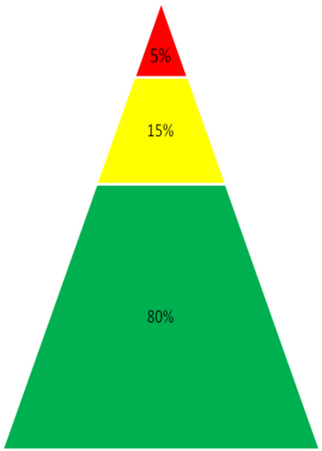 | - DP monitoring cards and attendance monitoring cards  - Learning Centre and Homework Centre programs and referrals  - Literacy and Numeracy programs  - New scheme teachers mentoring programs  - Work experience/ referral programs e.g. Links, Break the Mould (BTM), I.Track, Step it Up  - Gifted & Talented programs  - Tuition programs & lunch time activities  - Transition programs with Bidwill PS  - AMP/NRL, Rock and Water programs  - Responsiblity Learning and Respect (RLR) lessons  - Teacher Mentoring (HSC students)  - CICO –Check In Check Out  - Enrichment and engagement group  - Think tank group
Intensive & Individualised ENHANCEMENT & Intervention
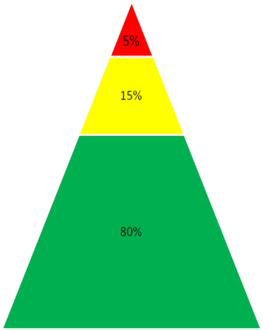 | - Headspace  - Home School Liasion Program HT Administration interviews and attendance cards  - Learning Support Team (LST)  - Coordinated Support Team (CST)  - Return To School Centre (RTSC)  - Planning Room  - Learning assessments and support including: Support Teacher Learning Assistance (STLA), English as a Second Language(ESL)  - Western Area Adolescent Team(WAAT)  - MIDAS  - Marist  - Department of Community Services(DOCS)

